Summer Festival 2026
Project management file: initiation and project start
Project | Summer Festival 2026
Kind of project | Event
Organisation | Example GmbH, Corporate Communications
Project status | Closed
PM plan version | 1.0
Prepared by | Marc Huber
Last updated | 31 Jul 2026
A summer festival for about 400 employees and their families on 27 June 2026, planned and run by an internal project team of six.
Contents
To add page numbers in Word, right-click the list and choose Update Field.
Project at a glance
1 Process map: the ten steps
2 Core ideas and planning depth
Three views of a project
Four principles of the approach
The project management process
Planning effort
Triple constraint and planning depth
Method pyramid
3.1 Assess the idea
Business case
3.2 Categorise the project
3.3 Boundaries and context: the six fields
Time
Content
People
3.3 Project Charter
3.4 Stakeholder analysis
Steps 1 to 3: collect, group and assess
Steps 4 to 6: relation, measures, responsible and deadline
3.5 Scope: results plan and work breakdown structure
Three levels of scope
Results plan
Work breakdown structure
3.5 Schedule: milestones and bar chart
Milestones
Duration estimates
Dates
3.5 Resources and costs
Step 1: resource and cost types
Steps 2 and 3: depth and the plan per line
Step 4: staff placement and cost table
Step 5: availability
3.6 Project approval
4.1 Project organisation
Role descriptions
Organisational incorporation
4.1 Communication, culture and team development
Project culture
Team development
4.2 Who does what: RACI chart
4.2 Work package specifications
4.2 Detailed schedule: linked bar chart and network
Critical path
4.2 Detailed resources and costs: over time
Staff over time
Costs over time
Payments and gross margin
4.3 Consolidate and coordinate the detailed planning
Project marketing
4.4 Finalise the PM plan
4.5 Approve the PM plan
5 Risk management
Identify and assess
Risk budget and reserves
Risk controlling
6 Kick-off and start workshop
Kick-off meeting
Project start workshop
7 Contract management in customer projects
Contract analysis
8 Tailoring the planning process
Situation analysis
Method check
Planning navigator

Project at a glance
Your project file for the initiation and start of a project, from the first idea to the approved PM plan. Fill it in section by section; the graphics update as you type.
Method: How to use this workbook
- Start with the project details below. Name, dates and status feed the graphics on every page.
- Work through the sections in the menu in order. Section 1 shows the ten steps and where each one is documented.
- Grey text in a field or table is a hint from the template. Replace it with your own words.
- Switch on Example at the top to see a filled-in sample project. It is read-only, and your own file stays as it is.
- Your entries are saved as you type.
- Export makes a Word file with every table and graphic, and an Excel file with every table.

Project
Project name | Summer Festival 2026
Kind of project | Event
Project status | Closed
Organisation | Example GmbH, Corporate Communications
Prepared by | Marc Huber
PM plan version | 1.0
Last updated | 31 Jul 2026
Currency | €
Short description | A summer festival for about 400 employees and their families on 27 June 2026, planned and run by an internal project team of six.

Start and end
Start event | Project assignment signed by the sponsor
Start date | 2 Feb 2026
End event | Evaluation report accepted by the sponsor
End date | 31 Jul 2026
Duration | 180 days (25.7 weeks, about 5.9 months)

Project at a glance
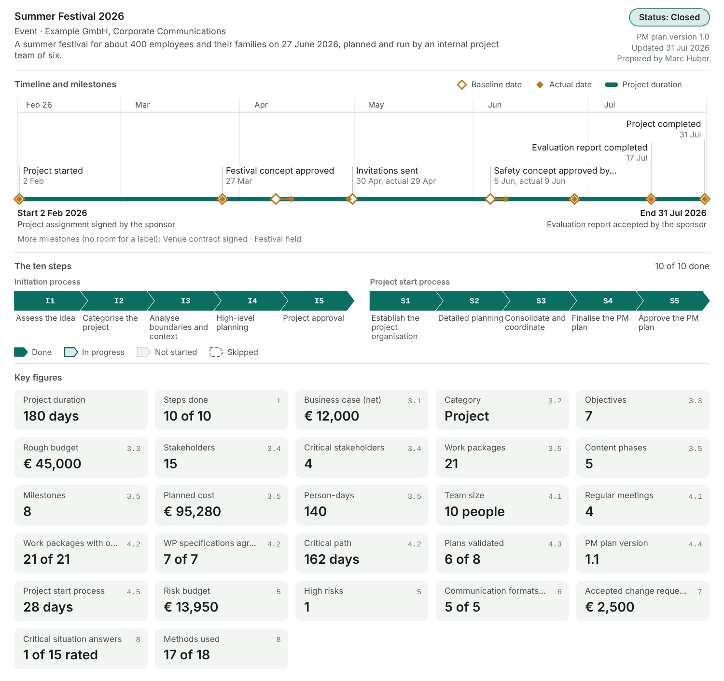
Figure 1: Project, timeline with the milestones, the status of the ten steps and the key figures of the plans. Hollow diamonds are baseline dates, filled ones actual dates.

Key figures
Figure | Value | From section
Project duration | 180 days | At a glance
Steps done | 10 of 10 | 1 Process map
Business case (net) | € 12,000 | 3.1 Assess the idea
Category | Project | 3.2 Categorise the project
Objectives | 7 | 3.3 Six fields
Rough budget | € 45,000 | 3.3 Six fields
Stakeholders | 15 | 3.4 Stakeholders
Critical stakeholders | 4 | 3.4 Stakeholders
Work packages | 21 | 3.5 Scope and WBS
Content phases | 5 | 3.5 Scope and WBS
Milestones | 8 | 3.5 Schedule
Planned cost | € 95,280 | 3.5 Resources and costs
Person-days | 140 | 3.5 Resources and costs
Team size | 10 people | 4.1 Project organisation
Regular meetings | 4 | 4.1 Communication and culture
Work packages with one R | 21 of 21 | 4.2 RACI chart
WP specifications agreed | 7 of 7 | 4.2 Work package specifications
Critical path | 162 days | 4.2 Linked bar chart and network
Plans validated | 6 of 8 | 4.3 Consolidate and coordinate
PM plan version | 1.1 | 4.4 Finalise the PM plan
Project start process | 28 days | 4.5 Approve the PM plan
Risk budget | € 13,950 | 5 Risk management
High risks | 1 | 5 Risk management
Communication formats used | 5 of 5 | 6 Kick-off and start workshop
Accepted change requests | € 2,500 | 7 Contract management
Critical situation answers | 1 of 15 rated | 8 Tailoring
Methods used | 17 of 18 | 8 Tailoring

Glossary
Term | Meaning | What we call it in our organisation
PO, PS | Project owner or project sponsor: two names for the same role. Strategic responsibility; represents the company in the project. | Sponsor (Head of HR)
PSC | Steering committee above the project. | Management board
PMO | Project management office. | None; HR project office helps
Project Charter | The project assignment, signed by PO and PM. | Project assignment
PM plan, PHB | All project plans and documents in one place, also called the project handbook. | Project handbook (team drive)
PD | Person-days (also written MD or PT). | Person-days
CR | Change request: a formal request to change scope, dates or costs. | Change request form

1 Process map: the ten steps
Two processes of five steps each take a project from the first idea to an approved PM plan. Record for each step what happened in your project.
Method: What goes in and what comes out
- Initiation process (steps I1 to I5): starts with a project idea and ends with the (preliminarily) released Project Charter.
- Project start process (steps S1 to S5): starts with the preliminary charter and ends with the final charter and the approved PM plan, version 1.0.
- Each process ends with a decision of the PO: project approval in I5 and approval of the PM plan in S5.
- The ten steps are an example. Section 8 shows how to scale them to your project.

Process map
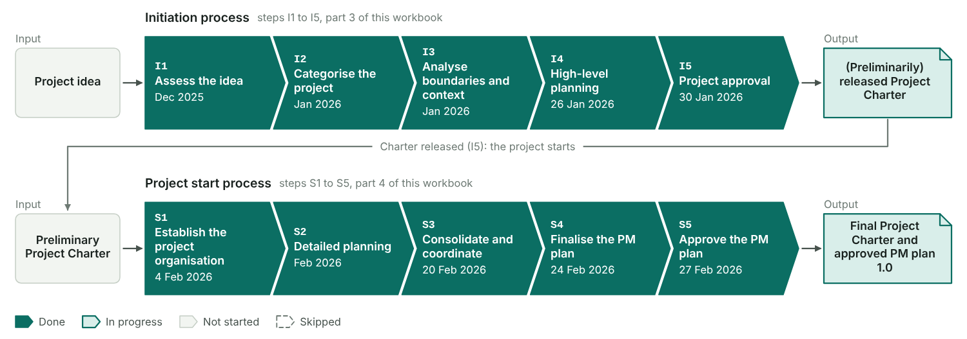
Figure 2: Each chevron is one step, coloured by its status in the table below, with the date you entered. The released charter at the end of the initiation is the input of the project start.

The ten steps in your project
Step | Step | Status | When | Format used | Who took part | What we did | Result
I1 | Assess the idea | Done | Dec 2025 | One-to-one talks | Head of HR, Corporate Communications, Controlling | Described the festival idea, checked it against the employer-branding strategy, made a first business case | Management decided to run the festival
I2 | Categorise the project | Done | Jan 2026 | One-to-one talks | Anna Berger (PO), PMO | Checked the project criteria (4 divisions, 6 months, > 50 person-days, > €20,000 external spend); appointed PO and PM | Category: project; PO and PM appointed
I3 | Analyse boundaries and context | Done | Jan 2026 | Initial PO meeting | Anna Berger, Marc Huber | Filled in the six fields, listed stakeholders, named the first risks | First draft of the charter
I4 | High-level planning | Done | 26 Jan 2026 | Planning workshop (half day) | PM and four designated core team members | Agreed objectives, phases, WBS, milestones and a rough budget | Initial charter and first draft of the PM plan
I5 | Project approval | Done | 30 Jan 2026 | PO meeting | Anna Berger, Marc Huber | Went through the charter, checked the business case | Charter released on 2 Feb 2026
S1 | Establish the project organisation | Done | 4 Feb 2026 | Kick-off (2 h) and start workshop (1 day) | PM, core team, team members, PO for the first hour | Presented the charter, agreed roles, meetings and ground rules | Working team with a shared picture of the festival
S2 | Detailed planning | Done | Feb 2026 | Individual planning, one-to-one talks | PM, core team | Wrote WP specifications, estimated dates, staff and costs | Detailed work packages
S3 | Consolidate and coordinate | Done | 20 Feb 2026 | Follow-up workshop | PM, core team | Completed the bar chart, staff plan, cost plan and risk table | Validated plans
S4 | Finalise the PM plan | Done | 24 Feb 2026 | E-mail, one-to-one talks | PM, project assistant | Put all plans into the PM plan and sent it round | PM plan 1.0 (draft)
S5 | Approve the PM plan | Done | 27 Feb 2026 | PO meeting | Anna Berger, Paul Gruber, Marc Huber | Presented the PM plan; agreed reporting every four weeks | PM plan 1.0 approved, baseline saved

Initiation process: activities, roles, formats, results
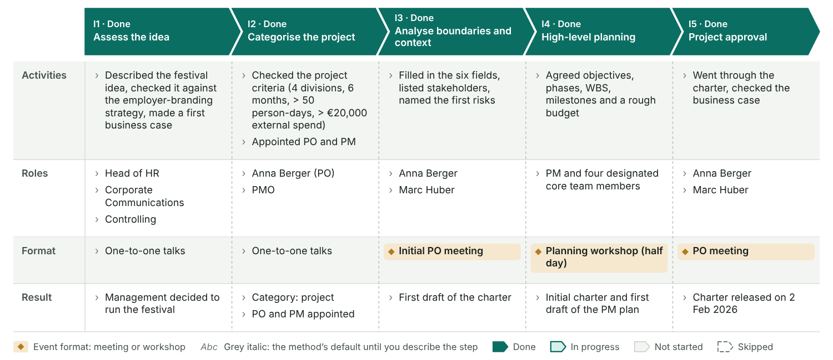
Figure 3: One column per step. Each cell shows what you wrote in the table above; until then it shows the method’s default in grey italics. Amber marks the formats that are events, the meetings and workshops.

Project start process: activities, roles, formats, results
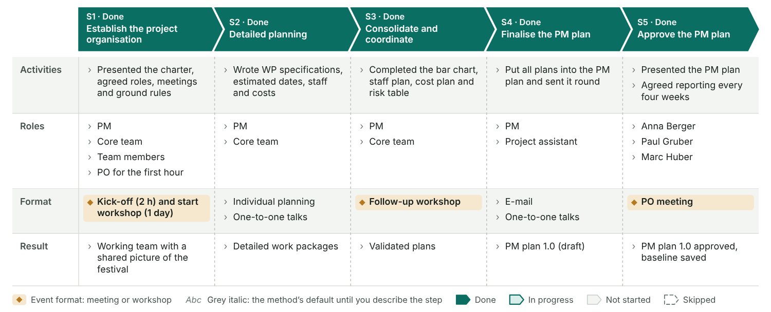
Figure 4: One column per step. Each cell shows what you wrote in the table above; until then it shows the method’s default in grey italics. Amber marks the formats that are events, the meetings and workshops.

2 Core ideas and planning depth
The ideas behind the method and how deep your planning goes. Note how each one applies to your project.

Three views of a project
A project is a task, a temporary organisation and a social system at the same time. Each view asks something different of the planning.
Task with special characteristics | A one-off festival for about 400 guests on a fixed date, 27 June. Nobody in the team had run an event of this size, and weather, safety and registrations were real risks.
Temporary organisation | A temporary team of six from Corporate Communications, Facility Management, Marketing and Finance, working on the festival next to their line jobs. The Head of HR was the project owner; a board member followed the project as steering committee.
Social system | Many people had an opinion about a staff festival: departments, the works council, families and the venue’s neighbours. The start workshop gave the team one shared picture, and the stakeholder plan kept the others on board.

Four principles of the approach
The method rests on four principles. Describe how you applied each one.

Principles in practice
 | Principle | In practice | How we applied it
M | Management process | Project management applies methods, tools, techniques and competencies to the project. | Used charter, WBS, milestone plan, cost plan and risk table, and reported to the sponsor every four weeks.
I | Iterative, process-oriented | Work in cycles of observing, deciding and acting. Plans are adapted step by step. | Planned in two rounds (planning workshop in January, start workshop in February) and re-planned catering and safety when the venue contract slipped by four days.
S | Systemic-constructivist | There is more than one reality, so the team has to build a common view. | Collected the expectations of HR, the works council and the departments before fixing the concept; the employee survey gave the guests a voice.
T | Team-oriented | Project management is shared work: the whole team plans and controls. | The core team planned together in the start workshop. Each core team member owned one phase and reported in the controlling meeting.

The project management process
Every stage ends with a document. This workbook covers the first two stages.

Project management process
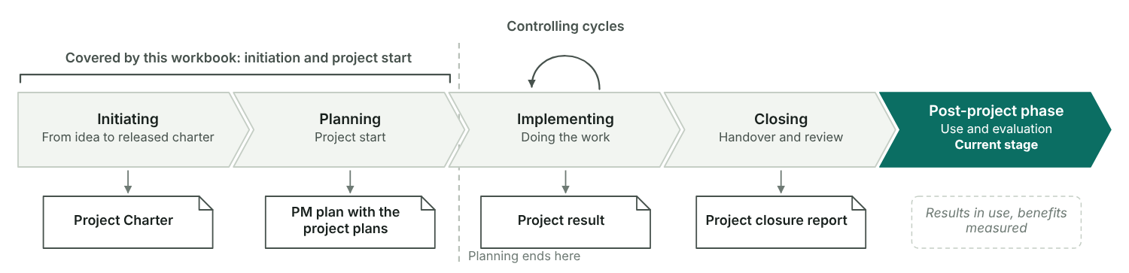
Figure 5: Initiating and planning are covered here; controlling runs in cycles during the implementation. The stage that matches the project status on the overview page is highlighted.

Planning effort
The more complex the task, the more planning it needs. Processes and line tasks stay in the line; projects and programmes get a temporary organisation.

Planning effort ladder
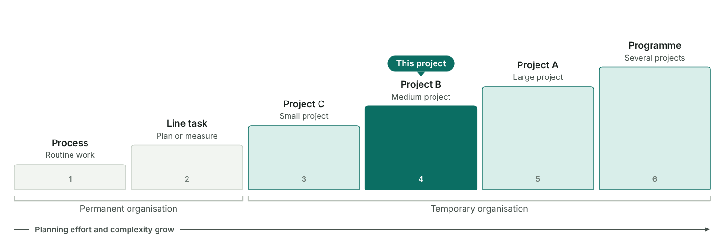
Figure 6: From routine process to programme, each step needs more planning. The marker shows the category set in section 3.2 (project class C, B or A).
The marker comes from the categorisation in section 3.2.

Triple constraint and planning depth
Scope, time, and resources and costs each get a plan. How deep each plan goes depends on the project, but no corner may be skipped.

How deep we plan
Scope plan | Detailed
Schedule | Detailed
Resource and cost plan | Rough

Triple constraint
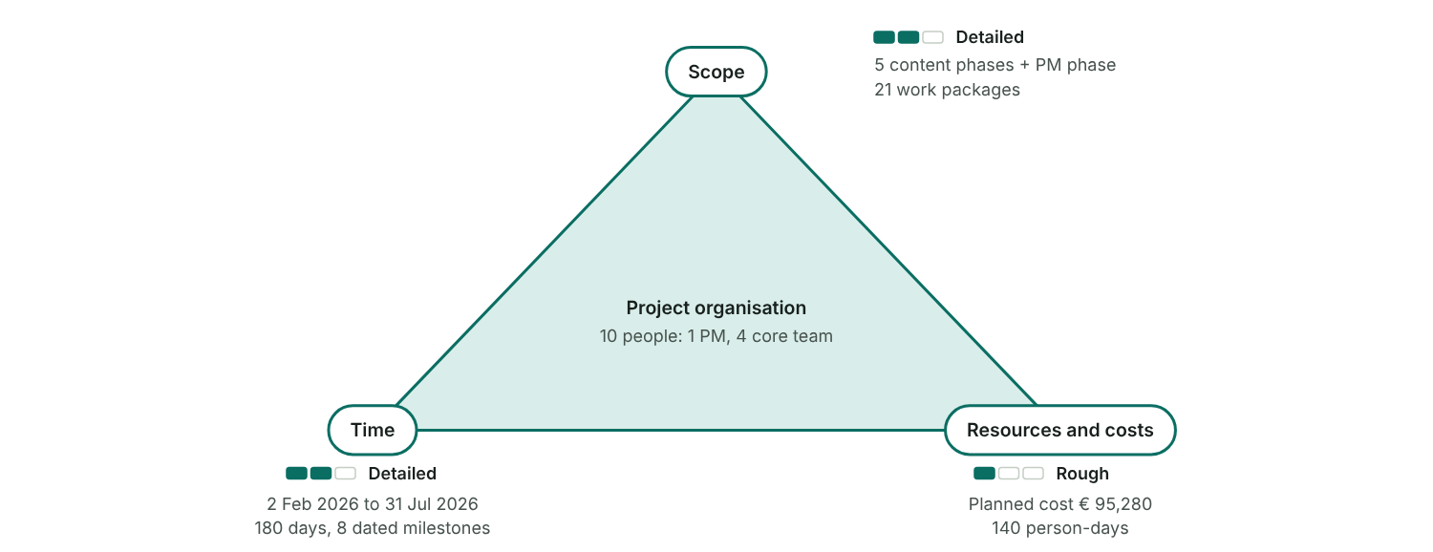
Figure 7: The project organisation sits in the middle and holds the three plans together. Each corner shows the chosen planning depth and this project’s figures.

Method pyramid
The more complex the project, the further up the pyramid the planning goes. Risk management grows with it.

Method pyramid
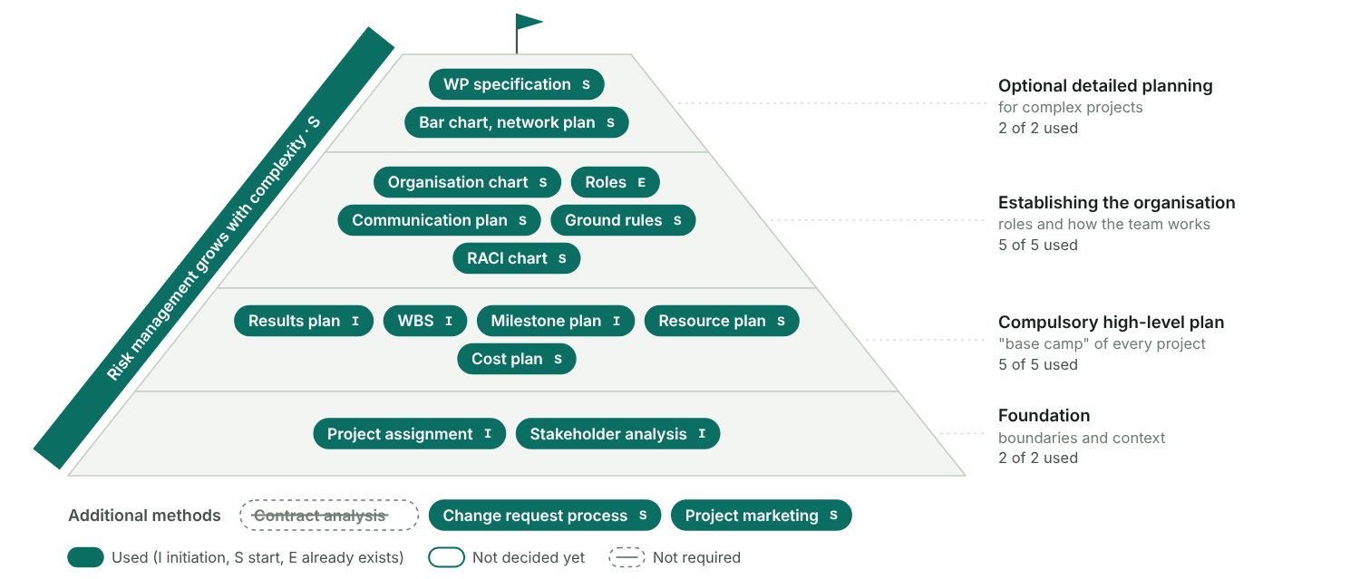
Figure 8: Methods by level, from the foundation to optional detailed planning, styled by the decisions in the method check.
Decide in the method check of section 8 which methods this project uses.

3.1 Assess the idea
Before anyone plans, check whether the idea fits the strategy, can be done and pays off. The result is a recorded decision.
Method: How to assess an idea
- Describe the idea in a few sentences: what it is, who proposed it and why now.
- Strategy fit: check that it serves the company strategy and makes the project portfolio better as a whole.
- Technical feasibility: check that the objectives are manageable, decide whether it is a concept or an implementation project, and whether a feasibility study must come first.
- Economic viability: set costs against benefits over the whole life cycle, name the uncertainties and compare the alternatives, including doing nothing.
- Close with a recorded decision: implement, reject, postpone or study feasibility first.

Step record I1: Assess the idea
Status | Done
When | Dec 2025
Format used | One-to-one talks
Who took part | Head of HR, Corporate Communications, Controlling
What we did | Described the festival idea, checked it against the employer-branding strategy, made a first business case
Result | Management decided to run the festival

The idea
Rough idea | A summer festival for all employees and their families: one day with food, music and a children’s programme at a rented venue. It thanks staff for a hard year and shows the company as a family-friendly employer.
Proposed by | Anna Berger (Head of HR) with Corporate Communications
Proposed on | 18 Nov 2025
Type of project | Implementation project
Feasibility study | Not needed

Three checks
Check | Question | Answer | Assessment
A. Strategy fit | Does the project close a gap between our objectives and the company strategy? | Yes. Employer branding is one of the HR goals for 2026; the festival shows us as a family-friendly employer. | Yes
A. Strategy fit | Does it make our project portfolio better as a whole? | Yes. No other project works on engagement, and Corporate Communications has free capacity in spring. | Yes
B. Technical feasibility | Are the objectives manageable with our skills, tools and capacity? | Yes. The team has run smaller events; venue, catering and artists can be bought in. | Yes
B. Technical feasibility | Is it clear whether this is a concept project or an implementation project? | Implementation project: the format is known, the work is organising it. | Yes
B. Technical feasibility | Can we plan it without a feasibility study first? | No study needed, but the safety concept for 400 guests needs early talks with the authority. | Partly
C. Economic viability | Do the benefits outweigh the costs over the whole life cycle (business case)? | Costs about € 91,000 incl. staff time, benefits about € 103,000 over three years. Break-even in 2028. | Yes
C. Economic viability | Are the uncertainties in costs and benefits known and acceptable? | Recruiting savings and the value of engagement are estimates. Bad weather is a risk for the day. | Partly
C. Economic viability | Is this the best of the alternatives we compared, including doing nothing? | Compared with vouchers for team events and doing nothing. Only the festival reaches families and the public. | Yes

Business case
Costs and benefits over the whole life cycle, by year or period

Costs and benefits
No. | Item | Type | Nature | Year or period | Amount (€) | Note
1 | Venue rent incl. cleaning | Cost | One-off | 2026 | € 9,000 | Quote
2 | Catering for 400 guests | Cost | One-off | 2026 | € 16,000 | Quote, € 40 per guest
3 | Programme: band, children’s programme, host | Cost | One-off | 2026 | € 7,500 | Estimate
4 | Event technology: stage, sound, safety crew | Cost | One-off | 2026 | € 6,000 | 12 days × € 500
5 | Communication: invitations, posters, decoration | Cost | One-off | 2026 | € 2,500 | Estimate
6 | Internal staff time | Cost | One-off | 2026 | € 50,000 | About 125 person-days × € 400; not paid out
7 | Sponsoring income | Benefit | One-off | 2026 | € 8,000 | Main sponsor, two instalments
8 | Lower recruiting costs (referrals, fewer agency fees) | Benefit | Recurring | 2026 | € 15,000 | Estimate by HR
9 | Lower recruiting costs (referrals, fewer agency fees) | Benefit | Recurring | 2027 | € 30,000 | Estimate by HR
10 | Lower recruiting costs (referrals, fewer agency fees) | Benefit | Recurring | 2028 | € 25,000 | Estimate by HR
11 | Higher engagement, lower staff turnover | Benefit | Recurring | 2026 | € 15,000 | Valued from the engagement survey; uncertain
12 | Higher engagement, lower staff turnover | Benefit | Recurring | 2027 | € 10,000 | Uncertain
 | Total |  |  |  | Cost € 91,000 / Benefit € 103,000

Result
Total cost | € 91,000
Total benefit | € 103,000
Net benefit | € 12,000
Benefit / cost ratio | 1.13

Business case
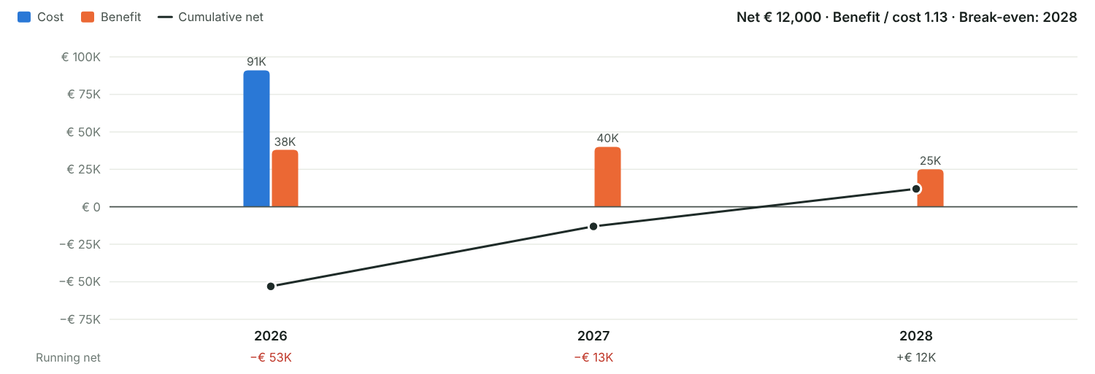
Figure 9: Columns show cost and benefit per period. The line adds up benefit minus cost over time; where it crosses zero, the idea has paid for itself.

Alternatives compared
No. | Alternative | Description | Cost (€) | Benefit | Risk | Decision
1 | Summer festival for staff and families | One day at a rented venue for about 400 guests, with catering, band and a children’s programme | € 91,000 | Visible employer brand, families involved, sponsor income | Medium | Chosen
2 | Vouchers for team events | Each team gets € 60 per person for an event of its own | € 24,000 | Team spirit inside the teams; no effect outside the company | Low | Kept as fallback
3 | Do nothing | Keep the usual Christmas party only | € 0 | None beyond today | Low | Rejected

Decision
Decision | Implement
Decided by | Management board, on the proposal of Anna Berger
Decided on | 15 Dec 2025
Conditions and next steps | External spend up to about €41,000; at least €5,000 from sponsors; one festival in 2026, repeat only after a positive evaluation.

Idea assessment
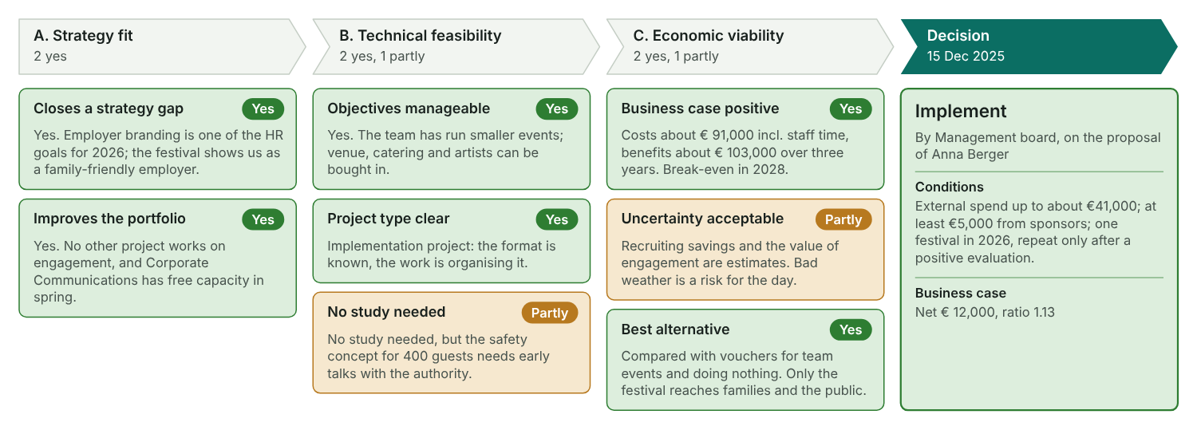
Figure 10: Each card is one question of the three checks, coloured by its assessment. The last column shows the decision they led to.

3.2 Categorise the project
Decide whether the idea is worth a project and how big it is. Then appoint the project owner and the project manager.
Method: How to categorise
- Check whether the task is worth a project at all. Small tasks run better in the line organisation.
- Compare the project with your company’s thresholds for divisions involved, duration, internal effort and external spend.
- Take the category most criteria reach, then confirm it or overrule it with a reason.
- Give it a size class if your company uses them: C small, B medium, A large.
- Appoint the project owner and the project manager, and name the first core team members if you can.

Step record I2: Categorise the project
Status | Done
When | Jan 2026
Format used | One-to-one talks
Who took part | Anna Berger (PO), PMO
What we did | Checked the project criteria (4 divisions, 6 months, > 50 person-days, > €20,000 external spend); appointed PO and PM
Result | Category: project; PO and PM appointed
Every company sets its own limits. The grey numbers are one company’s example; type your own values over them.

Category criteria
Criterion | Unit | Rule | Plan or measure | Project | Programme | Our project | Reaches
Divisions involved | Divisions | at least |  |  |  | 4 | Project
Duration | Months | at least |  |  |  | 6 | Project
Internal effort | Person-days | more than |  |  |  | 140 | Project
External spend | Money (€) | more than |  |  |  | 41,000 | Project

Category
Suggested category | Project (4 of 4 criteria)
Final category | Project (suggested)
Size class | B (medium)
Worth a project? | Yes, run it as a project
Reason | All four criteria reach the project level. Four divisions, six months and about €41,000 external spend need a temporary team; class B because the festival is new for the company but the risks are known.

Where the project sits
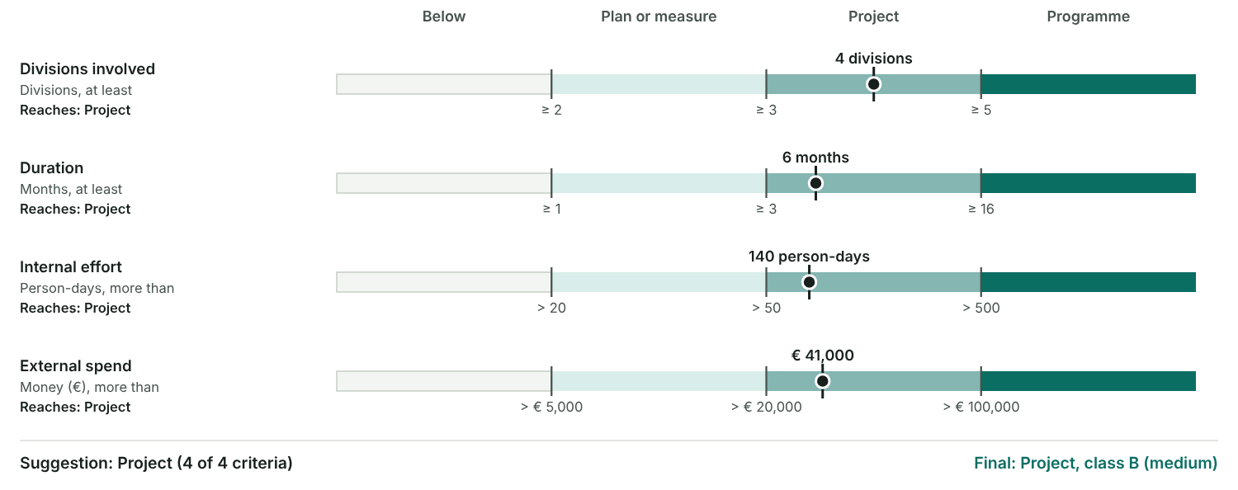
Figure 11: One scale per criterion. Each band runs from one threshold to the next and has the same width, so small and large numbers read alike. The dot is your project.

First project roles
No. | Role | Person | Appointed on | Appointed by | Note
1 | Project owner | Anna Berger | 12 Jan 2026 | Management board | Sponsor of the idea, Head of HR
2 | Project manager | Marc Huber | 12 Jan 2026 | Management board | Corporate Communications
3 | Core team member | Lea Novak | 19 Jan 2026 | Marc Huber with the line managers | Programme
4 | Core team member | Tom Schmid | 19 Jan 2026 | Marc Huber with the line managers | Venue and logistics
5 | Core team member | Sara Kovac | 19 Jan 2026 | Marc Huber with the line managers | Communication
6 | Core team member | Jonas Weber | 19 Jan 2026 | Marc Huber with the line managers | Budget and sponsoring
From here on the project manager steers the process, usually with a vague brief, a preliminary status and a team that still has to be put together.

3.3 Boundaries and context: the six fields
Mark out what belongs to the project and look at what surrounds it, for time, content and people. The result is the first draft of the Project Charter.

Step record I3: Analyse boundaries and context
Status | Done
When | Jan 2026
Format used | Initial PO meeting
Who took part | Anna Berger, Marc Huber
What we did | Filled in the six fields, listed stakeholders, named the first risks
Result | First draft of the charter
Method: Why boundaries and context
- Only what is clearly defined can be planned, controlled and measured.
- Boundaries are the inside view: what belongs to the project and what does not. They become the Project Charter.
- Context is the outside view: what came before, what comes after, what runs alongside and who is affected. Knowing it is the basis for acceptance.
- Look at both for time, content and people. That gives six fields, the foundation for high-level and detailed planning.
- PO and PM fill them in together, in variants if the scope is still open. The same step covers the stakeholder analysis (3.4) and a first risk assessment (5).

The six fields
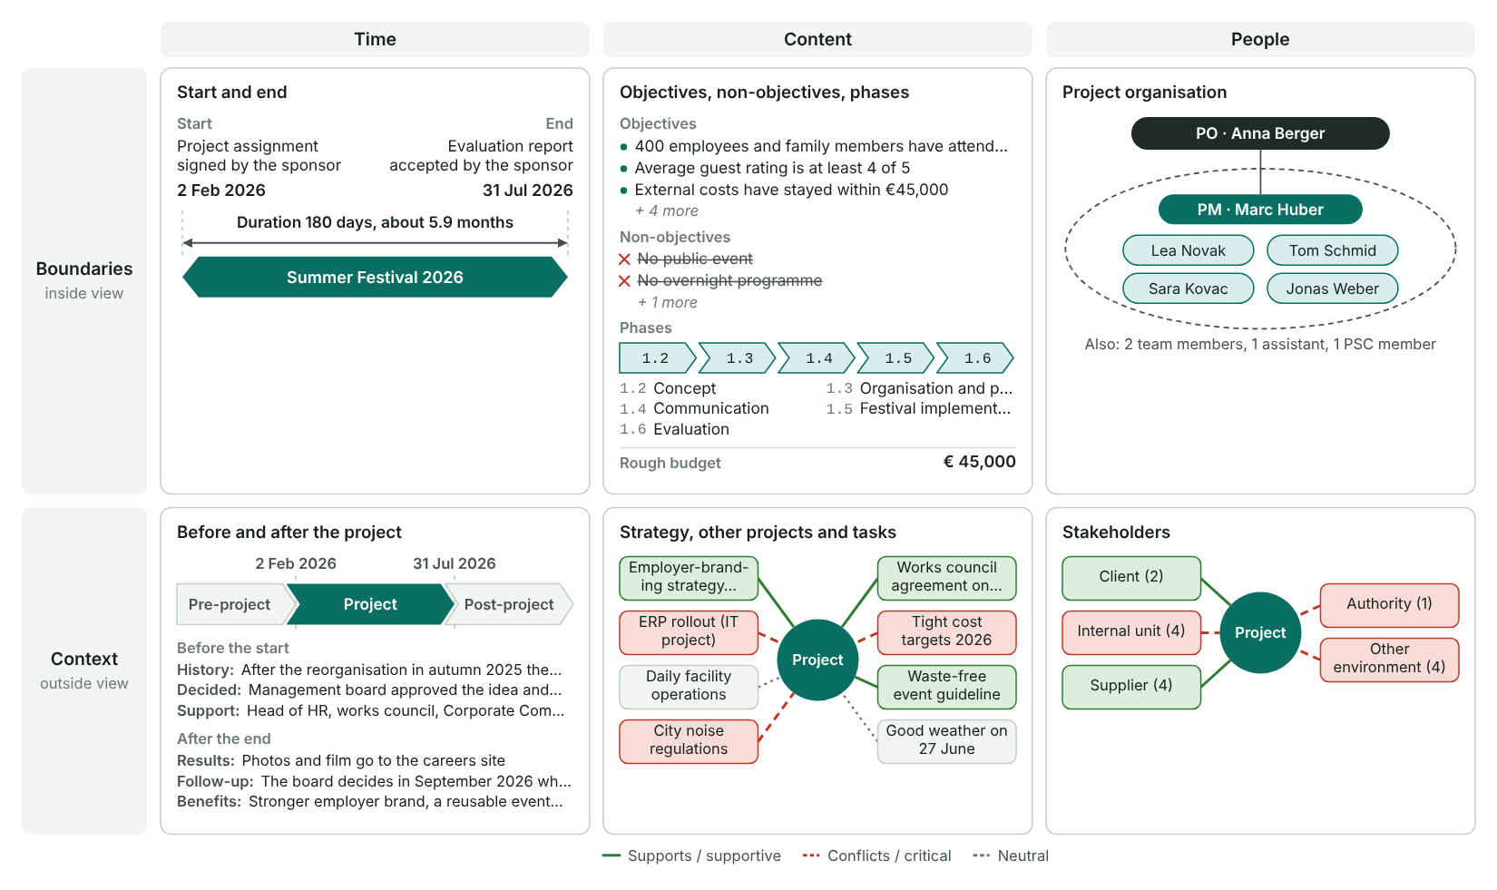
Figure 12: A one-page summary of this section. The top row is the boundary of the project, the bottom row its context. Edges in the context fields show whether a factor or a stakeholder group supports the project or conflicts with it.

Time
Fix start and end as an event and as a date. The event stays when the date moves.

Time boundaries
Start event | Project assignment signed by the sponsor
End event | Evaluation report accepted by the sponsor
Start date | 2 Feb 2026
End date | 31 Jul 2026
Duration | 180 days (25.7 weeks, about 5.9 months)

Pre-project phase: the history
What happened before the start | After the reorganisation in autumn 2025 the engagement survey dropped by 12 points. HR proposed a festival for employees and their families in December 2025.
Decisions already taken | Management board approved the idea and a budget frame of €45,000 on 15 Jan 2026; the date is the last Saturday in June.
Documents that exist | Engagement survey 2025; idea paper and business case; venue offer with an option on 27 June.
Who supported the project | Head of HR, works council, Corporate Communications
Who held it back | IT management, because the ERP rollout needs the same staff in spring

Post-project phase: the consequences
What happens with the results | Photos and film go to the careers site; the feedback flows into the 2027 engagement survey.
Decisions and follow-up projects | The board decides in September 2026 whether the festival becomes a yearly event.
Further benefits | Stronger employer brand, a reusable event concept and a tested supplier list.
What we organise during the project for this phase | Collect photos with consent, keep supplier contacts and a lessons-learned list, draft the proposal for 2027.

Pre-project phase, project, post-project phase
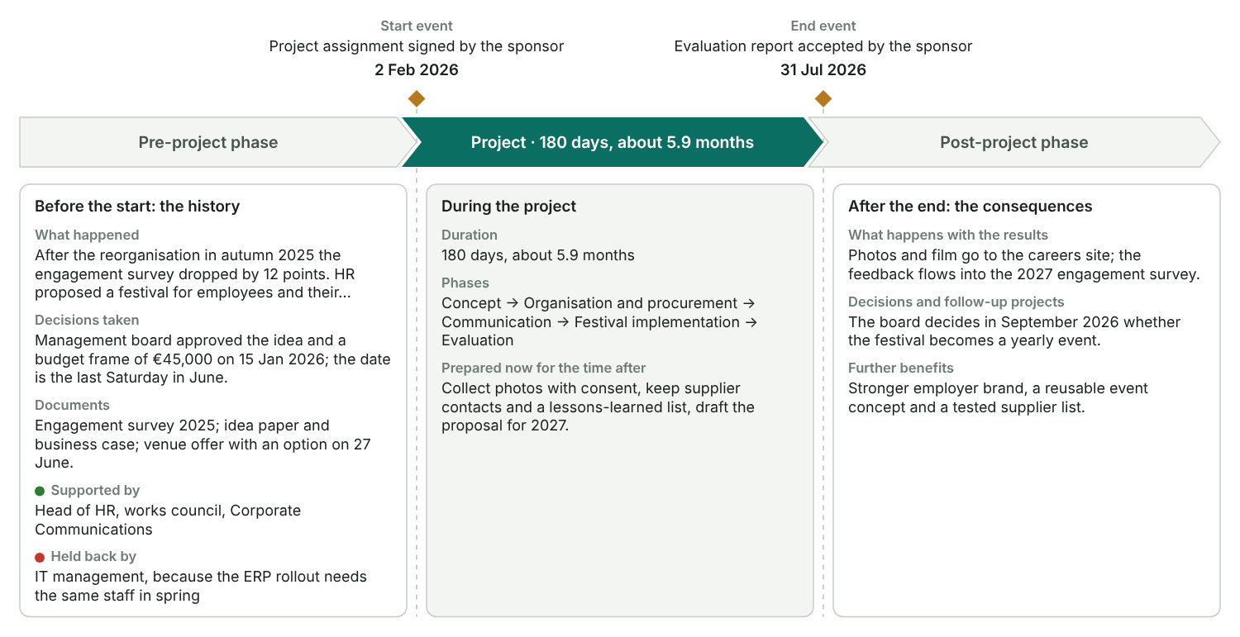
Figure 13: The start and end events (amber) mark the time boundary. Left: what led to the project. Right: what follows from it. The middle card lists what the project prepares now for the time after.

Content
Objectives, non-objectives, phases and a rough budget, and the factors around the project.

Top objective and rough budget
Top objective | Employees and their families have spent a day together that strengthens their bond with the company and with each other.
Rough budget | € 45,000
What the budget covers | External services and material (41,000 + 4,000). Staff time (140 person-days) is tracked separately.

Objectives
No. | Objective | Class | Sub-class | Indicator | Target value | Priority
1 | 400 employees and family members have attended the festival | Scope or functional | Participation | Guests counted at the entrance | ≥ 400 guests | Should
2 | Average guest rating is at least 4 of 5 | Scope or functional | Guest satisfaction | Feedback survey | ≥ 4.0 of 5 | Should
3 | External costs have stayed within €45,000 | Budget | External costs | Final cost statement | ≤ €45,000 | Must
4 | Staff time has stayed within 140 person-days | Budget | Internal effort | Logged person-days | ≤ 140 PD | Should
5 | The festival has been held on 27 June 2026 | Schedule | Event date | Festival date | 27 Jun 2026 | Must
6 | The festival has passed without safety incidents | Procedural | Safety | Incidents reported | 0 incidents | Must
7 | The festival is visible in the employer-branding channels | Other | Employer brand | Posts on the careers channels | ≥ 5 posts | Nice to have

Objective pyramid
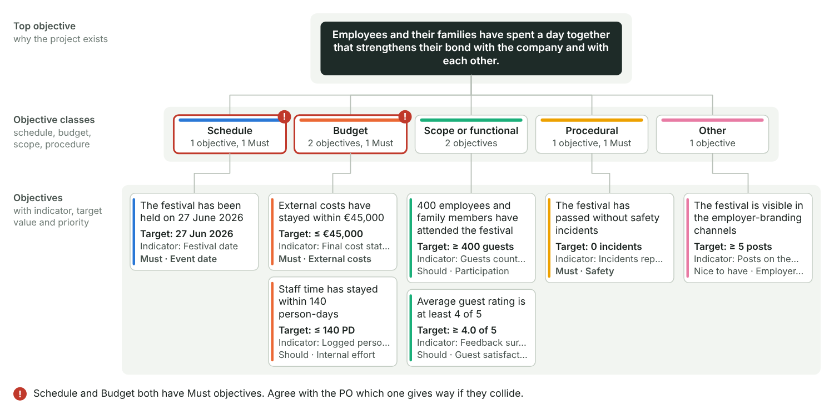
Figure 14: From the top objective through the objective classes to the measurable objectives. A red outline and "!" mark classes that pull against each other: when schedule, budget or scope both carry a Must objective, decide early which one gives way.

Non-objectives
No. | Non-objective | Why it is out
1 | No public event | Only employees and their families are invited
2 | No overnight programme | Day event; music ends at 22:00 because of the noise rules
3 | No festivals at the other sites | Other sites get their own budget

Phases
WBS | Phase | Main result of the phase | Rough start | Rough end
1.1 | Project management | Charter, PM plan, progress reports, closure report | 2 Feb 2026 | 31 Jul 2026
1.2 | Concept | Approved festival concept | 16 Feb 2026 | 27 Mar 2026
1.3 | Organisation and procurement | All contracts signed, safety concept approved | 30 Mar 2026 | 5 Jun 2026
1.4 | Communication | Final guest list | 13 Apr 2026 | 19 Jun 2026
1.5 | Festival implementation | Festival held, venue handed back | 22 Jun 2026 | 30 Jun 2026
1.6 | Evaluation | Evaluation report and final cost statement | 29 Jun 2026 | 17 Jul 2026
Method: Typical phase models
Phases can be standardised per type of project. Use these as a starting point and keep 4 to 5 phases.
- Construction or investment: engineering → approval by the authorities → procurement → construction and assembly → start-up → training → handover.
- Organisational development: analysis → target concept → pilot phase → roll-out of the full concept → training → introduction.
- Product development: market and internal analysis → feasibility study → development → testing and approval → pilot run → market launch.
- Software development: pre-study → functional concept → IT concept → build → test → training → introduction.

Context: strategy, other projects and outside factors
No. | Factor | Type | Effect | Information and coordination | Contact or shared role
1 | Employer-branding strategy 2026 | Company strategy | Supports | Festival photos feed the careers campaign; monthly sync with Marketing | Sara Kovac (also in the branding team)
2 | ERP rollout (IT project) | Similar or parallel project | Conflicts | Same key users in Finance and Facility; PMs align plans every two weeks | Jonas Weber (ERP key user)
3 | Daily facility operations | Line task | Neutral | Shift plan for the set-up week agreed with the facility manager | Mia Fischer
4 | City noise regulations | Legal | Conflicts | Music ends at 22:00; event permit from the city by 5 June | Tom Schmid with the city authority
5 | Works council agreement on family events | Legal | Supports | Covers insurance and working time of helpers; works council informed monthly | Anna Berger
6 | Tight cost targets 2026 | Economic | Conflicts | Monthly cost report to Finance | Jonas Weber
7 | Waste-free event guideline | Ecological | Supports | Reusable dishes and a waste concept with the caterer | Tom Schmid
8 | Good weather on 27 June | Assumption or critical parameter | Neutral | Tent option held until 13 June; weather check from 20 June | Tom Schmid

Context of the project
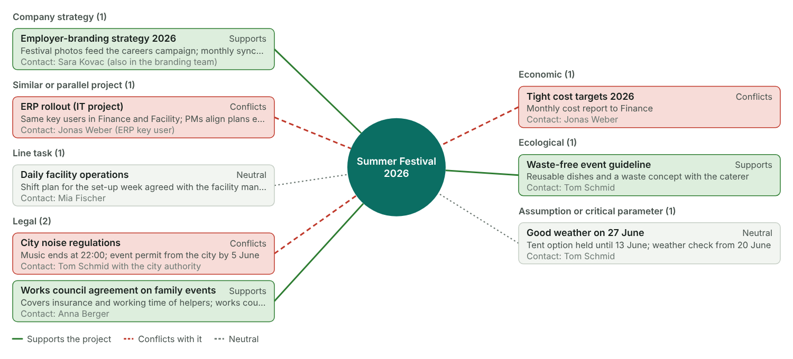
Figure 15: The project in the centre and the factors around it, grouped by type. Green solid edges support the project, red dashed edges conflict with it, grey dotted edges are neutral.

People
Who is inside the project: the project organisation.

Project organisation
No. | Name | Short | Project roles | Department / company | Sub-team | Contact
1 | Anna Berger | AB | Project owner | Head of HR |  | ab@example.com
2 | Marc Huber | MH | Project manager | Corporate Communications |  | mh@example.com
3 | Lea Novak | LN | PMTM | Corporate Communications | Programme | ln@example.com
4 | Tom Schmid | TS | PMTM | Facility Management | Venue and logistics | ts@example.com
5 | Sara Kovac | SK | PMTM | Marketing | Communication | sk@example.com
6 | Jonas Weber | JW | PMTM | Finance | Budget and sponsoring | jw@example.com
7 | Mia Fischer | MF | Team member | Facility Management | Venue and logistics | mf@example.com
8 | Ben Wolf | BW | Team member | Marketing | Communication | bw@example.com
9 | Eva Lang | EL | Project assistant | Corporate Communications |  | el@example.com
10 | Paul Gruber | PG | PSC member | Management board |  | pg@example.com

Project organisation (boundary)
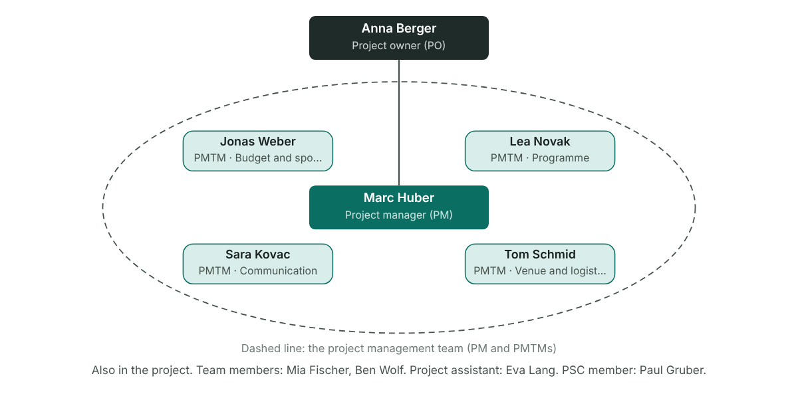
Figure 16: The project owner on top, the project manager below, and the core team (PMTM) around the PM. The dashed line is the boundary of the project management team.
The people context, everyone outside the project who is affected by it and may try to influence it, is the stakeholder analysis in 3.4.
A project that is defined too narrowly misses what it depends on, and vague boundaries invite scope creep. Agree a joint big project picture with the PO and the core team.

3.3 Project Charter
The formal assignment of the project: what it must achieve, by when, with which resources and with whom. PO and PM sign it.
PO, PM and the core team develop it together. It goes to the whole project organisation and to selected stakeholders. The signed version is part of the PM plan.

Charter
Status | Released (final)
Version | 1.0
Date | 2 Feb 2026
Start event | Project assignment signed by the sponsor
Start date | 2 Feb 2026
Duration | 180 days (25.7 weeks, about 5.9 months)
End event | Evaluation report accepted by the sponsor
End date | 31 Jul 2026
Business need | After the 2025 reorganisation, employee engagement dropped. A shared summer festival for employees and their families brings people together across the new divisions and strengthens the employer brand for recruiting.

Roles
Project sponsor (PO) | Anna Berger
Project manager | Marc Huber
Project core team | Lea Novak, Tom Schmid, Sara Kovac, Jonas Weber
Project team members | Mia Fischer, Ben Wolf, Eva Lang

Objectives
No. | Objective | Class | Sub-class | Indicator | Target value | Priority
1 | 400 employees and family members have attended the festival | Scope or functional | Participation | Guests counted at the entrance | ≥ 400 guests | Should
2 | Average guest rating is at least 4 of 5 | Scope or functional | Guest satisfaction | Feedback survey | ≥ 4.0 of 5 | Should
3 | External costs have stayed within €45,000 | Budget | External costs | Final cost statement | ≤ €45,000 | Must
4 | Staff time has stayed within 140 person-days | Budget | Internal effort | Logged person-days | ≤ 140 PD | Should
5 | The festival has been held on 27 June 2026 | Schedule | Event date | Festival date | 27 Jun 2026 | Must
6 | The festival has passed without safety incidents | Procedural | Safety | Incidents reported | 0 incidents | Must
7 | The festival is visible in the employer-branding channels | Other | Employer brand | Posts on the careers channels | ≥ 5 posts | Nice to have

Non-objectives
No. | Non-objective | Why it is out
1 | No public event | Only employees and their families are invited
2 | No overnight programme | Day event; music ends at 22:00 because of the noise rules
3 | No festivals at the other sites | Other sites get their own budget

Main deliverables
No. | Main deliverable | Description | Due
1 | Approved festival concept | Programme, catering, venue and safety concept, approved by the PO | 27 Mar 2026
2 | Invitations and final guest list | Invitation campaign, registrations and the final guest list | 19 Jun 2026
3 | Festival day for about 400 guests | Held at the venue with programme, catering and a children's area | 27 Jun 2026
4 | Evaluation report | Guest survey, final cost statement and lessons learned | 17 Jul 2026

Non-deliverables
No. | Non-deliverable | Note
1 | Public marketing campaign | Internal communication only; Marketing may reuse photos later
2 | Transport for guests | Guests travel on their own; parking is provided
3 | Overnight accommodation | Day event only

Project phases
WBS | Phase | Main result of the phase | Rough start | Rough end
1.1 | Project management | Charter, PM plan, progress reports, closure report | 2 Feb 2026 | 31 Jul 2026
1.2 | Concept | Approved festival concept | 16 Feb 2026 | 27 Mar 2026
1.3 | Organisation and procurement | All contracts signed, safety concept approved | 30 Mar 2026 | 5 Jun 2026
1.4 | Communication | Final guest list | 13 Apr 2026 | 19 Jun 2026
1.5 | Festival implementation | Festival held, venue handed back | 22 Jun 2026 | 30 Jun 2026
1.6 | Evaluation | Evaluation report and final cost statement | 29 Jun 2026 | 17 Jul 2026

Resources and costs
No. | Type | What | Quantity | Unit | Cost per unit (€) | Cost (€)
1 | Staff (internal) | Project team | 140 | PD | € 400 | € 56,000
2 | External labour | Venue, catering, artists, technology | 1 | lump sum | € 41,000 | € 41,000
3 | Material or investment | Decoration and give-aways | 1 | lump sum | € 4,000 | € 4,000
 | Total |  |  |  |  | € 101,000

Signatures
Role | Name | Place | Date | Signed
Project owner (sponsor) | Anna Berger | Graz | 2 Feb 2026 | Yes
Project manager | Marc Huber | Graz | 2 Feb 2026 | Yes

Distribution
No. | Received by | Role | Date
1 | Core team (Lea Novak, Tom Schmid, Sara Kovac, Jonas Weber) | Project organisation | 2 Feb 2026
2 | Paul Gruber, management board | Stakeholder | 3 Feb 2026
3 | Team members and project assistant | Project organisation | 4 Feb 2026
4 | Works council | Stakeholder | 5 Feb 2026
5 | Head of IT (ERP rollout) | Stakeholder | 5 Feb 2026

Project Charter on one page
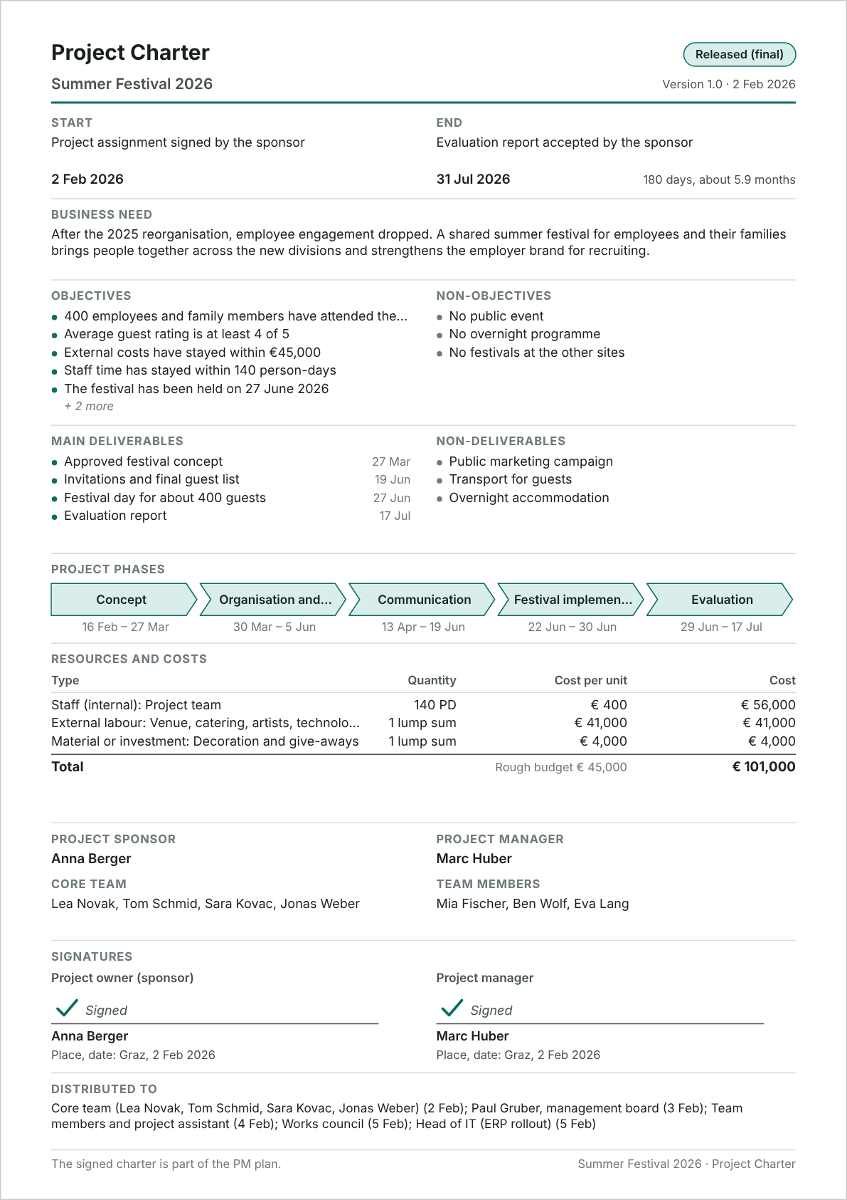
Figure 17: An A4 page in the classic charter layout, ready to print and sign. Long lists are cut with a "+ n more" note; the full lists are in the tables above. Phases leave out project management (1.1).

Charter checks
✓ Start has an event and a date.
✓ End has an event and a date.
✓ 7 objectives listed.
✓ 3 non-objectives listed.
✓ Objectives are worded as future states.
✓ Project owner: Anna Berger.
✓ Project manager: Marc Huber.
✓ Only one project manager.
✓ Both signatures are complete.
• Resources and costs total € 101,000; rough budget in 3.3: € 45,000.

3.4 Stakeholder analysis
Find everyone who is affected by the project or can influence it, judge where action is needed, and agree a measure, an owner and a deadline for each.
A good result still fails when the people around the project reject it. Stakeholder management means managing expectations: know who is affected and who has influence, plan what you do for each group, and build the understanding that prevents conflict. It is also the base for project marketing.
Method: The six steps
- Collect everyone who is affected by the project or holds an opinion about it. Inside: owner, manager, team. Outside: client, management, works council, suppliers, authorities, press, competitors. Start from the people context of the six fields. (Stakeholder table)
- Sort them into groups and draw them around the project in the stakeholder chart. (Stakeholder table, column Group)
- Rate how strongly each one is affected and how much influence they have, and mark them supportive, neutral or critical. The need for action follows from that. (Stakeholder table)
- For each one that needs attention, describe the relation: what each side expects, what they can offer, where conflicts lie. (Measures table)
- Derive a strategy and concrete measures, linked to a work package where one fits. (Measures table)
- Give every measure one responsible person and a deadline, and track its status. (Measures table)

The six steps in this file
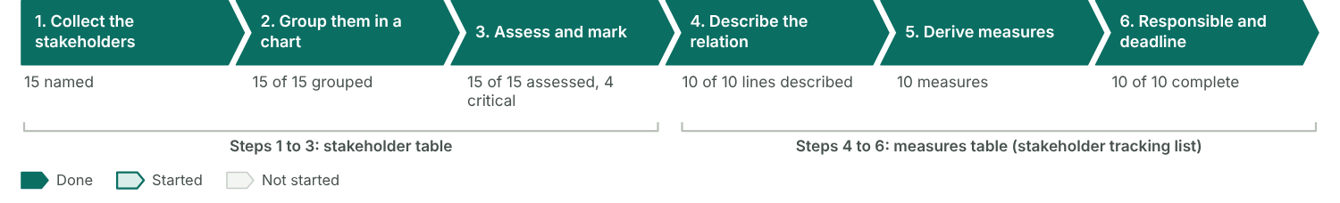
Figure 18: How far each step is filled in. Steps 1 to 3 live in the stakeholder table, steps 4 to 6 in the measures table.

Steps 1 to 3: collect, group and assess

Stakeholder table
No. | Stakeholder | Group | Internal / external | How affected | Influence | Attitude | Need for action | Expectations
1 | Management board | Client | Internal | Moderately | Very strongly | Supportive | Medium | A visible thank-you to staff that strengthens the employer brand; budget kept; no incidents.
2 | Employees | Client | Internal | Very strongly | Slightly | Supportive | Low | A relaxed day with colleagues, easy registration, good food.
3 | Works council | Internal unit | Internal | Moderately | Strongly | Critical | High | Voluntary helper shifts, time off in lieu for Saturday work, a fair rota.
4 | HR department | Internal unit | Internal | Moderately | Moderately | Supportive | Low | Festival fits the employer-branding campaign; data protection for registrations.
5 | Facility Management | Internal unit | Internal | Strongly | Moderately | Neutral | Low | A clear setup plan; no extra work in the week of the office move.
6 | IT (ERP rollout) | Internal unit | Internal | Slightly | Moderately | Critical | Medium | ERP go-live in June needs the same staff; no helpers from IT in that week.
7 | Catering company | Supplier | External | Strongly | Strongly | Neutral | Medium | Final guest numbers early, a fixed menu, access for delivery vans.
8 | Venue owner | Supplier | External | Moderately | Strongly | Neutral | Medium | Venue handed back clean and undamaged, insurance proof.
9 | Event-technology supplier | Supplier | External | Moderately | Moderately | Supportive | Low | Clear stage plan and power supply, setup time on Friday.
10 | Insurance company | Supplier | External | Slightly | Moderately | Neutral | Low | Safety concept and guest numbers before the policy is issued.
11 | City authority | Authority | External | Slightly | Very strongly | Critical | High | Complete permit application with safety concept; noise limits after 22:00.
12 | Neighbours of the venue | Other environment | External | Strongly | Slightly | Critical | High | Little noise and no parked cars in their street on a Saturday.
13 | Employees’ families | Other environment | External | Strongly | Hardly | Supportive | Low | A programme for children, accessible paths, shade.
14 | Sponsors | Other environment | External | Slightly | Moderately | Supportive | Low | Visible logo placement and a mention in the opening speech.
15 | Local press | Other environment | External | Hardly | Moderately | Neutral | Low | A story and photos; they report on complaints too.

Stakeholder chart
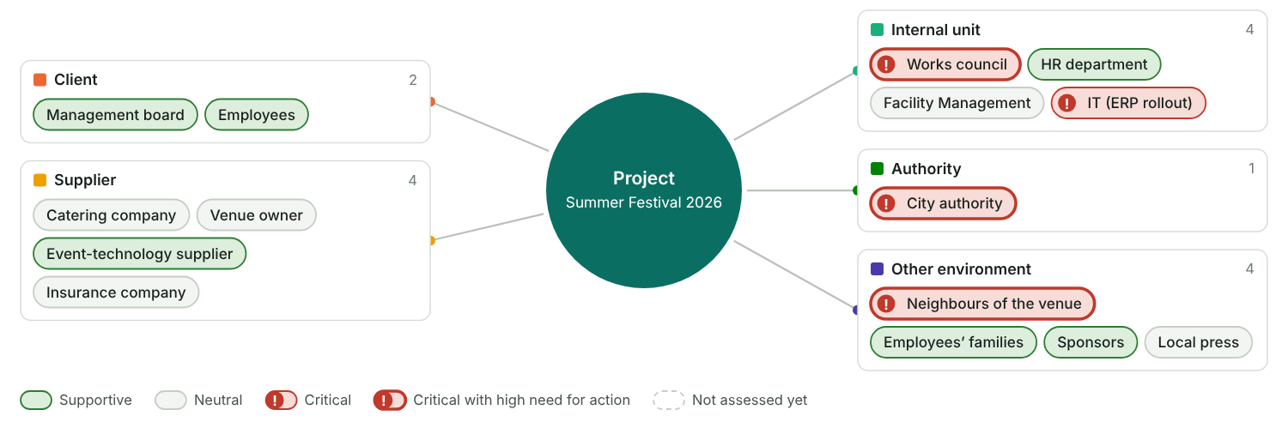
Figure 19: Step 2 and 3: the project in the centre, the stakeholders grouped around it. A red "!" marks critical stakeholders; a thick outline means a high need for action.

Influence and affectedness
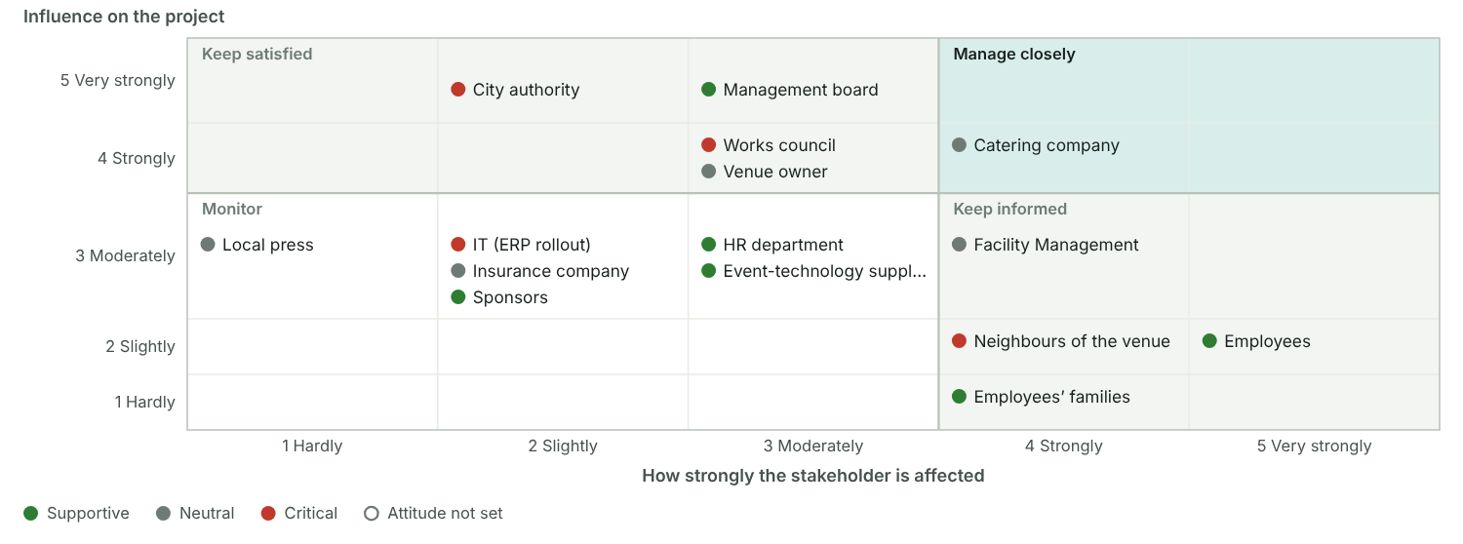
Figure 20: Step 3: each stakeholder placed by how strongly they are affected and how much influence they have. Those in the top right need the closest attention, especially when critical.

Steps 4 to 6: relation, measures, responsible and deadline

Measures table (stakeholder tracking list)
No. | Stakeholder | Relation | Description of relation | Measure | WBS | Responsible | Deadline | Status
1 | Employees | Supportive | Staff want a say in the programme; good turnout depends on it. | Run the employee survey on festival wishes | 1.2.1 Surveying employee wishes | Lea Novak | 27 Feb 2026 | Done
2 | Works council | Critical | Wants voluntary shifts and time off in lieu; could block the helper rota. | Agree helper rota and time off in lieu with the works council | 1.1.2 Coordinating the project | Anna Berger | 13 Mar 2026 | Done
3 | Works council | Critical | Wants to be heard before the concept is fixed. | Present the festival concept at the works council meeting | 1.2.3 Getting the concept approved | Marc Huber | 25 Mar 2026 | Done
4 | IT (ERP rollout) | Critical | ERP go-live in June ties up the same people the festival needs as helpers. | Agree with the IT lead which staff are free in June; plan helpers outside IT | 1.1.2 Coordinating the project | Marc Huber | 10 Apr 2026 | Done
5 | City authority | Critical | Grants the event permit; noise limits could cut the evening programme. | Submit the permit application with safety and noise concept | 1.3.4 Organising technology and safety | Tom Schmid | 15 May 2026 | Done
6 | City authority | Critical | Inspects the venue before the permit is final. | Walk through the venue with the authority | 1.3.4 Organising technology and safety | Tom Schmid | 5 Jun 2026 | Done
7 | Neighbours of the venue | Critical | Expect noise and parking problems; may complain to the city. | Send a letter to the neighbours with times, a contact and an invitation | 1.4.2 Running the invitation campaign | Sara Kovac | 5 Jun 2026 | Done
8 | Catering company | Neutral | Needs reliable numbers to plan staff and food. | Send final guest numbers two weeks before the festival | 1.4.3 Managing registrations | Sara Kovac | 12 Jun 2026 | Done
9 | Management board | Supportive | Expects a visible employer-branding effect and a short report. | Invite board members to open the festival; send a summary afterwards | 1.5.2 Running the festival day | Marc Huber | 19 Jun 2026 | In progress
10 | Local press | Neutral | Could report positively or pick up complaints. | Send a press release and invite a photographer | 1.4.2 Running the invitation campaign | Ben Wolf | 22 Jun 2026 | Open

Measures per stakeholder
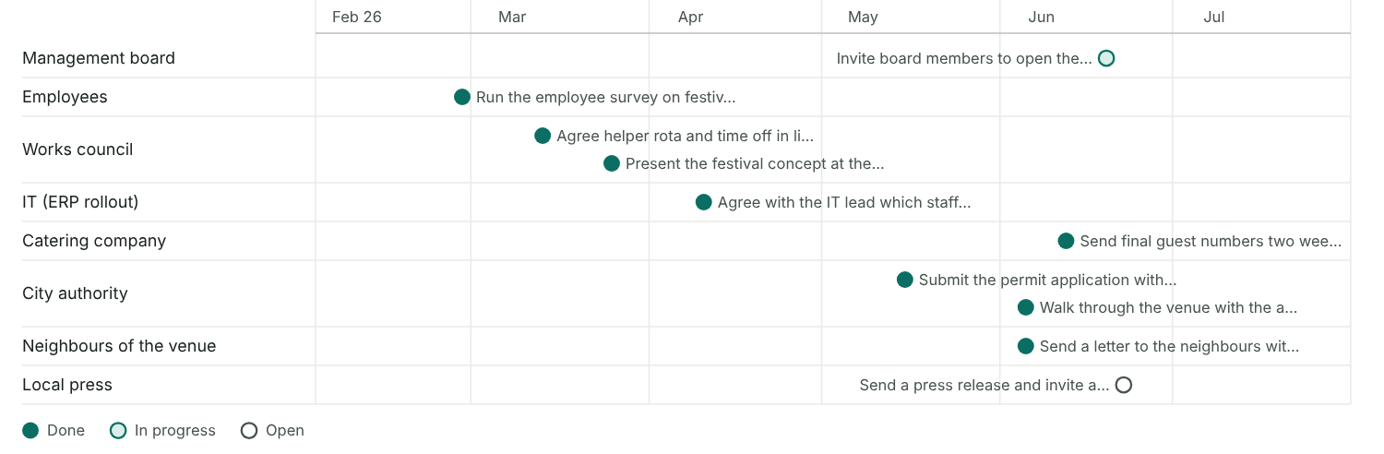
Figure 21: Step 6: every measure at its deadline, one line per stakeholder, filled when done.

Checks
✓ All 3 stakeholders with a high need for action have at least one measure.
✓ Every measure has a responsible person and a deadline.
✓ All deadlines lie inside the project (2 Feb 2026 to 31 Jul 2026).
✓ Every measure is linked to a WBS line.
✓ Every stakeholder is rated and has an attitude.

3.5 Scope: results plan and work breakdown structure
Scope planning works on three levels: why the project exists, what it delivers and what has to be done. List the results first, then build the work breakdown structure from them.

Step record I4: High-level planning
Status | Done
When | 26 Jan 2026
Format used | Planning workshop (half day)
Who took part | PM and four designated core team members
What we did | Agreed objectives, phases, WBS, milestones and a rough budget
Result | Initial charter and first draft of the PM plan
Method: Scope planning in five steps
Steps 1 to 3 happen in the planning workshop. Steps 4 and 5 follow in detailed planning.
- List the results. Ask what has to exist at the end of the project, tangible or intangible, and break the overall result into partial results.
- Check the phases against the content boundaries from 3.3 (objectives, exclusions, phases) and put them in process order.
- Define the work packages within each phase, so that every result comes out of a work package.
- Give every work package one responsible person.
- Write a specification for each work package (see 4.2).

Three levels of scope
Each level answers its own question and ends up in its own document.

Scope levels
Level | Guiding question | Document | In our project
1 Objective | Why, and what has to be made possible for whom? | Project Charter, scope statement | Top objective: employees and their families spend a day together that strengthens their bond with the company. The scope statement is part of the charter.
2 Deliverables (interim and final results) | What is supplied? What do we have to think of? | Results plan | Results plan with 18 results, from the survey results to the final cost statement.
3 Process (tasks) | What has to be done? | Work breakdown structure, WP specifications | WBS with 5 content phases, the project management phase and 21 work packages.

Scope statement and approach
Scope statement | The project plans, runs and evaluates a one-day summer festival for about 400 employees and their families on 27 June 2026 at a rented park venue near the head office. It covers the concept, venue, catering, programme, invitations, safety, the festival day and the evaluation. Not included: travel to the venue, overnight stays and a second festival date.
Planning approach | Both
Wording of work packages | As tasks
Template WBS used | Event WBS from the 2024 company anniversary

Results plan
What has to exist at the end of the project, broken down from the overall result.
The results plan is the best completeness check for the WBS: every result needs a work package that produces it.

Results plan
No. | Result | Part of | Type | Description | Produced by
1 | Festival held |  | Intangible | A one-day festival for about 400 employees and their families on 27 June 2026 | 1.5.2 Running the festival day
2 | Concept | Festival held | Tangible | Agreed picture of what the festival offers and how it runs | 1.2 Concept
3 | Survey results | Concept | Tangible | What employees want from the festival, from an online survey | 1.2.1 Surveying employee wishes
4 | Festival concept | Concept | Tangible | Theme, programme outline and budget frame, approved by the sponsor | 1.2.2 Developing the festival concept
5 | Venue and logistics | Festival held | Tangible | Everything needed on site | 1.3 Organisation and procurement
6 | Venue contract | Venue and logistics | Tangible | Signed rental contract for the park venue | 1.3.1 Booking the venue
7 | Catering | Venue and logistics | Tangible | Catering contract and menu for 400 guests | 1.3.2 Contracting the catering
8 | Technology and safety concept | Venue and logistics | Tangible | Stage, sound and power, plus the safety concept approved by the authority | 1.3.4 Organising technology and safety
9 | Programme | Festival held | Intangible | What the guests experience on the day | 1.3.3 Booking artists and programme
10 | Artists | Programme | Intangible | Band, DJ and host booked with contracts | 1.3.3 Booking artists and programme
11 | Kids' programme | Programme | Intangible | Play area, workshops and supervision for children | 1.3.3 Booking artists and programme
12 | Communication | Festival held | Intangible | Employees know about the festival and register | 1.4 Communication
13 | Invitation | Communication | Tangible | Invitation, festival logo and reminders | 1.4.1 Designing the invitation
14 | Guest list | Communication | Tangible | Final list of registered guests with dietary needs | 1.4.3 Managing registrations
15 | Evaluation | Festival held | Tangible | What we learned and what it cost | 1.6 Evaluation
16 | Participant feedback | Evaluation | Intangible | Feedback from guests and helpers | 1.6.1 Surveying participants
17 | Evaluation report | Evaluation | Tangible | Report for the sponsor with lessons learned | 1.6.2 Writing the evaluation report
18 | Final cost statement | Evaluation | Tangible | All invoices settled, costs compared with the budget | 1.6.3 Settling all invoices

Results plan
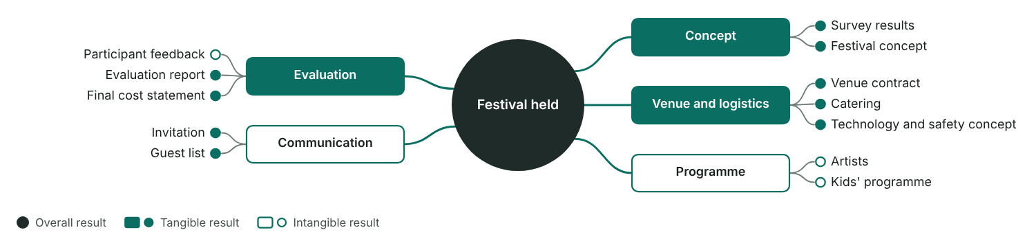
Figure 22: The overall result sits in the centre, main results around it, sub-results branch off them. Filled boxes and dots are tangible results (documents, objects); outlined ones are intangible (services, decisions, knowledge). Set the parent in the "Part of" column.

Work breakdown structure
All the work of the project, by phase. Code 1 is the project, 1.1 is project management, 1.2 onwards are the content phases.

Work breakdown structure
WBS code | Name | Responsible | Result / deliverable | Type
1 | Summer Festival 2026 | Marc Huber | Festival held, evaluated and closed | Project
1.1 | Project management | Marc Huber |  | PM phase
1.1.1 | Starting the project | Marc Huber | Charter and PM plan approved | Work package
1.1.2 | Coordinating the project | Marc Huber | Team meetings held, minutes filed | Work package
1.1.3 | Controlling the project | Marc Huber | Progress reports for the sponsor | Work package
1.1.4 | Closing the project | Marc Huber | Closure report accepted | Work package
1.2 | Concept | Lea Novak |  | Phase
1.2.1 | Surveying employee wishes | Lea Novak | Survey results | Work package
1.2.2 | Developing the festival concept | Lea Novak | Festival concept | Work package
1.2.3 | Getting the concept approved | Marc Huber | Approved concept | Work package
1.3 | Organisation and procurement | Tom Schmid |  | Phase
1.3.1 | Booking the venue | Tom Schmid | Signed venue contract | Work package
1.3.2 | Contracting the catering | Tom Schmid | Catering contract and menu | Work package
1.3.3 | Booking artists and programme | Lea Novak | Programme with contracts | Work package
1.3.4 | Organising technology and safety | Tom Schmid | Approved safety concept | Work package
1.3.5 | Securing sponsors | Jonas Weber | Sponsor agreements | Work package
1.4 | Communication | Sara Kovac |  | Phase
1.4.1 | Designing the invitation | Sara Kovac | Invitation and festival logo | Work package
1.4.2 | Running the invitation campaign | Sara Kovac | Invitations sent, reminders done | Work package
1.4.3 | Managing registrations | Sara Kovac | Final guest list | Work package
1.5 | Festival implementation | Tom Schmid |  | Phase
1.5.1 | Setting up the venue | Tom Schmid | Venue ready and inspected | Work package
1.5.2 | Running the festival day | Marc Huber | Festival held | Work package
1.5.3 | Dismantling and cleaning up | Tom Schmid | Venue handed back | Work package
1.6 | Evaluation | Lea Novak |  | Phase
1.6.1 | Surveying participants | Sara Kovac | Feedback survey results | Work package
1.6.2 | Writing the evaluation report | Lea Novak | Evaluation report | Work package
1.6.3 | Settling all invoices | Jonas Weber | Final cost statement | Work package

Work breakdown structure
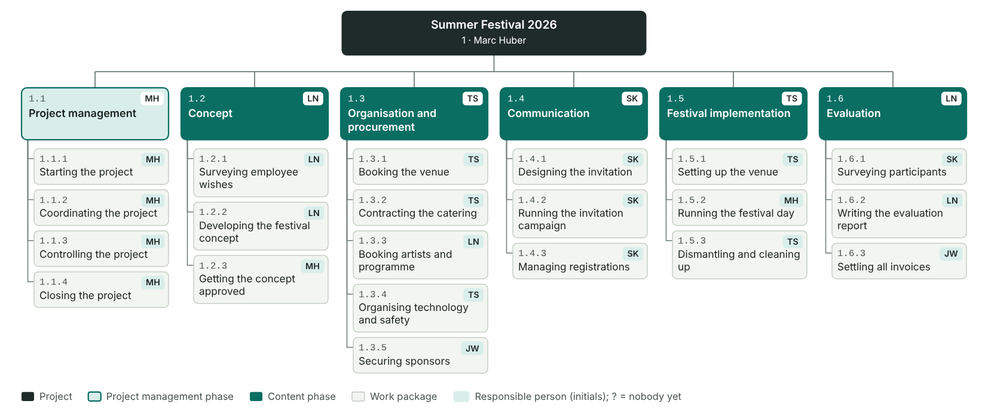
Figure 23: The project on top, the phases in one row with project management first, the work packages below each phase. Tags show who is responsible; a "?" means nobody is assigned yet. More than six phases wrap into a second row.

Work breakdown structure as a process
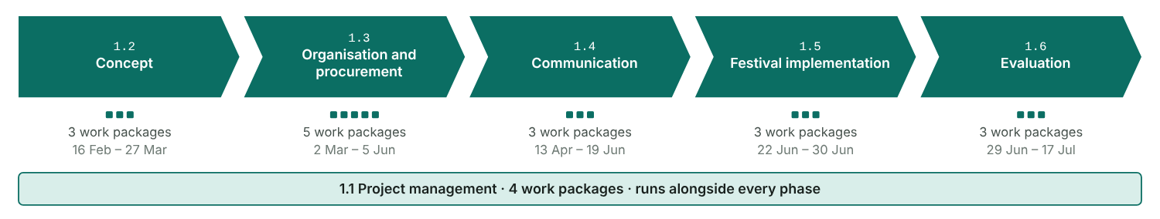
Figure 24: The content phases in process order, with one square per work package. Project management runs alongside every phase.

WBS rules
✓ At least 4 content phases plus the project management phase 1.1. Now: 5 content phases, project management phase present.
✓ Every phase has at least 3 work packages.
✓ Every work package has exactly one responsible person.
✓ All codes are unique and every code has its parent line.
✓ Within each phase, all work packages sit on the same level.
✓ Every work package name has at least two words (noun and verb).
• Wording: 21 of 21 names read as tasks ("building …"), 0 as results ("… built"). Chosen style: as tasks.
• All 18 results in the results plan are linked to a work package.
• Every work package produces a result.
• Project management phase 1.1 covers start, coordination, controlling and closing.

3.5 Schedule: milestones and bar chart
Turn the WBS into dates: milestones first, then a phase plan and a bar chart. Estimate how long each work package takes.
Method: How to build the schedule
Inputs: the time boundaries with any fixed deadlines, the WBS, and first assumptions about who works on what.
- Pick the tools that fit the project and the people who will read the plan (table below).
- Mark the time-critical events as milestones in the WBS.
- Move them into the milestone plan.
- Estimate the duration of each work package and set start and end dates.
- Draw the high-level schedule: a phase plan with the milestones. The detailed schedule with links follows in the start process (4.2).
Method: No project without a milestone plan
- Find the time-critical events and place them as milestones in the WBS.
- Copy them into the milestone plan and word each one as an event ("… completed").
- Give each a realistic date, top-down from the deadline or bottom-up from the work packages.
- Freeze these baseline dates once the sponsor approves the project.
- During controlling, fill in the revised and actual dates.

Scheduling tools
Tool | Content | Use | Used in our project? | Who reads it
Milestone plan | Time-critical events (duration 0) with baseline, revised and actual dates | Plans the critical dates at a high level and focuses the team | Yes | Sponsor, steering committee, whole team
Schedule list | All work packages with start and end date | Detailed dates when there are only a few work packages | Yes | Core team (weekly meeting)
Bar chart | Work packages as bars on a timeline | Makes the dates visible at a glance | Yes | Core team, work package owners
Linked bar chart | Bars plus the links between predecessors and successors | Shows dependencies; lets you simulate changes | Yes | Project manager, core team
Network diagram | Work packages and dependencies as a network with earliest and latest dates | Shows float and the critical path; for complex projects | Later | Project manager (critical path check)

Milestones
Events with no duration that mark the start or end of a work package or phase.

Milestone plan
No. | WBS | Milestone | Type | Baseline | Revised | Actual | Shift
1 | 1.1.1 Starting the project | Project started | Internal | 2 Feb 2026 |  | 2 Feb 2026 | 0
2 | 1.2.3 Getting the concept approved | Festival concept approved | Internal | 27 Mar 2026 |  | 27 Mar 2026 | 0
3 | 1.3.1 Booking the venue | Venue contract signed | External | 10 Apr 2026 | 14 Apr 2026 | 14 Apr 2026 | 4
4 | 1.4.2 Running the invitation campaign | Invitations sent | Internal | 30 Apr 2026 |  | 29 Apr 2026 | -1
5 | 1.3.4 Organising technology and safety | Safety concept approved by the authority | External | 5 Jun 2026 | 10 Jun 2026 | 9 Jun 2026 | 4
6 | 1.5.2 Running the festival day | Festival held | External | 27 Jun 2026 |  | 27 Jun 2026 | 0
7 | 1.6.2 Writing the evaluation report | Evaluation report completed | Internal | 17 Jul 2026 |  | 17 Jul 2026 | 0
8 | 1.1.4 Closing the project | Project completed | Internal | 31 Jul 2026 |  | 31 Jul 2026 | 0

Milestone rules
✓ Every phase has at least one milestone.
✓ All milestones are worded as events.
✓ Every milestone has a baseline date.
• 8 dated milestones over about 6.4 controlling cycles of 4 weeks: about one per cycle.
✓ All milestone dates lie between the start and end date.
• 5 internal and 3 external milestones. External ones are dates others see (customer, authority, guests).

Milestone plan
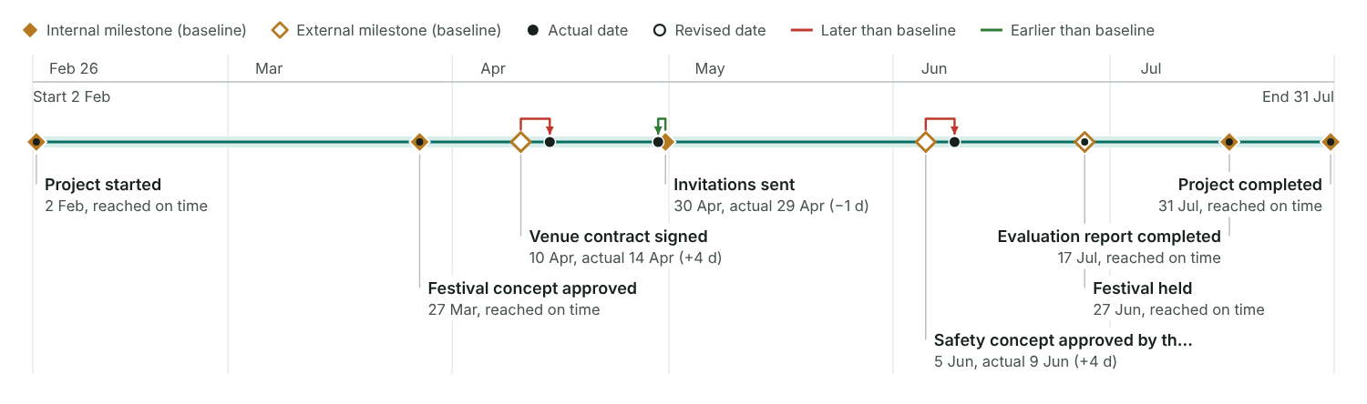
Figure 25: Each diamond sits at its baseline date. A dot marks the actual date (filled) or the revised date (hollow); the bracket above the line shows the shift.

Duration estimates
Estimate per work package before you set dates.

Duration estimates per work package
WBS | Work package | Method | Optimistic | Realistic | Pessimistic | Three-point | Spread | Amount of work | Output per day | Analytical | Planned | Fixed start | Basis and assumptions
1.1.1 | Starting the project | Intuitive | 8 | 12 | 16 | 12.0 | 1.3 |  |  |  | 12 |  | Charter, kick-off and start workshop in the first two weeks
1.1.2 | Coordinating the project | Analogous | 140 | 152 | 160 | 151.3 | 3.3 |  |  |  | 152 |  | Runs alongside the project until the evaluation
1.1.3 | Controlling the project | Analogous | 140 | 152 | 160 | 151.3 | 3.3 |  |  |  | 152 |  | Reports every four weeks until the evaluation
1.1.4 | Closing the project | Analogous | 10 | 12 | 20 | 13.0 | 1.7 |  |  |  | 12 |  | Closure report and lessons learned, as for the 2024 event
1.2.1 | Surveying employee wishes | Analogous | 10 | 12 | 18 | 12.7 | 1.3 |  |  |  | 12 |  | Online survey open for 10 days, as for the last staff survey
1.2.2 | Developing the festival concept | Intuitive | 14 | 19 | 28 | 19.7 | 2.3 |  |  |  | 19 |  | Two concept workshops plus write-up; depends on the survey results
1.2.3 | Getting the concept approved | Intuitive | 3 | 5 | 10 | 5.5 | 1.2 |  |  |  | 5 |  | One sponsor meeting; a second one if changes are needed
1.3.1 | Booking the venue | Analogous | 10 | 12 | 21 | 13.2 | 1.8 |  |  |  | 12 |  | Three venue visits and contract; 2024 took 12 days
1.3.2 | Contracting the catering | Analogous | 20 | 26 | 35 | 26.5 | 2.5 |  |  |  | 26 |  | Tender to three caterers, tasting, contract
1.3.3 | Booking artists and programme | Intuitive | 35 | 47 | 60 | 47.2 | 4.2 |  |  |  | 47 |  | Artists book 6 to 8 weeks ahead
1.3.4 | Organising technology and safety | Analogous | 45 | 54 | 70 | 55.2 | 4.2 |  |  |  | 54 |  | Authority needs about 6 weeks for the safety approval
1.3.5 | Securing sponsors | Intuitive | 45 | 60 | 75 | 60.0 | 5.0 |  |  |  | 60 |  | Talks with five possible sponsors
1.4.1 | Designing the invitation | Analogous | 10 | 12 | 15 | 12.2 | 0.8 |  |  |  | 12 |  | Agency briefing, two design rounds
1.4.2 | Running the invitation campaign | Analogous | 40 | 47 | 55 | 47.2 | 2.5 |  |  |  | 47 |  | Invitation, two reminders, intranet posts
1.4.3 | Managing registrations | Analytical | 45 | 54 | 60 | 53.5 | 2.5 | 400 | 8 | 50.0 | 54 |  | 400 guests, about 8 registrations handled per day
1.5.1 | Setting up the venue | Analytical | 4 | 5 | 7 | 5.2 | 0.5 | 40 | 8 | 5.0 | 5 |  | 40 stands and tents, a crew of four sets up about 8 per day
1.5.2 | Running the festival day | Intuitive | 1 | 1 | 1 | 1.0 | 0.0 |  |  |  | 1 |  | The festival day itself
1.5.3 | Dismantling and cleaning up | Analytical | 2 | 3 | 4 | 3.0 | 0.3 | 40 | 15 | 2.7 | 3 |  | 40 stands and tents, about 15 taken down per day
1.6.1 | Surveying participants | Analogous | 10 | 12 | 14 | 12.0 | 0.7 |  |  |  | 12 |  | Online feedback survey open for 10 days
1.6.2 | Writing the evaluation report | Intuitive | 8 | 12 | 18 | 12.3 | 1.7 |  |  |  | 12 |  | Report starts while the survey is still open
1.6.3 | Settling all invoices | Analytical | 12 | 17 | 24 | 17.3 | 2.0 | 60 | 4 | 15.0 | 17 |  | About 60 invoices, 4 checked and paid per day

Dates
Planned (baseline) and actual dates per work package.

Dates per work package
WBS | Name | Start | End | Days | Predecessors | Actual start | Actual end | Done (%)
1.1.1 | Starting the project | 2 Feb 2026 | 13 Feb 2026 | 12 |  | 2 Feb 2026 | 13 Feb 2026 | 100%
1.1.2 | Coordinating the project | 16 Feb 2026 | 17 Jul 2026 | 152 | 1.1.1 | 16 Feb 2026 | 17 Jul 2026 | 100%
1.1.3 | Controlling the project | 16 Feb 2026 | 17 Jul 2026 | 152 | 1.1.1 | 16 Feb 2026 | 17 Jul 2026 | 100%
1.1.4 | Closing the project | 20 Jul 2026 | 31 Jul 2026 | 12 | 1.6.2; 1.6.3 | 20 Jul 2026 | 31 Jul 2026 | 100%
1.2.1 | Surveying employee wishes | 16 Feb 2026 | 27 Feb 2026 | 12 | 1.1.1 | 16 Feb 2026 | 27 Feb 2026 | 100%
1.2.2 | Developing the festival concept | 2 Mar 2026 | 20 Mar 2026 | 19 | 1.2.1 | 2 Mar 2026 | 20 Mar 2026 | 100%
1.2.3 | Getting the concept approved | 23 Mar 2026 | 27 Mar 2026 | 5 | 1.2.2 | 23 Mar 2026 | 27 Mar 2026 | 100%
1.3.1 | Booking the venue | 30 Mar 2026 | 10 Apr 2026 | 12 | 1.2.3 | 30 Mar 2026 | 14 Apr 2026 | 100%
1.3.2 | Contracting the catering | 13 Apr 2026 | 8 May 2026 | 26 | 1.3.1 | 15 Apr 2026 | 15 May 2026 | 100%
1.3.3 | Booking artists and programme | 30 Mar 2026 | 15 May 2026 | 47 | 1.2.3 | 30 Mar 2026 | 15 May 2026 | 100%
1.3.4 | Organising technology and safety | 13 Apr 2026 | 5 Jun 2026 | 54 | 1.3.1 | 15 Apr 2026 | 9 Jun 2026 | 100%
1.3.5 | Securing sponsors | 2 Mar 2026 | 30 Apr 2026 | 60 | 1.2.1 | 2 Mar 2026 | 30 Apr 2026 | 100%
1.4.1 | Designing the invitation | 13 Apr 2026 | 24 Apr 2026 | 12 | 1.3.1 | 15 Apr 2026 | 24 Apr 2026 | 100%
1.4.2 | Running the invitation campaign | 27 Apr 2026 | 12 Jun 2026 | 47 | 1.4.1 | 27 Apr 2026 | 12 Jun 2026 | 100%
1.4.3 | Managing registrations | 27 Apr 2026 | 19 Jun 2026 | 54 | 1.4.1 SS+10 | 27 Apr 2026 | 19 Jun 2026 | 100%
1.5.1 | Setting up the venue | 22 Jun 2026 | 26 Jun 2026 | 5 | 1.3.2; 1.3.4; 1.4.3 | 22 Jun 2026 | 26 Jun 2026 | 100%
1.5.2 | Running the festival day | 27 Jun 2026 | 27 Jun 2026 | 1 | 1.5.1 | 27 Jun 2026 | 27 Jun 2026 | 100%
1.5.3 | Dismantling and cleaning up | 28 Jun 2026 | 30 Jun 2026 | 3 | 1.5.2 | 28 Jun 2026 | 30 Jun 2026 | 100%
1.6.1 | Surveying participants | 29 Jun 2026 | 10 Jul 2026 | 12 | 1.5.2 | 29 Jun 2026 | 10 Jul 2026 | 100%
1.6.2 | Writing the evaluation report | 6 Jul 2026 | 17 Jul 2026 | 12 | 1.6.1 SS+5 | 6 Jul 2026 | 17 Jul 2026 | 100%
1.6.3 | Settling all invoices | 1 Jul 2026 | 17 Jul 2026 | 17 | 1.5.3 | 1 Jul 2026 | 17 Jul 2026 | 100%

Phase plan with milestones
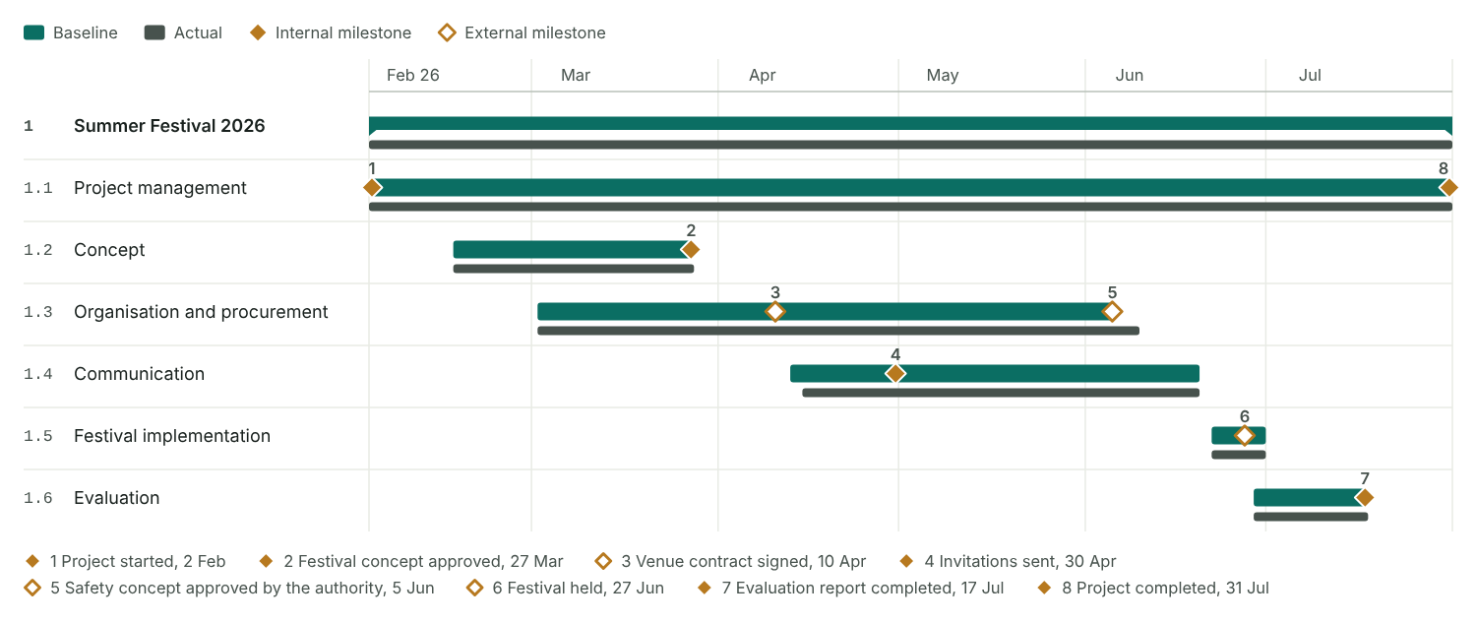
Figure 26: The high-level schedule: the project and each phase as a bar from its earliest to its latest work package, the actual span below it, and the milestones (numbered as in the milestone table) on their phase.

Bar chart
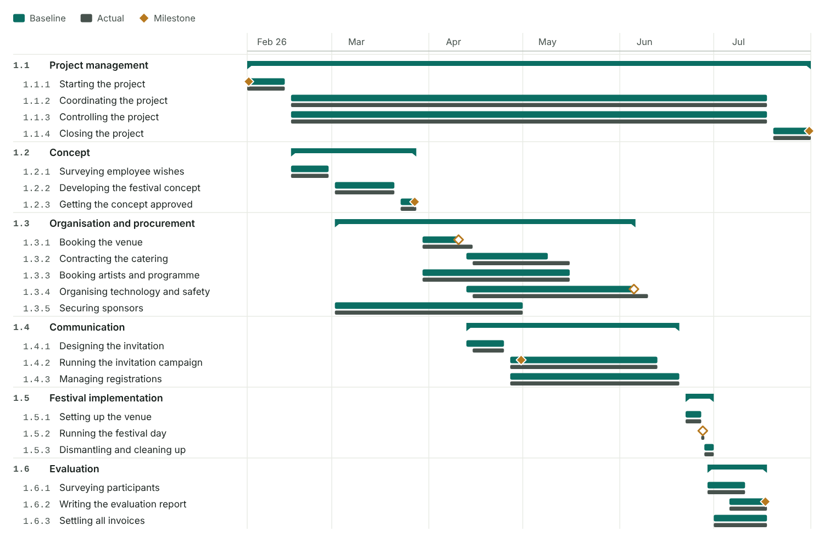
Figure 27: All WBS lines grouped by phase. Upper bar: baseline; lower bar: actual dates, partly filled while a work package is still running.

3.5 Resources and costs
Plan who is needed, how many person-days and what it costs, per phase or work package. Every table and chart below comes from the one cost plan.
Method: How to plan resources and costs
Build on the WBS and the schedule, and on the experience of the people who will do the work. Plan it together with the team.
- Choose the resource types (divisions or qualifications) and the cost types you plan with.
- Decide the planning depth: per phase for a rough plan, per work package for a detailed one.
- For each phase or work package, plan the person-days per resource type and the other costs.
- Merge the lines into the staff placement table and the cost table.
- Check with the line managers that the people and the budget are available.
- Optional: spread person-days and costs over the schedule (section 4.2).
- Optional: draw the histograms and the cumulative cost curve (section 4.2).
Who is needed, with which qualification? How many person-days, and when? From where: internal or bought in? Are they available then? Staff cost = person-days × internal cost rate.
Derive the staffing from the WBS, the work package specifications and the RACI chart. Plan critical resources in detail. Make sure actual values can be measured later, for example by booking time on WBS codes.

Step 1: resource and cost types

Resource types
No. | Resource type | Unit | Cost rate (€) | Available | From | Note
1 | Project management | PD | € 480 | 30 | Internal | Marc Huber, Eva Lang
2 | Corporate Communications | PD | € 400 | 35 | Internal | Programme and evaluation
3 | Facility Management | PD | € 360 | 30 | Internal | Fewer days because of the ERP rollout
4 | Marketing | PD | € 380 | 30 | Internal | Invitation and registrations
5 | Finance | PD | € 420 | 12 | Internal | Sponsoring and invoices
6 | Event technology | PD | € 500 | 15 | External | Stage, sound and safety crew (framework contract)

Project cost types
Project cost type | Accounting cost types grouped here | Plan (€)
Staff | Internal staff costs of all departments (person-days × internal cost rate) | € 51,780
External labour | External services domestic, external services international, event technology crew, catering service, artists | € 29,500
Material or investment | Material, printed matter, decoration, small equipment | € 2,500
Other | Rent, travel expenses, copying, electricity, postage, phone, fees, risk reserve | € 11,500
Total |  | € 95,280

Steps 2 and 3: depth and the plan per line
Planning depth | Work package

Resource and cost plan
No. | WBS | Resource or cost type | Cost type | Quantity | Unit | Cost per unit (€) | Plan (€) | Actual (€) | Remaining (€) | Forecast (€) | Deviation (€) | Note
1 | 1.1.1 Starting the project | Project management | Staff | 4 | PD |  | € 1,920 | € 1,920 | € 0 | € 1,920 | € 0 | Charter, start workshop
2 | 1.1.2 Coordinating the project | Project management | Staff | 12 | PD |  | € 5,760 | € 6,720 | € 0 | € 6,720 | € 960 | Team meetings, coordination
3 | 1.1.3 Controlling the project | Project management | Staff | 6 | PD |  | € 2,880 | € 2,880 | € 0 | € 2,880 | € 0 | Reports every four weeks
4 | 1.1.4 Closing the project | Project management | Staff | 3 | PD |  | € 1,440 | € 1,440 | € 0 | € 1,440 | € 0
5 | 1.2.3 Getting the concept approved | Project management | Staff | 1 | PD |  | € 480 | € 480 | € 0 | € 480 | € 0
6 | 1.5.2 Running the festival day | Project management | Staff | 1 | PD |  | € 480 | € 480 | € 0 | € 480 | € 0 | Lead on the festival day
7 | 1.1.2 Coordinating the project | Corporate Communications | Staff | 4 | PD |  | € 1,600 | € 1,600 | € 0 | € 1,600 | € 0 | Project assistant: minutes, filing
8 | 1.2.1 Surveying employee wishes | Corporate Communications | Staff | 4 | PD |  | € 1,600 | € 1,600 | € 0 | € 1,600 | € 0
9 | 1.2.2 Developing the festival concept | Corporate Communications | Staff | 10 | PD |  | € 4,000 | € 3,600 | € 0 | € 3,600 | −€ 400
10 | 1.3.3 Booking artists and programme | Corporate Communications | Staff | 6 | PD |  | € 2,400 | € 2,800 | € 0 | € 2,800 | € 400 | More artists to compare
11 | 1.4.3 Managing registrations | Corporate Communications | Staff | 2 | PD |  | € 800 | € 800 | € 0 | € 800 | € 0
12 | 1.5.2 Running the festival day | Corporate Communications | Staff | 2 | PD |  | € 800 | € 800 | € 0 | € 800 | € 0
13 | 1.6.2 Writing the evaluation report | Corporate Communications | Staff | 4 | PD |  | € 1,600 | € 1,600 | € 0 | € 1,600 | € 0
14 | 1.3.1 Booking the venue | Facility Management | Staff | 3 | PD |  | € 1,080 | € 1,440 | € 0 | € 1,440 | € 360 | Contract talks took longer
15 | 1.3.2 Contracting the catering | Facility Management | Staff | 4 | PD |  | € 1,440 | € 1,800 | € 0 | € 1,800 | € 360
16 | 1.3.4 Organising technology and safety | Facility Management | Staff | 6 | PD |  | € 2,160 | € 2,880 | € 0 | € 2,880 | € 720 | Extra round with the authority
17 | 1.5.1 Setting up the venue | Facility Management | Staff | 10 | PD |  | € 3,600 | € 3,960 | € 0 | € 3,960 | € 360
18 | 1.5.2 Running the festival day | Facility Management | Staff | 3 | PD |  | € 1,080 | € 1,080 | € 0 | € 1,080 | € 0
19 | 1.5.3 Dismantling and cleaning up | Facility Management | Staff | 6 | PD |  | € 2,160 | € 1,800 | € 0 | € 1,800 | −€ 360
20 | 1.2.1 Surveying employee wishes | Marketing | Staff | 2 | PD |  | € 760 | € 760 | € 0 | € 760 | € 0 | Survey tool
21 | 1.4.1 Designing the invitation | Marketing | Staff | 5 | PD |  | € 1,900 | € 1,520 | € 0 | € 1,520 | −€ 380
22 | 1.4.2 Running the invitation campaign | Marketing | Staff | 8 | PD |  | € 3,040 | € 3,040 | € 0 | € 3,040 | € 0
23 | 1.4.3 Managing registrations | Marketing | Staff | 5 | PD |  | € 1,900 | € 2,280 | € 0 | € 2,280 | € 380 | Many late registrations
24 | 1.5.2 Running the festival day | Marketing | Staff | 2 | PD |  | € 760 | € 760 | € 0 | € 760 | € 0
25 | 1.6.1 Surveying participants | Marketing | Staff | 4 | PD |  | € 1,520 | € 1,140 | € 0 | € 1,140 | −€ 380
26 | 1.1.3 Controlling the project | Finance | Staff | 2 | PD |  | € 840 | € 840 | € 0 | € 840 | € 0 | Budget control
27 | 1.3.5 Securing sponsors | Finance | Staff | 5 | PD |  | € 2,100 | € 2,100 | € 0 | € 2,100 | € 0
28 | 1.6.3 Settling all invoices | Finance | Staff | 4 | PD |  | € 1,680 | € 1,260 | € 0 | € 1,260 | −€ 420
29 | 1.3.4 Organising technology and safety | Event technology | External labour | 4 | PD |  | € 2,000 | € 2,500 | € 0 | € 2,500 | € 500 | Safety concept, technical planning
30 | 1.5.1 Setting up the venue | Event technology | External labour | 4 | PD |  | € 2,000 | € 2,000 | € 0 | € 2,000 | € 0 | Stage and sound set-up
31 | 1.5.2 Running the festival day | Event technology | External labour | 2 | PD |  | € 1,000 | € 1,500 | € 0 | € 1,500 | € 500 | Crew on the festival day
32 | 1.5.3 Dismantling and cleaning up | Event technology | External labour | 2 | PD |  | € 1,000 | € 1,000 | € 0 | € 1,000 | € 0 | Dismantling
33 | 1.3.1 Booking the venue | Other | Other | 1 | — | € 9,000 | € 9,000 | € 9,000 | € 0 | € 9,000 | € 0 | Venue rent incl. cleaning
34 | 1.3.2 Contracting the catering | External labour | External labour | 1 | — | € 16,000 | € 16,000 | € 17,400 | € 0 | € 17,400 | € 1,400 | Catering for 400 guests; 30 more registered
35 | 1.3.3 Booking artists and programme | External labour | External labour | 1 | — | € 7,500 | € 7,500 | € 7,500 | € 0 | € 7,500 | € 0 | Band, children’s programme, host
36 | 1.4.2 Running the invitation campaign | Material or investment | Material or investment | 1 | — | € 1,500 | € 1,500 | € 1,350 | € 0 | € 1,350 | −€ 150 | Printing invitations and posters
37 | 1.5.1 Setting up the venue | Material or investment | Material or investment | 1 | — | € 1,000 | € 1,000 | € 1,150 | € 0 | € 1,150 | € 150 | Decoration and signage
38 | 1.3.4 Organising technology and safety | Other | Other | 1 | — | € 2,500 | € 2,500 | € 2,400 | € 0 | € 2,400 | −€ 100 | Risk reserve: marquee as bad-weather fallback
 | Total |  |  |  |  |  | € 95,280 | € 99,180 | € 0 | € 99,180 | € 3,900

Step 4: staff placement and cost table

Staff placement
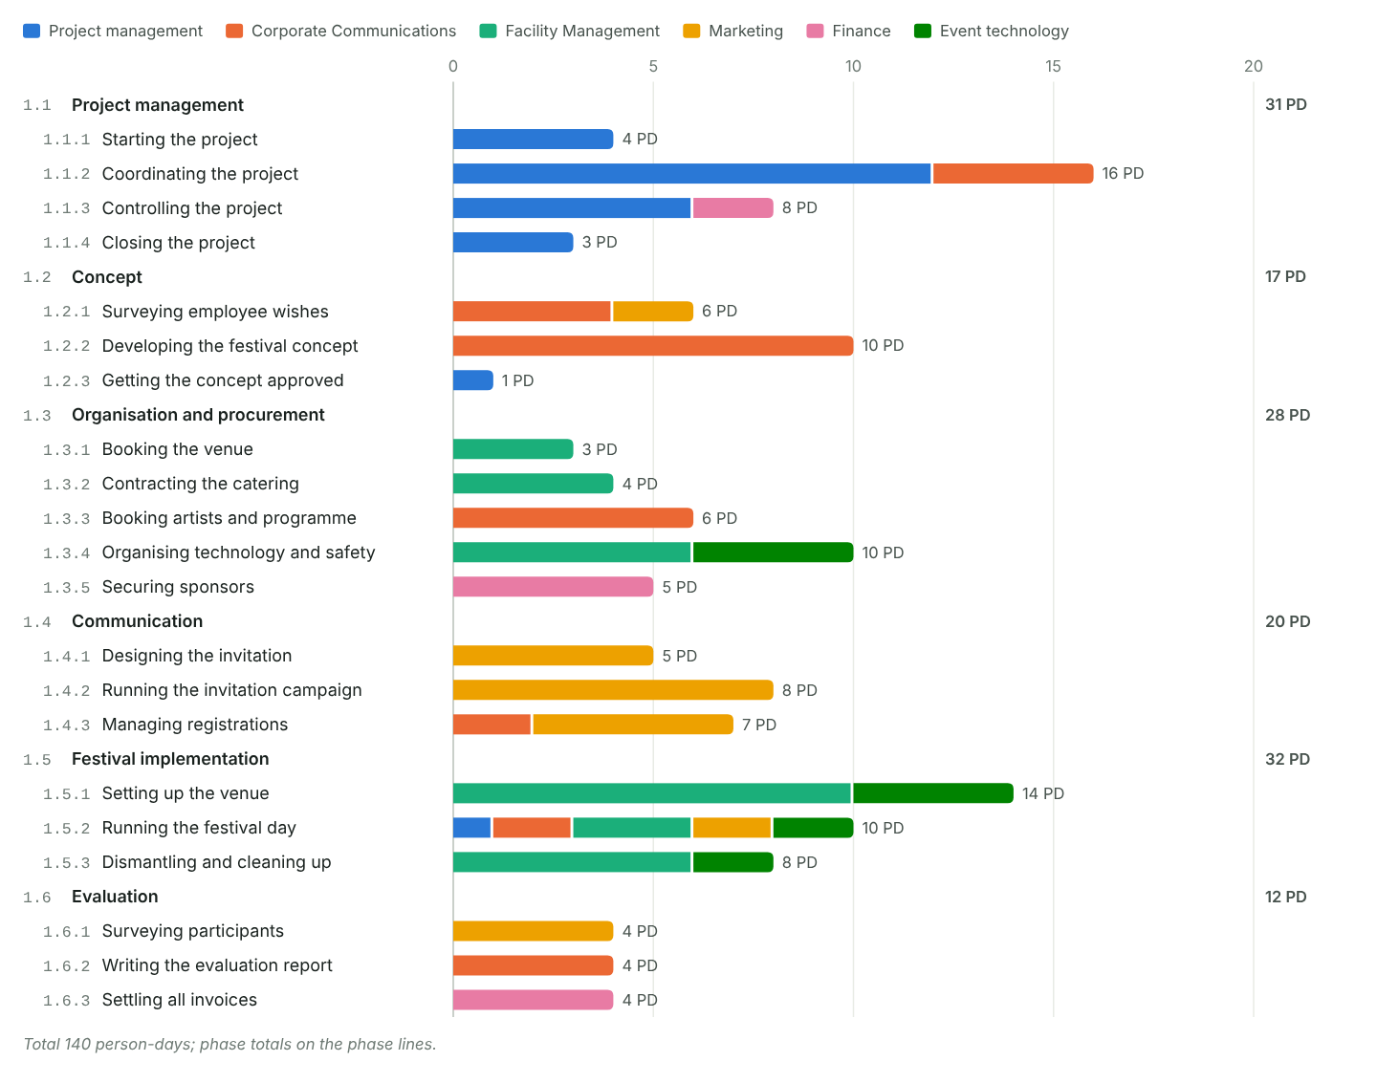
Figure 28: Person-days per phase or work package (as set in the planning depth), stacked by resource type. Built from the cost plan.

Staff placement table
Built from the cost plan: person-days per WBS line and resource type. Actual and remaining are converted from money with the rate of the line.
WBS | Phase / WP | Resource type | Plan (PD) | Actual (PD) | Remaining (PD) | Forecast (PD) | Deviation (PD)
1.1.1 | Starting the project | Project management | 4 | 4 | 0 | 4 | 0
1.1.2 | Coordinating the project | Project management | 12 | 14 | 0 | 14 | 2
 |  | Corporate Communications | 4 | 4 | 0 | 4 | 0
 |  | Sum | 16 | 18 | 0 | 18 | 2
1.1.3 | Controlling the project | Project management | 6 | 6 | 0 | 6 | 0
 |  | Finance | 2 | 2 | 0 | 2 | 0
 |  | Sum | 8 | 8 | 0 | 8 | 0
1.1.4 | Closing the project | Project management | 3 | 3 | 0 | 3 | 0
1.2.1 | Surveying employee wishes | Corporate Communications | 4 | 4 | 0 | 4 | 0
 |  | Marketing | 2 | 2 | 0 | 2 | 0
 |  | Sum | 6 | 6 | 0 | 6 | 0
1.2.2 | Developing the festival concept | Corporate Communications | 10 | 9 | 0 | 9 | -1
1.2.3 | Getting the concept approved | Project management | 1 | 1 | 0 | 1 | 0
1.3.1 | Booking the venue | Facility Management | 3 | 4 | 0 | 4 | 1
1.3.2 | Contracting the catering | Facility Management | 4 | 5 | 0 | 5 | 1
1.3.3 | Booking artists and programme | Corporate Communications | 6 | 7 | 0 | 7 | 1
1.3.4 | Organising technology and safety | Facility Management | 6 | 8 | 0 | 8 | 2
 |  | Event technology | 4 | 5 | 0 | 5 | 1
 |  | Sum | 10 | 13 | 0 | 13 | 3
1.3.5 | Securing sponsors | Finance | 5 | 5 | 0 | 5 | 0
1.4.1 | Designing the invitation | Marketing | 5 | 4 | 0 | 4 | -1
1.4.2 | Running the invitation campaign | Marketing | 8 | 8 | 0 | 8 | 0
1.4.3 | Managing registrations | Corporate Communications | 2 | 2 | 0 | 2 | 0
 |  | Marketing | 5 | 6 | 0 | 6 | 1
 |  | Sum | 7 | 8 | 0 | 8 | 1
1.5.1 | Setting up the venue | Facility Management | 10 | 11 | 0 | 11 | 1
 |  | Event technology | 4 | 4 | 0 | 4 | 0
 |  | Sum | 14 | 15 | 0 | 15 | 1
1.5.2 | Running the festival day | Project management | 1 | 1 | 0 | 1 | 0
 |  | Corporate Communications | 2 | 2 | 0 | 2 | 0
 |  | Facility Management | 3 | 3 | 0 | 3 | 0
 |  | Marketing | 2 | 2 | 0 | 2 | 0
 |  | Event technology | 2 | 3 | 0 | 3 | 1
 |  | Sum | 10 | 11 | 0 | 11 | 1
1.5.3 | Dismantling and cleaning up | Facility Management | 6 | 5 | 0 | 5 | -1
 |  | Event technology | 2 | 2 | 0 | 2 | 0
 |  | Sum | 8 | 7 | 0 | 7 | -1
1.6.1 | Surveying participants | Marketing | 4 | 3 | 0 | 3 | -1
1.6.2 | Writing the evaluation report | Corporate Communications | 4 | 4 | 0 | 4 | 0
1.6.3 | Settling all invoices | Finance | 4 | 3 | 0 | 3 | -1
Total |  |  | 140 | 146 | 0 | 146 | 6

Costs by phase and cost type
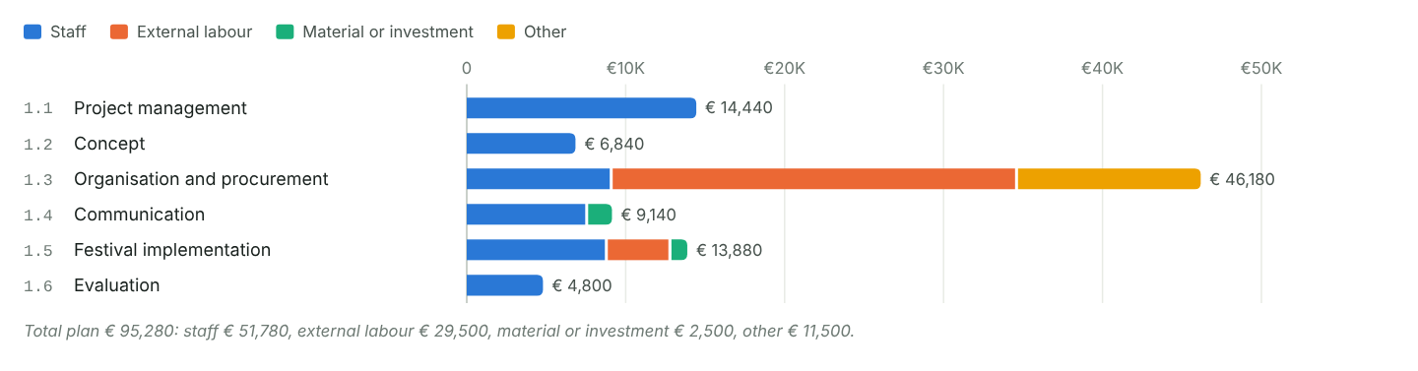
Figure 29: Planned costs per phase, stacked by the four project cost types, with the phase totals.

Cost table
Built from the cost plan: costs per WBS line and project cost type.
WBS | Phase / WP | Cost type | Plan (€) | Actual (€) | Remaining (€) | Forecast (€) | Deviation (€)
1.1.1 | Starting the project | Staff | € 1,920 | € 1,920 | € 0 | € 1,920 | € 0
1.1.2 | Coordinating the project | Staff | € 7,360 | € 8,320 | € 0 | € 8,320 | € 960
1.1.3 | Controlling the project | Staff | € 3,720 | € 3,720 | € 0 | € 3,720 | € 0
1.1.4 | Closing the project | Staff | € 1,440 | € 1,440 | € 0 | € 1,440 | € 0
1.2.1 | Surveying employee wishes | Staff | € 2,360 | € 2,360 | € 0 | € 2,360 | € 0
1.2.2 | Developing the festival concept | Staff | € 4,000 | € 3,600 | € 0 | € 3,600 | −€ 400
1.2.3 | Getting the concept approved | Staff | € 480 | € 480 | € 0 | € 480 | € 0
1.3.1 | Booking the venue | Staff | € 1,080 | € 1,440 | € 0 | € 1,440 | € 360
 |  | Other | € 9,000 | € 9,000 | € 0 | € 9,000 | € 0
 |  | Sum | € 10,080 | € 10,440 | € 0 | € 10,440 | € 360
1.3.2 | Contracting the catering | Staff | € 1,440 | € 1,800 | € 0 | € 1,800 | € 360
 |  | External labour | € 16,000 | € 17,400 | € 0 | € 17,400 | € 1,400
 |  | Sum | € 17,440 | € 19,200 | € 0 | € 19,200 | € 1,760
1.3.3 | Booking artists and programme | Staff | € 2,400 | € 2,800 | € 0 | € 2,800 | € 400
 |  | External labour | € 7,500 | € 7,500 | € 0 | € 7,500 | € 0
 |  | Sum | € 9,900 | € 10,300 | € 0 | € 10,300 | € 400
1.3.4 | Organising technology and safety | Staff | € 2,160 | € 2,880 | € 0 | € 2,880 | € 720
 |  | External labour | € 2,000 | € 2,500 | € 0 | € 2,500 | € 500
 |  | Other | € 2,500 | € 2,400 | € 0 | € 2,400 | −€ 100
 |  | Sum | € 6,660 | € 7,780 | € 0 | € 7,780 | € 1,120
1.3.5 | Securing sponsors | Staff | € 2,100 | € 2,100 | € 0 | € 2,100 | € 0
1.4.1 | Designing the invitation | Staff | € 1,900 | € 1,520 | € 0 | € 1,520 | −€ 380
1.4.2 | Running the invitation campaign | Staff | € 3,040 | € 3,040 | € 0 | € 3,040 | € 0
 |  | Material or investment | € 1,500 | € 1,350 | € 0 | € 1,350 | −€ 150
 |  | Sum | € 4,540 | € 4,390 | € 0 | € 4,390 | −€ 150
1.4.3 | Managing registrations | Staff | € 2,700 | € 3,080 | € 0 | € 3,080 | € 380
1.5.1 | Setting up the venue | Staff | € 3,600 | € 3,960 | € 0 | € 3,960 | € 360
 |  | External labour | € 2,000 | € 2,000 | € 0 | € 2,000 | € 0
 |  | Material or investment | € 1,000 | € 1,150 | € 0 | € 1,150 | € 150
 |  | Sum | € 6,600 | € 7,110 | € 0 | € 7,110 | € 510
1.5.2 | Running the festival day | Staff | € 3,120 | € 3,120 | € 0 | € 3,120 | € 0
 |  | External labour | € 1,000 | € 1,500 | € 0 | € 1,500 | € 500
 |  | Sum | € 4,120 | € 4,620 | € 0 | € 4,620 | € 500
1.5.3 | Dismantling and cleaning up | Staff | € 2,160 | € 1,800 | € 0 | € 1,800 | −€ 360
 |  | External labour | € 1,000 | € 1,000 | € 0 | € 1,000 | € 0
 |  | Sum | € 3,160 | € 2,800 | € 0 | € 2,800 | −€ 360
1.6.1 | Surveying participants | Staff | € 1,520 | € 1,140 | € 0 | € 1,140 | −€ 380
1.6.2 | Writing the evaluation report | Staff | € 1,600 | € 1,600 | € 0 | € 1,600 | € 0
1.6.3 | Settling all invoices | Staff | € 1,680 | € 1,260 | € 0 | € 1,260 | −€ 420
Total |  |  | € 95,280 | € 99,180 | € 0 | € 99,180 | € 3,900

Step 5: availability

Availability check
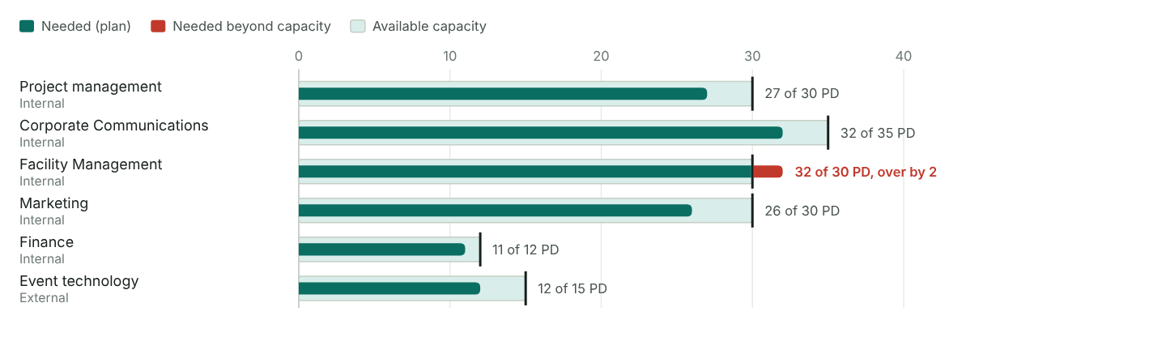
Figure 30: Person-days needed per resource type against the capacity the line managers can give (box and tick). Hours count as 8 per person-day.

Checks
✓ Resource plan against the schedule: every line sits on a WBS line with dates.
✓ Every phase has at least one line.
✓ Business case costs € 91,000; cost plan € 95,280 in total (+5%).
✓ Rough budget € 45,000; cost plan € 43,500 without staff (−3%).
✓ The risk budget (€ 13,950) has its own line in the cost plan.
✓ Actual values entered for 38 of 38 lines.
Steps 6 and 7 (spreading over time, histograms, cost curve) are in section 4.2.

3.6 Project approval
The project owner and the project manager meet face to face to authorise the planning so far. The result is the (preliminarily) released Project Charter.

Step record I5: Project approval
Status | Done
When | 30 Jan 2026
Format used | PO meeting
Who took part | Anna Berger, Marc Huber
What we did | Went through the charter, checked the business case
Result | Charter released on 2 Feb 2026

Approval meeting
Date | 30 Jan 2026
Place | Meeting room 4.12, head office
Format | PO meeting face to face
Participants | Anna Berger, Marc Huber
Project Charter | Preliminarily released
Business case verified | Yes

Agenda of the approval meeting
☑ Authorise the current planning
☑ Decide how to go forward
☑ Verify the investment appraisal (business case)
☑ Approve the project and the further planning process
☑ Agree the PM plan draft

Approval path
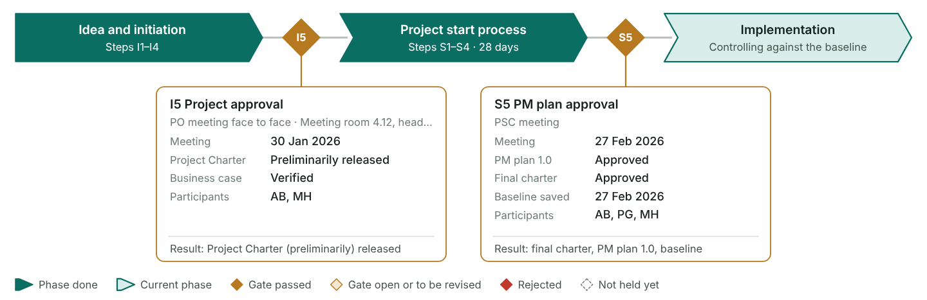
Figure 31: The two gates of the method. The project approval (I5) releases the charter, at least preliminarily, and opens the project start process. The PM plan approval (S5) confirms the final charter and the PM plan and freezes the baseline. Dates and decisions come from this section and from 4.5.

Decisions and conditions
No. | Decision | Condition or requirement | Owner | Due
1 | Project Charter preliminarily released | Anna Berger signs the charter once the budget line is booked (signed on 2 Feb 2026) | Anna Berger | 2 Feb 2026
2 | Go ahead with the project start process, kick-off on 4 Feb | Detailed planning ready for PM plan approval by the end of February | Marc Huber | 27 Feb 2026
3 | Business case accepted | Confirm sponsor income by April; without it, shorten the evening programme | Jonas Weber | 30 Apr 2026

Open points
No. | Open point | Owner | Due | Status
1 | Works council approval for helper shifts on a Saturday | Marc Huber | 20 Feb 2026 | Done
2 | Clash with the ERP go-live: no IT staff as helpers in June | Marc Huber | 20 Feb 2026 | Done
3 | Insurance cover for guests and families | Jonas Weber | 13 Mar 2026 | Done
A preliminarily released charter lets the start process begin while some conditions are still open. Give each condition an owner and a date, and confirm the final charter in step S5.

4.1 Project organisation
Set up who steers, who leads and who works in the project, what each role may decide, and how the project sits in the line organisation.

Step record S1: Establish the project organisation
Status | Done
When | 4 Feb 2026
Format used | Kick-off (2 h) and start workshop (1 day)
Who took part | PM, core team, team members, PO for the first hour
What we did | Presented the charter, agreed roles, meetings and ground rules
Result | Working team with a shared picture of the festival
Method: Principles
Plan the organisation on purpose once the charter is released.
- Start from the scope plan: bring in every unit and every kind of know-how the work packages need, internal and external.
- Everyone responsible for a work package belongs to the core team.
- Make the paths for information and decisions clear: who informs whom, who decides what.
- Settle the sub-teams, functional or interdisciplinary, and what each of them may decide.
Method: Six steps
- Draw the organisation chart.
- Describe the roles.
- Set up the communication plan (next section).
- Agree the cultural elements (next section).
- Check the organisational incorporation.
- Optional: create a RACI chart (section 4.2).

People and roles
No. | Name | Short | Project roles | Department / company | Sub-team | Contact
1 | Anna Berger | AB | Project owner | Head of HR |  | ab@example.com
2 | Marc Huber | MH | Project manager | Corporate Communications |  | mh@example.com
3 | Lea Novak | LN | PMTM | Corporate Communications | Programme | ln@example.com
4 | Tom Schmid | TS | PMTM | Facility Management | Venue and logistics | ts@example.com
5 | Sara Kovac | SK | PMTM | Marketing | Communication | sk@example.com
6 | Jonas Weber | JW | PMTM | Finance | Budget and sponsoring | jw@example.com
7 | Mia Fischer | MF | Team member | Facility Management | Venue and logistics | mf@example.com
8 | Ben Wolf | BW | Team member | Marketing | Communication | bw@example.com
9 | Eva Lang | EL | Project assistant | Corporate Communications |  | el@example.com
10 | Paul Gruber | PG | PSC member | Management board |  | pg@example.com

Sub-teams
No. | Sub-team | Type | Lead | Members | Decision power | Meets
1 | Programme | Interdisciplinary | Lea Novak |  | Books artists up to €2,000 per booking | As required
2 | Venue and logistics | Functional | Tom Schmid | Mia Fischer | Orders from suppliers up to €5,000 within budget | Weekly
3 | Communication | Functional | Sara Kovac | Ben Wolf | Wording and design of all festival communication | As required
4 | Budget and sponsoring | Functional | Jonas Weber |  | Sponsor packages according to the agreed price list | As required

Organisation chart
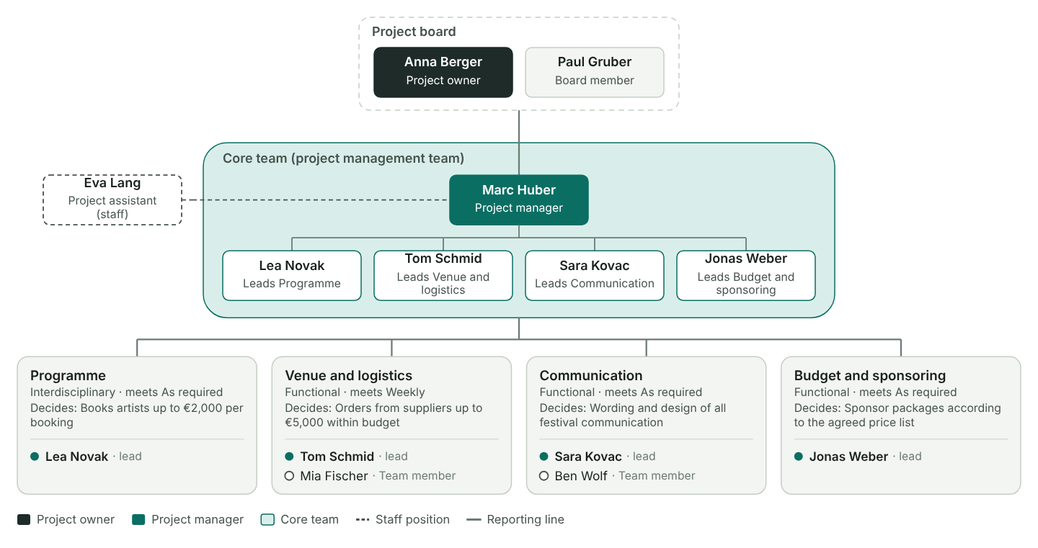
Figure 32: The board with the project owner on top, the PM and the core team in the band, staff positions beside the PM and the sub-teams below. People with a sub-team that is not in the table form their own sub-team.

Role descriptions
Each role has tasks, powers and responsibilities. Roles are independent of people; one person often holds several.

Roles
No. | Role | Kind | Tasks | Powers | Responsibilities | Held by
1 | Project owner | Individual | Commissions the festival, sets objectives and the budget frame, opens the festival | Releases charter, PM plan and changes over €2,000; decides on escalations | Benefit of the festival for employer branding and team spirit | Anna Berger
2 | Project manager | Individual | Plans and steers the project, leads the core team, chairs the controlling meeting, reports every four weeks | Decides within the approved plan; uses up to 50% of the reserve | Festival held on 27 June within budget and with the agreed quality | Marc Huber
3 | Project management team member | Individual | Plans and runs own work packages, leads a sub-team, reports status in the controlling meeting | Decides on content and suppliers within own work packages and sub-team budget | Results, dates and costs of own work packages | Lea Novak, Tom Schmid, Sara Kovac, Jonas Weber
4 | Project team member | Individual | Works on tasks in a sub-team, e.g. set-up plan or mailings | Decides how to carry out assigned tasks | Quality and dates of own tasks | Mia Fischer, Ben Wolf
5 | Project assistant | Individual | Keeps the project folder, writes the minutes, prepares status reports | Sends invitations and minutes on behalf of the PM | Complete and current project documents | Eva Lang
6 | Project board | Group | Steers the festival from the management side, settles conflicts between departments | Approves milestones, changes over €2,000 and the use of the reserve above 50% | Fit of the festival with the HR and communication strategy | Anna Berger, Paul Gruber
7 | Project management team | Group | Coordinates the work packages and prepares decisions for the board | Decides cross-cutting questions in the controlling meeting | Integrated plan and status of the whole festival | Marc Huber, Lea Novak, Tom Schmid, Sara Kovac, Jonas Weber
8 | Project team(s) | Group | Do the content work in the four sub-teams | Decision power as set for each sub-team | Results of the sub-team | Lea Novak, Tom Schmid, Sara Kovac, Jonas Weber, Mia Fischer, Ben Wolf

Mutual expectations
No. | From role | To role | Expectation | Agreed
1 | Project owner | Project manager | Reports deviations as soon as they appear, with causes and options | Yes
2 | Project owner | Project manager | Keeps the festival within the approved budget and asks before using more than half of the reserve | Yes
3 | Project owner | Project manager | Sends a one-page status report two days before each board meeting | Yes
4 | Project manager | Project owner | Decides within five working days when the controlling meeting asks for a decision | Yes
5 | Project manager | Project owner | Backs the project with the heads of department when staff are needed | Yes
6 | Project manager | Project owner | Takes part in the first hour of the kick-off and opens the festival

Mutual expectations
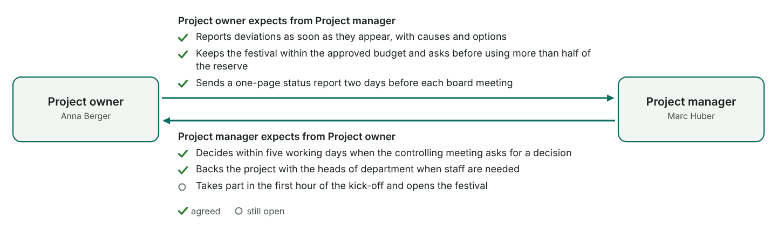
Figure 33: The pair of roles with the most expectations, facing each other. The upper list is what the left role expects, the lower list what the right role expects.

Organisational incorporation
The form of organisation settles who decides about a team member: the line manager or the PM.

Who decides?
Question | Content side | Staff side | Influence | Matrix | Pure project | Content side | Staff side
What? | Work package, content | Tasks, competencies | Line | PM | PM | PM | PM
When? | WP dates, deadlines | Holidays, time off | Line | PM | PM | PM | Shared
How? | Methods, procedures | Qualifications, equipment | Line | Line | PM | Line | Line
How good? | Quality | Performance assessment | Line | Line | PM | Line | Shared
How much? | Resources, costs | Salary, bonus | Line | PM | PM | PM | Line
Who? | Responsible person for the WP | Selection of team members | Line | Line | PM | Line | Line

Form of organisation
Form we use | Matrix organisation
Closest to your answers | Matrix organisation (10 of 12 points)
Why this form | Team members stay in their departments and work on the festival part-time, so a pure project unit would be too much. The PM needs a say on dates and costs, so a staff position would be too weak. Weak point: double reporting. We agreed with the heads of department in February how many days each person gives to the project.

The three forms compared
Form | Position of the PM | Advantages | Disadvantages | Fits us?
Influence organisation | Coordinates from a staff position without authority to decide | Team members stay in their departments; continuous workload; heads of department keep control of the resources | Long decision paths; line work often comes first; low identification with the project; escalation through the line is laborious | No
Pure project organisation | Leads a temporary organisational unit with full authority to decide | Full concentration on the project; fast decisions; strong identification | Staff have to be released and re-integrated; continuous workload for project staff has to be ensured; people may lose touch with the home organisation | No
Matrix organisation | Cross-sectional function with responsibility for the whole project | Flexible use of staff; specialists are coordinated; team members stay anchored in their departments | Team members report twice; resource management is demanding; highest coordination effort of the three | Yes

Organisational incorporation
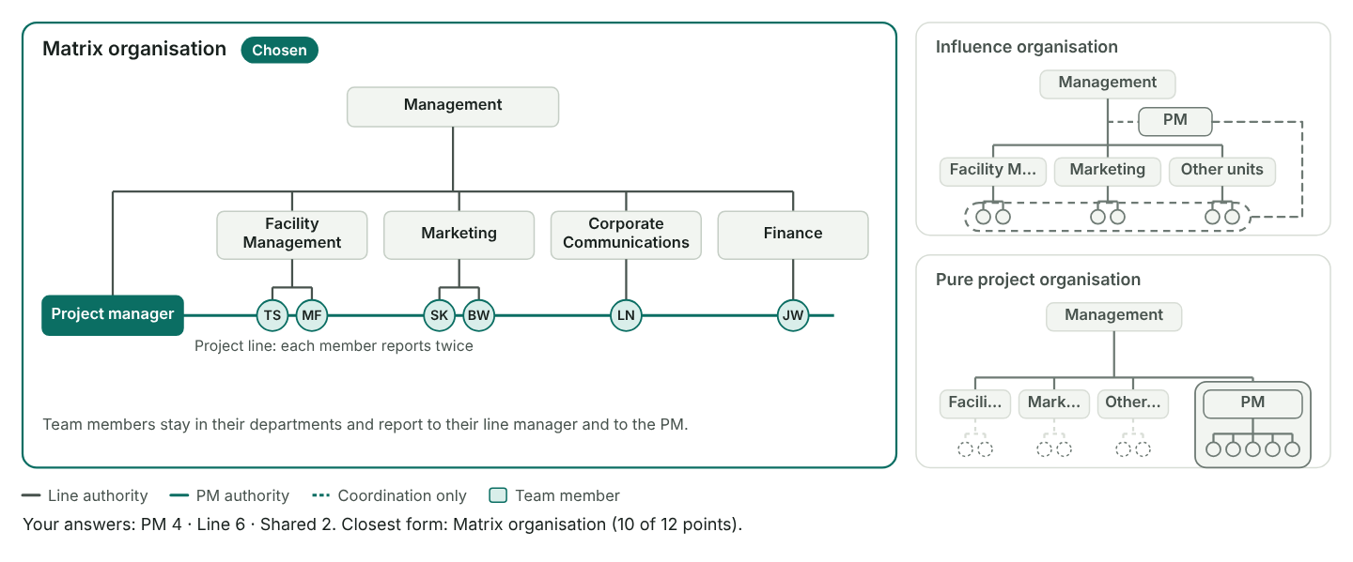
Figure 34: The line organisation with its departments and the project side by side. The large panel shows the chosen form (or the suggested one); the two small panels show the other forms for comparison. Departments come from the people list.

Checks
✓ Project owner and project manager are named.
✓ Everyone responsible for a work package is in the core team.
✓ Every sub-team has a lead.
✓ Every sub-team knows its decision power.
✓ Every role has a holder.
✓ The chosen form matches your answers.

4.1 Communication, culture and team development
Plan the regular meetings, agree the culture of the project and follow how the team grows together.
Method: Communication plan
- Set clear paths for information and decisions, and cover the regular needs, including information for stakeholders.
- Keep content meetings apart from project management meetings.
- Choose the form by purpose: one-to-one talk, meeting, workshop or presentation.
- Give every regular meeting a chair, a rhythm and someone who writes the minutes.

Communication plan
No. | Meeting | Objectives and content | Participants | Chair | Rhythm | First date | Place | Form | Kind | Minutes by
1 | Kick-off meeting | Present the charter and the festival idea, introduce the team and the roles, explain the next steps | PO, PM, core team, team members | Marc Huber | Once | 4 Feb 2026 | Canteen, head office | Presentation | Project management | Eva Lang
2 | Project start workshop | Agree objectives, WBS, roles, meetings and ground rules; build the team | PM, core team, team members | Marc Huber | Once | 5 Feb 2026 | Seminar hotel by the lake | Workshop | Project management | Eva Lang
3 | Project controlling meeting | Project status; controlling of scope, dates, resources and costs; stakeholder relations and risks; overarching problems; prepare decisions for the board; next steps | PM, core team, project assistant | Marc Huber | Every 2 weeks | 18 Feb 2026 | Room 2.14 | Meeting | Project management | Eva Lang
4 | Project board meeting | Present progress; discuss deviations with causes and measures; take the decisions the controlling meeting asks for; approve the progress report | PO, management board member, PM | Anna Berger | Every 4 weeks | 2 Mar 2026 | Board room | Meeting | Project management | Eva Lang
5 | Sub-team Venue and logistics | Coordinate suppliers, set-up plan and safety topics; plan next steps | Tom Schmid, Mia Fischer, suppliers when needed | Tom Schmid | Weekly | 4 Mar 2026 | Facility office | Meeting | Content | Mia Fischer
6 | Other sub-team meetings | Coordinate the sub-team; discuss content topics and the decisions they need; plan next steps (Programme, Communication, Budget and sponsoring) | Sub-team lead and members |  | As required |  | Team rooms | Meeting | Content

Communication calendar
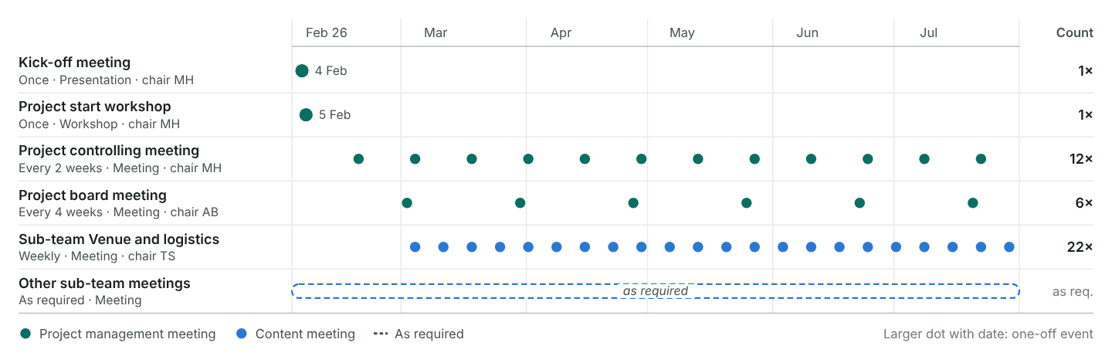
Figure 35: Each dot is one meeting, computed from the first date and the rhythm up to the project end. The number on the right counts the meetings.

Project culture
Every project has its own culture, which can differ from the company's. Name, logo, slogan, roles, ground rules, rituals and the style of management give it an identity.

Identity
Project name | Sommerfest 26
Slogan | One team, one summer
Logo | A sun over a festival tent in the company colours, drawn by the marketing team; stored in the shared project folder
Style of management and communication | Open and direct. Decisions are taken in the controlling meeting and written into the minutes. Sub-team leads decide within their budget. Five minutes of feedback at the end of each controlling meeting.

Ground rules
No. | Rule | Why | Agreed on
1 | No deputies | Decisions need the people who carry them out | 5 Feb 2026
2 | Minutes are binding | What is in the minutes counts; objections within two working days | 5 Feb 2026
3 | E-mail is the primary channel | Everyone gets the same information; chat only for quick questions | 5 Feb 2026
4 | Phones off in meetings | Short meetings with full attention | 5 Feb 2026
5 | We give and receive feedback | Five minutes of feedback at the end of each controlling meeting | 5 Feb 2026

Rituals and social events
No. | What | When | Who
1 | Friday coffee | Every Friday, 9:00, 15 minutes | Whole project team
2 | Festival crew T-shirts | Handed out at the start workshop, worn on the festival day | Everyone in the project
3 | Wrap-up party | 24 Jul 2026 | Project team, PO and helpers

Team development
Teams go through five phases. Watch for the signs and steer: give orientation early, settle conflicts, delegate once the norms hold, close with a joint review.

Team phases
Phase | Typical signs | When | What we noticed | What the PM did
Forming | Polite, careful, insecure | Feb 2026 | Polite, careful questions at the kick-off; many questions went to the PM | Explained goals and roles; ran the start workshop with team exercises
Storming | Conflicts, unclear roles, slow progress | Mar 2026 | Conflict between Programme and Budget about artist fees; sub-team leads unsure what they may decide | Moderated a clarification meeting; set spending limits per sub-team
Norming | Ground rules, roles settle, feedback | Apr 2026 | Ground rules are lived; sub-teams coordinate on their own | Delegated decisions to the sub-team leads; started the Friday coffee
Performing | Efficient, flexible, mutual support | May–Jun 2026 | Fast decisions and mutual help in the festival week | Stayed out of details; kept extra requests away from the team
Adjourning | Joint review, taking in what was learned | Jul 2026 | Lessons learned workshop and wrap-up party | Held the review, thanked the team, released members back to the line

Team development
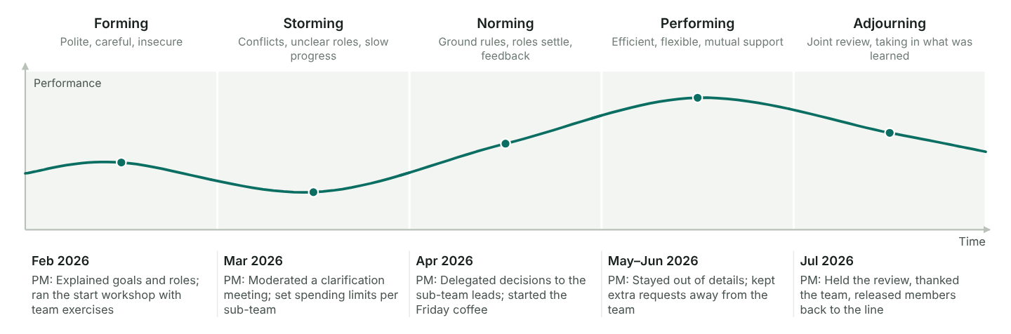
Figure 36: Performance over time through the five phases, with the dip in storming. Under each phase: when it happened and what the PM did. Phases without entries are drawn muted.

Checks
✓ The plan has a board meeting.
✓ The plan has a controlling meeting.
✓ Content and project management meetings are kept apart.
✓ Every regular meeting has a chair and a minute-taker.
✓ All ground rules are agreed.

4.2 Who does what: RACI chart
Decide for every work package who leads it, who works on it, who approves it and who is kept informed.

Step record S2: Detailed planning
Status | Done
When | Feb 2026
Format used | Individual planning, one-to-one talks
Who took part | PM, core team
What we did | Wrote WP specifications, estimated dates, staff and costs
Result | Detailed work packages
Method: Three ways to record who does what
Pick the level of detail the project needs. Each way adds to the one before.
- A list with the responsible person for each work package.
- Names or initials written into the WBS or the bar chart.
- A RACI chart: work packages as rows, people or roles as columns, a letter in each cell where someone is involved.
Method: The four letters
R and C are always used. A and I are optional; add them when approvals or reporting lines need to be clear.
- R, responsible: leads the work package and delivers its result. Exactly one per work package.
- C, contributes: works on the package and supplies part of the result.
- A, accountable: approves the result, often the project owner.
- I, informed: hears about progress and results, without working on them.
The chart makes responsibilities explicit, gives target agreements a base, shows every person the number and kind of their tasks, and helps in conflicts and when planning staff.
Make a first version now and complete it once the work package specifications are written. The specifications show who really has to contribute.

Columns
People shown as columns | All people

RACI chart
WBS | Work package | AB | MH | LN | TS | SK | JW | MF | BW | EL | PG | People
1.1.1 | Starting the project | A | R | C | C | C | C |  |  | C | I | 8
1.1.2 | Coordinating the project | I | R | C | C | C | C |  |  | C |  | 7
1.1.3 | Controlling the project | I | R |  |  |  | C |  |  | C | I | 5
1.1.4 | Closing the project | A | R | C |  |  | C |  |  | C | I | 6
1.2.1 | Surveying employee wishes | I |  | R |  | C |  |  | C |  |  | 4
1.2.2 | Developing the festival concept | I | C | R | C | C | C |  |  |  |  | 6
1.2.3 | Getting the concept approved | A | R | C |  |  | C |  |  |  | I | 5
1.3.1 | Booking the venue | I |  |  | R |  | C | C |  |  |  | 4
1.3.2 | Contracting the catering |  |  | C | R |  | C | C |  |  |  | 4
1.3.3 | Booking artists and programme | I |  | R | C |  | C |  |  |  |  | 4
1.3.4 | Organising technology and safety |  | I | C | R |  |  | C |  |  |  | 4
1.3.5 | Securing sponsors | I |  |  |  | C | R |  |  | C |  | 4
1.4.1 | Designing the invitation | I |  | C |  | R |  |  | C |  |  | 4
1.4.2 | Running the invitation campaign | I |  |  |  | R |  |  | C | C |  | 4
1.4.3 | Managing registrations |  |  |  | I | R |  |  | C | C |  | 4
1.5.1 | Setting up the venue |  |  | C | R |  |  | C | C |  |  | 4
1.5.2 | Running the festival day | I | R | C | C | C | C | C | C | C | I | 10
1.5.3 | Dismantling and cleaning up |  |  |  | R |  | I | C |  | C |  | 4
1.6.1 | Surveying participants | I |  | C |  | R |  |  | C |  |  | 4
1.6.2 | Writing the evaluation report | A | C | R |  | C | C |  |  | I | I | 7
1.6.3 | Settling all invoices | I | I |  | C |  | R |  |  | C |  | 5

Checks
✓ Every work package has exactly one R (21 work packages).
✓ Every core team member (PMTM) leads at least one work package.
✓ Team members outside the core team only contribute (C) or are informed (I).
✓ The R matches the responsible person in the WBS.
✓ Everyone in the people list is involved in at least one work package.
• People per work package: 4 to 10 (average 5.1).
• Work packages per person: AB 16, LN 14, JW 14, TS 12, SK 11, EL 11, MH 10, BW 7, MF 6, PG 6.

Involvement per person
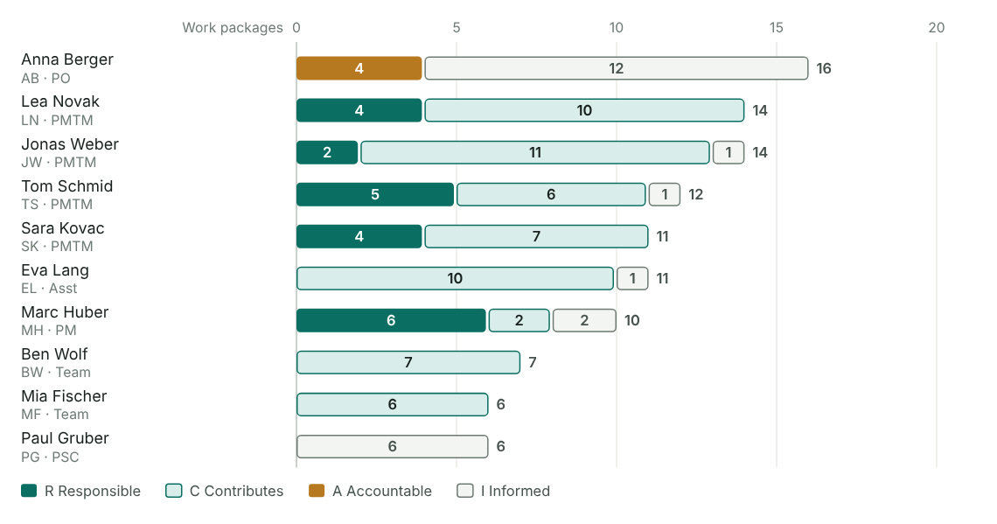
Figure 37: How many work packages each person leads (R), works on (C), approves (A) or follows (I), sorted by total. Use it to spot overloaded people and people who are barely involved.

RACI matrix
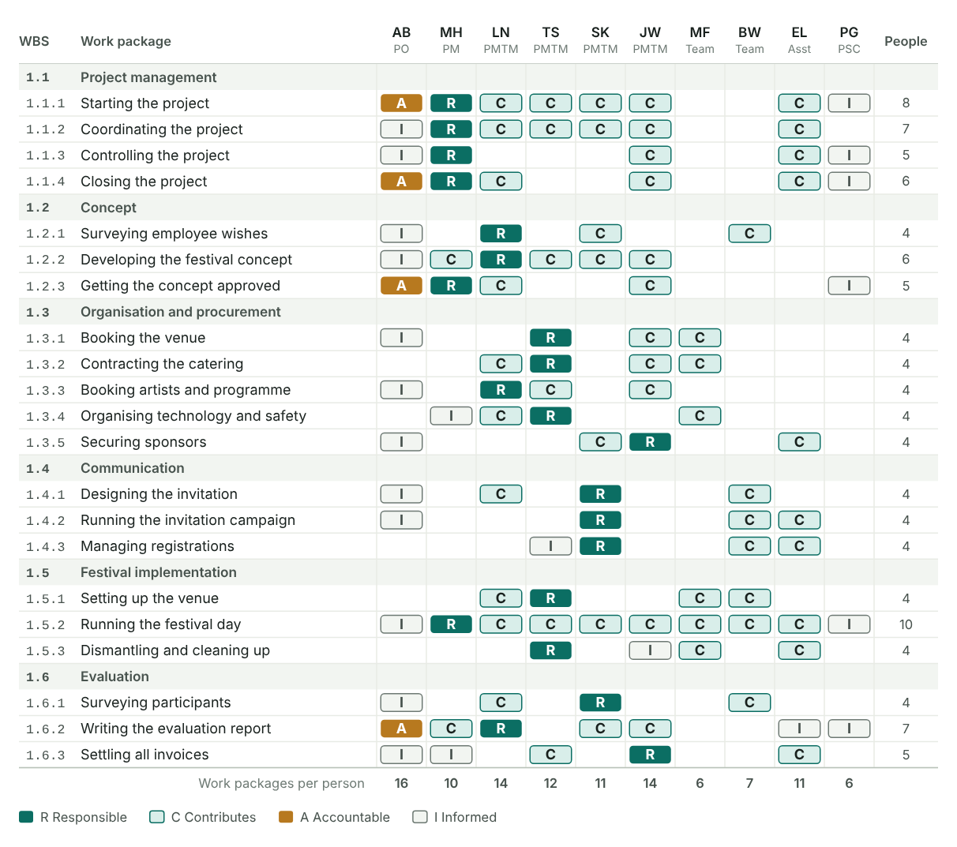
Figure 38: The chart as a picture for the PM plan, grouped by phase. The last column counts the people per work package, the last row the work packages per person. A red code marks a row without an R or with more than one.

4.2 Work package specifications
Describe the larger or riskier work packages in a short, agreed form, so that the responsible person and the PM mean the same thing.
Method: What a specification is for
It gives the PM and the work package owner the same picture, avoids duplicated work and idle time, makes schedule, staff and cost estimates more reliable and makes progress measurable.
- Settle who is responsible for each work package (RACI chart) and choose the work packages that need a specification.
- Agree a template if the one below does not fit.
- Define the specifications together with the whole team.
- Each responsible person works out the specification for their work package.
- Agree the specifications in the team, across all disciplines.
- Adapt, detail or extend the schedule, staff and cost plans where needed.
Split a long work package into a few visible steps and give each the share of work done when it is reached, for example "offers in = 25%". Progress is then counted, not guessed.

Which work packages need a specification
WBS | Work package | Responsible | Needs a specification | Status | Note
1.1.1 | Starting the project | Marc Huber | No |  | Covered by the PM plan
1.1.2 | Coordinating the project | Marc Huber | No |  | Covered by the PM plan
1.1.3 | Controlling the project | Marc Huber | No |  | Covered by the PM plan
1.1.4 | Closing the project | Marc Huber | No |  | Covered by the PM plan
1.2.1 | Surveying employee wishes | Lea Novak | No
1.2.2 | Developing the festival concept | Lea Novak | Yes | Agreed | Base for all later work packages
1.2.3 | Getting the concept approved | Marc Huber | No
1.3.1 | Booking the venue | Tom Schmid | Yes | Agreed
1.3.2 | Contracting the catering | Tom Schmid | Yes | Agreed
1.3.3 | Booking artists and programme | Lea Novak | No |  | Programme list is detailed enough
1.3.4 | Organising technology and safety | Tom Schmid | Yes | Agreed | Needs the authority, high risk
1.3.5 | Securing sponsors | Jonas Weber | No
1.4.1 | Designing the invitation | Sara Kovac | No
1.4.2 | Running the invitation campaign | Sara Kovac | Yes | Agreed
1.4.3 | Managing registrations | Sara Kovac | No
1.5.1 | Setting up the venue | Tom Schmid | Yes | Agreed
1.5.2 | Running the festival day | Marc Huber | Yes | Agreed | Whole team on the day
1.5.3 | Dismantling and cleaning up | Tom Schmid | No
1.6.1 | Surveying participants | Sara Kovac | No
1.6.2 | Writing the evaluation report | Lea Novak | No
1.6.3 | Settling all invoices | Jonas Weber | No

WP 1.2.2 Developing the festival concept
Responsible | Lea Novak
Status | Agreed
Content | Turn the survey results into a festival concept: motto, programme outline for adults and children, food and drink idea, rough site layout and a budget frame. Test the draft with the core team.
Non-content | Booking artists, caterers or the venue; detailed safety planning.
Results | Festival concept (12 pages) with motto, programme outline, site sketch and budget frame, ready for approval.
Measuring progress | Survey analysed = 20%, three concept options drafted = 50%, option chosen with the core team = 75%, concept document final = 100%
Duration | 19 calendar days (from the schedule)
Resources | 12 PD Lea Novak, 4 PD core team for the concept workshop
Predecessors | 1.2.1 Surveying employee wishes
Notes | Goes to the sponsor on 23 March for approval (WP 1.2.3).

WP 1.3.1 Booking the venue
Responsible | Tom Schmid
Status | Agreed
Content | List the venue requirements (400 guests, shade, parking, power, toilets), visit three possible sites, compare the offers and negotiate the contract.
Non-content | Furnishing and decorating the venue; permits from the authority (WP 1.3.4).
Results | Signed venue contract for 26 to 28 June, including the set-up and dismantling days.
Measuring progress | Requirements listed = 20%, three sites visited = 50%, offers compared = 70%, contract signed = 100%
Duration | 12 calendar days (from the schedule)
Resources | 6 PD Tom Schmid, 3 PD Mia Fischer, rent €6,500
Predecessors | 1.2.3 Getting the concept approved
Notes | Signed on 14 April, four days late because the owner was on holiday.

WP 1.3.2 Contracting the catering
Responsible | Tom Schmid
Status | Agreed
Content | Write the catering brief from the concept (menu for adults and children, vegetarian and vegan dishes, drinks), get three offers, hold a tasting and sign the contract.
Non-content | Serving staff on the day (steered in WP 1.5.2); the ice cream stand paid by a sponsor.
Results | Catering contract with final menu, quantities for 420 guests and a cancellation clause.
Measuring progress | Brief sent to three caterers = 25%, offers in = 50%, tasting held = 75%, contract signed = 100%
Duration | 24 days (schedule: 26 calendar days)
Resources | 5 PD Tom Schmid, 2 PD Mia Fischer, 1 PD Jonas Weber for the contract check
Predecessors | 1.3.1 Booking the venue

WP 1.3.4 Organising technology and safety
Responsible | Tom Schmid
Status | Agreed
Content | Plan stage, sound, light and power with the technical service; write the safety concept (escape routes, first aid, security staff, bad-weather plan) and get it approved by the authority.
Non-content | Artists' own equipment; Wi-Fi for guests.
Results | Technical plan confirmed by the service provider and safety concept approved by the authority.
Measuring progress | Technical needs listed = 20%, technical service contracted = 40%, safety concept submitted = 70%, approval received = 100%
Duration | 54 calendar days (from the schedule)
Resources | 10 PD Tom Schmid, 6 PD Mia Fischer, external safety consultant for 3 days
Predecessors | 1.3.1 Booking the venue
Notes | Approval came on 9 June after one round of questions from the authority.

WP 1.4.2 Running the invitation campaign
Responsible | Sara Kovac
Status | Agreed
Content | Send the invitation by e-mail and on the intranet, put up posters at all sites, send two reminders and answer questions from employees.
Non-content | Designing the invitation (WP 1.4.1); handling the registrations (WP 1.4.3).
Results | Every employee invited, two reminders sent, intranet page live.
Measuring progress | Invitation sent = 40%, posters up at all sites = 60%, first reminder sent = 80%, second reminder sent = 100%
Duration | 40 days (schedule: 47 calendar days)
Resources | 6 PD Sara Kovac, 6 PD Ben Wolf, printing €900
Predecessors | 1.4.1 Designing the invitation

WP 1.5.1 Setting up the venue
Responsible | Tom Schmid
Status | Agreed
Content | Put up tents, stage, signs and food stands; connect power and water; final walk-through with the safety officer.
Non-content | Decoration ideas (part of the concept); dismantling (WP 1.5.3).
Results | Venue ready and inspected on the evening before the festival.
Measuring progress | Tents and stage up = 40%, power and water connected = 60%, stands and signs in place = 85%, safety inspection passed = 100%
Duration | 5 calendar days (from the schedule)
Resources | 4 PD Tom Schmid, 4 PD Mia Fischer, 2 PD Ben Wolf, set-up crew of the technical service
Predecessors | 1.3.2 Contracting the catering; 1.3.4 Organising technology and safety; 1.4.3 Managing registrations

WP 1.5.2 Running the festival day
Responsible | Marc Huber
Status | Agreed
Content | Lead the festival day from the control tent: team briefing at 8:00, opening at 11:00, programme on two stages, closing at 22:00; handle incidents and guest questions.
Non-content | Set-up on the day before and clean-up on the day after.
Results | Festival held for 412 guests without serious incidents.
Measuring progress | Team briefed = 10%, gates open = 30%, afternoon programme run = 70%, festival closed and site secured = 100%
Duration | 1 calendar days (from the schedule)
Resources | 8 PD project team (8 people for one day), 12 volunteer helpers from the staff
Predecessors | 1.5.1 Setting up the venue
Notes | The bad-weather plan was not needed.

Progress measurement
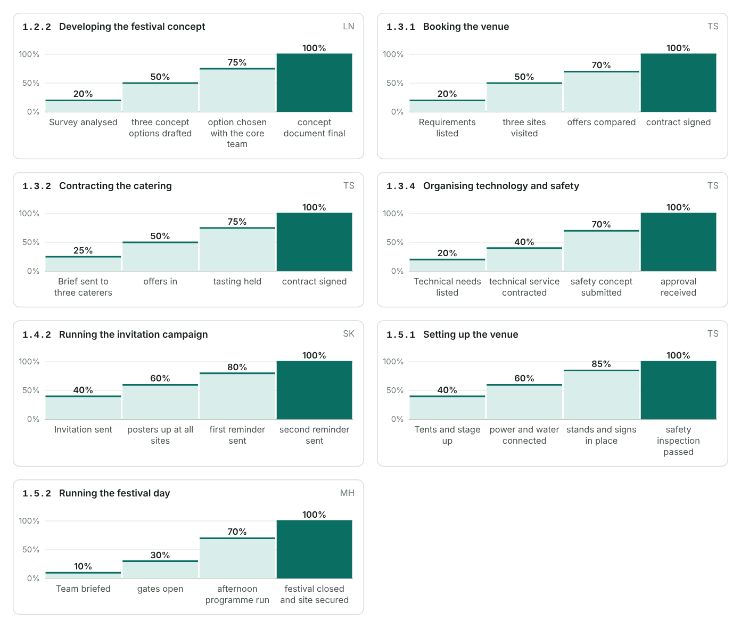
Figure 39: One ladder per specified work package: each column is a step inside the work package and the share of work done when it is reached. The filled column is 100%.

Checks
• 7 of 21 work packages need a specification; 7 of them agreed.
✓ Every marked work package has content, results and a way to measure progress.
✓ Durations in the specifications match the schedule within 20%.

4.2 Detailed schedule: linked bar chart and network
Link the work packages, find the critical path and see how much float each one has.
Method: From bar chart to linked bar chart
The schedule is finalised from the WP specifications. Network analysis is the most demanding method; use it for complex projects.
- Give every work package a duration and name what it depends on.
- Draw the bars with their links.
- Calculate forwards and backwards: earliest and latest dates and the float. The chain without float is the critical path.
- Check the result against the resource plan and fixed dates, and optimise.
Method: Accuracy grows step by step
- Rough: phases and milestones (initiation, 3.5).
- Detailed: work packages with dates and the main dependencies.
- Verified detailed: based on the WP specifications and the resource plan.
Give each reader the level they need: the sponsor the milestone plan, the core team the phase plan, work package owners the detailed bars. A detailed bar chart is rarely useful in a controlling meeting.

Types of dependency
Type | Name | Meaning | Write it as | Example | Used
FS | Finish-to-start | B can start when A has ended | 1.2.1 or 1.2.1 FS+5 | Set-up starts once the catering contract is signed | Yes
SS | Start-to-start | B can start when A has started | 1.2.1 SS+10 | Registrations open 10 days after the invitation design starts | Yes
Type the predecessors in the table below: "1.2.1" is finish-to-start, "1.3.2 SS" start-to-start, "1.4.1 FS+5" finish-to-start with 5 days lag, "1.4.1 SS-2" starts 2 days before. Separate several with a comma or semicolon. A phase code such as "1.3" stands for all its work packages.

Dates and predecessors
WBS | Name | Start | End | Days | Predecessors | Actual start | Actual end | Done (%)
1.1.1 | Starting the project | 2 Feb 2026 | 13 Feb 2026 | 12 |  | 2 Feb 2026 | 13 Feb 2026 | 100%
1.1.2 | Coordinating the project | 16 Feb 2026 | 17 Jul 2026 | 152 | 1.1.1 | 16 Feb 2026 | 17 Jul 2026 | 100%
1.1.3 | Controlling the project | 16 Feb 2026 | 17 Jul 2026 | 152 | 1.1.1 | 16 Feb 2026 | 17 Jul 2026 | 100%
1.1.4 | Closing the project | 20 Jul 2026 | 31 Jul 2026 | 12 | 1.6.2; 1.6.3 | 20 Jul 2026 | 31 Jul 2026 | 100%
1.2.1 | Surveying employee wishes | 16 Feb 2026 | 27 Feb 2026 | 12 | 1.1.1 | 16 Feb 2026 | 27 Feb 2026 | 100%
1.2.2 | Developing the festival concept | 2 Mar 2026 | 20 Mar 2026 | 19 | 1.2.1 | 2 Mar 2026 | 20 Mar 2026 | 100%
1.2.3 | Getting the concept approved | 23 Mar 2026 | 27 Mar 2026 | 5 | 1.2.2 | 23 Mar 2026 | 27 Mar 2026 | 100%
1.3.1 | Booking the venue | 30 Mar 2026 | 10 Apr 2026 | 12 | 1.2.3 | 30 Mar 2026 | 14 Apr 2026 | 100%
1.3.2 | Contracting the catering | 13 Apr 2026 | 8 May 2026 | 26 | 1.3.1 | 15 Apr 2026 | 15 May 2026 | 100%
1.3.3 | Booking artists and programme | 30 Mar 2026 | 15 May 2026 | 47 | 1.2.3 | 30 Mar 2026 | 15 May 2026 | 100%
1.3.4 | Organising technology and safety | 13 Apr 2026 | 5 Jun 2026 | 54 | 1.3.1 | 15 Apr 2026 | 9 Jun 2026 | 100%
1.3.5 | Securing sponsors | 2 Mar 2026 | 30 Apr 2026 | 60 | 1.2.1 | 2 Mar 2026 | 30 Apr 2026 | 100%
1.4.1 | Designing the invitation | 13 Apr 2026 | 24 Apr 2026 | 12 | 1.3.1 | 15 Apr 2026 | 24 Apr 2026 | 100%
1.4.2 | Running the invitation campaign | 27 Apr 2026 | 12 Jun 2026 | 47 | 1.4.1 | 27 Apr 2026 | 12 Jun 2026 | 100%
1.4.3 | Managing registrations | 27 Apr 2026 | 19 Jun 2026 | 54 | 1.4.1 SS+10 | 27 Apr 2026 | 19 Jun 2026 | 100%
1.5.1 | Setting up the venue | 22 Jun 2026 | 26 Jun 2026 | 5 | 1.3.2; 1.3.4; 1.4.3 | 22 Jun 2026 | 26 Jun 2026 | 100%
1.5.2 | Running the festival day | 27 Jun 2026 | 27 Jun 2026 | 1 | 1.5.1 | 27 Jun 2026 | 27 Jun 2026 | 100%
1.5.3 | Dismantling and cleaning up | 28 Jun 2026 | 30 Jun 2026 | 3 | 1.5.2 | 28 Jun 2026 | 30 Jun 2026 | 100%
1.6.1 | Surveying participants | 29 Jun 2026 | 10 Jul 2026 | 12 | 1.5.2 | 29 Jun 2026 | 10 Jul 2026 | 100%
1.6.2 | Writing the evaluation report | 6 Jul 2026 | 17 Jul 2026 | 12 | 1.6.1 SS+5 | 6 Jul 2026 | 17 Jul 2026 | 100%
1.6.3 | Settling all invoices | 1 Jul 2026 | 17 Jul 2026 | 17 | 1.5.3 | 1 Jul 2026 | 17 Jul 2026 | 100%

Network settings
Left out of the network | 1.1.2, 1.1.3

Critical path
Calculated from the durations and predecessors. Day 0 is the project start.

Earliest and latest dates per work package
WBS | Work package | Responsible | Duration from | Duration | ES | EF | LS | LF | TF | FF | Critical | Earliest start | Latest finish | Planned start
1.1.1 | Starting the project | Marc Huber | Dates | 12 | 0 | 12 | 0 | 12 | 0 | 0 | Yes | 2 Feb 2026 | 13 Feb 2026 | 0
1.1.2 | Coordinating the project | Marc Huber | Left out
1.1.3 | Controlling the project | Marc Huber | Left out
1.1.4 | Closing the project | Marc Huber | Dates | 12 | 150 | 162 | 150 | 162 | 0 | 0 | Yes | 2 Jul 2026 | 13 Jul 2026 | 18
1.2.1 | Surveying employee wishes | Lea Novak | Dates | 12 | 12 | 24 | 12 | 24 | 0 | 0 | Yes | 14 Feb 2026 | 25 Feb 2026 | 2
1.2.2 | Developing the festival concept | Lea Novak | Dates | 19 | 24 | 43 | 24 | 43 | 0 | 0 | Yes | 26 Feb 2026 | 16 Mar 2026 | 4
1.2.3 | Getting the concept approved | Marc Huber | Dates | 5 | 43 | 48 | 43 | 48 | 0 | 0 | Yes | 17 Mar 2026 | 21 Mar 2026 | 6
1.3.1 | Booking the venue | Tom Schmid | Dates | 12 | 48 | 60 | 48 | 60 | 0 | 0 | Yes | 22 Mar 2026 | 2 Apr 2026 | 8
1.3.2 | Contracting the catering | Tom Schmid | Dates | 26 | 60 | 86 | 98 | 124 | 38 | 38 | No | 3 Apr 2026 | 5 Jun 2026 | 10
1.3.3 | Booking artists and programme | Lea Novak | Dates | 47 | 48 | 95 | 115 | 162 | 67 | 67 | No | 22 Mar 2026 | 13 Jul 2026 | 8
1.3.4 | Organising technology and safety | Tom Schmid | Dates | 54 | 60 | 114 | 70 | 124 | 10 | 10 | No | 3 Apr 2026 | 5 Jun 2026 | 10
1.3.5 | Securing sponsors | Jonas Weber | Dates | 60 | 24 | 84 | 102 | 162 | 78 | 78 | No | 26 Feb 2026 | 13 Jul 2026 | 4
1.4.1 | Designing the invitation | Sara Kovac | Dates | 12 | 60 | 72 | 60 | 72 | 0 | 0 | Yes | 3 Apr 2026 | 14 Apr 2026 | 10
1.4.2 | Running the invitation campaign | Sara Kovac | Dates | 47 | 72 | 119 | 115 | 162 | 43 | 43 | No | 15 Apr 2026 | 13 Jul 2026 | 12
1.4.3 | Managing registrations | Sara Kovac | Dates | 54 | 70 | 124 | 70 | 124 | 0 | 0 | Yes | 13 Apr 2026 | 5 Jun 2026 | 14
1.5.1 | Setting up the venue | Tom Schmid | Dates | 5 | 124 | 129 | 124 | 129 | 0 | 0 | Yes | 6 Jun 2026 | 10 Jun 2026 | 16
1.5.2 | Running the festival day | Marc Huber | Dates | 1 | 129 | 130 | 129 | 130 | 0 | 0 | Yes | 11 Jun 2026 | 11 Jun 2026 | 16
1.5.3 | Dismantling and cleaning up | Tom Schmid | Dates | 3 | 130 | 133 | 130 | 133 | 0 | 0 | Yes | 12 Jun 2026 | 14 Jun 2026 | 16
1.6.1 | Surveying participants | Sara Kovac | Dates | 12 | 130 | 142 | 133 | 145 | 3 | 0 | No | 12 Jun 2026 | 26 Jun 2026 | 17
1.6.2 | Writing the evaluation report | Lea Novak | Dates | 12 | 135 | 147 | 138 | 150 | 3 | 3 | No | 17 Jun 2026 | 1 Jul 2026 | 19
1.6.3 | Settling all invoices | Jonas Weber | Dates | 17 | 133 | 150 | 133 | 150 | 0 | 0 | Yes | 15 Jun 2026 | 1 Jul 2026 | 16

Network checks
✓ All predecessor codes exist in the WBS.
✓ No loops in the dependencies.
✓ Every work package has a duration.
• Only the first work packages have no predecessor.
• Open ends without a successor: 1.3.5, 1.3.3, 1.4.2. Link them to a later work package (e.g. closing) so a delay shows in the end date.
✓ No work package is planned to start before its predecessors allow.
✓ Critical path 162 days (1.1.1, 1.2.1, 1.2.2, 1.2.3, 1.3.1, 1.4.1, 1.4.3, 1.5.1, 1.5.2, 1.5.3, 1.6.3, 1.1.4), ends 13 Jul: 18 days before the end date.

Linked bar chart
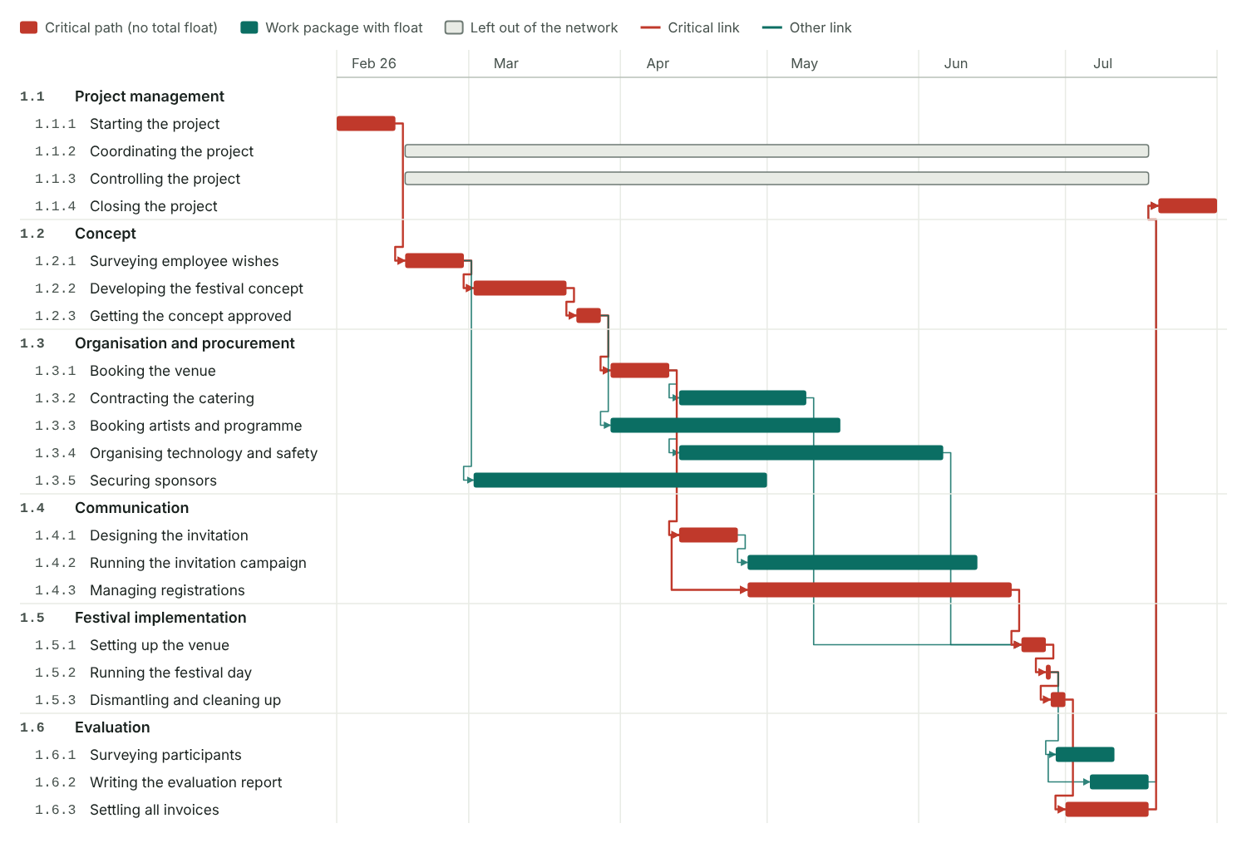
Figure 40: Bars at the planned dates. Each arrow runs from the end (FS, FF) or start (SS, SF) of the predecessor to the start (FS, SS) or end (FF, SF) of the successor. The critical path and its links are drawn in red.

Network diagram
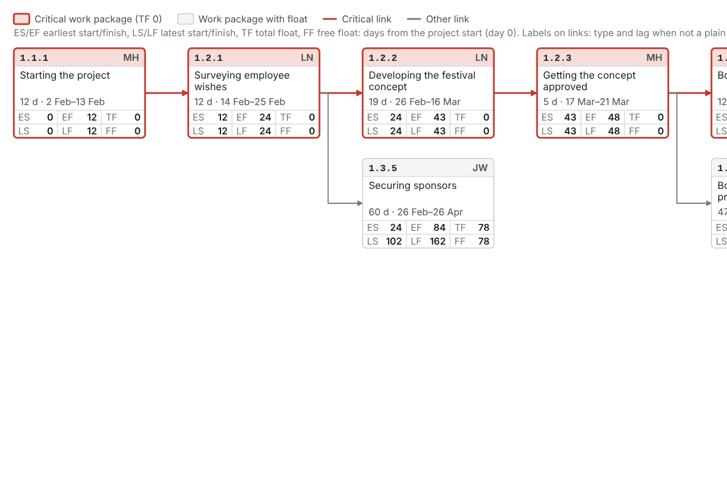
Figure 41: Part 1 of 3
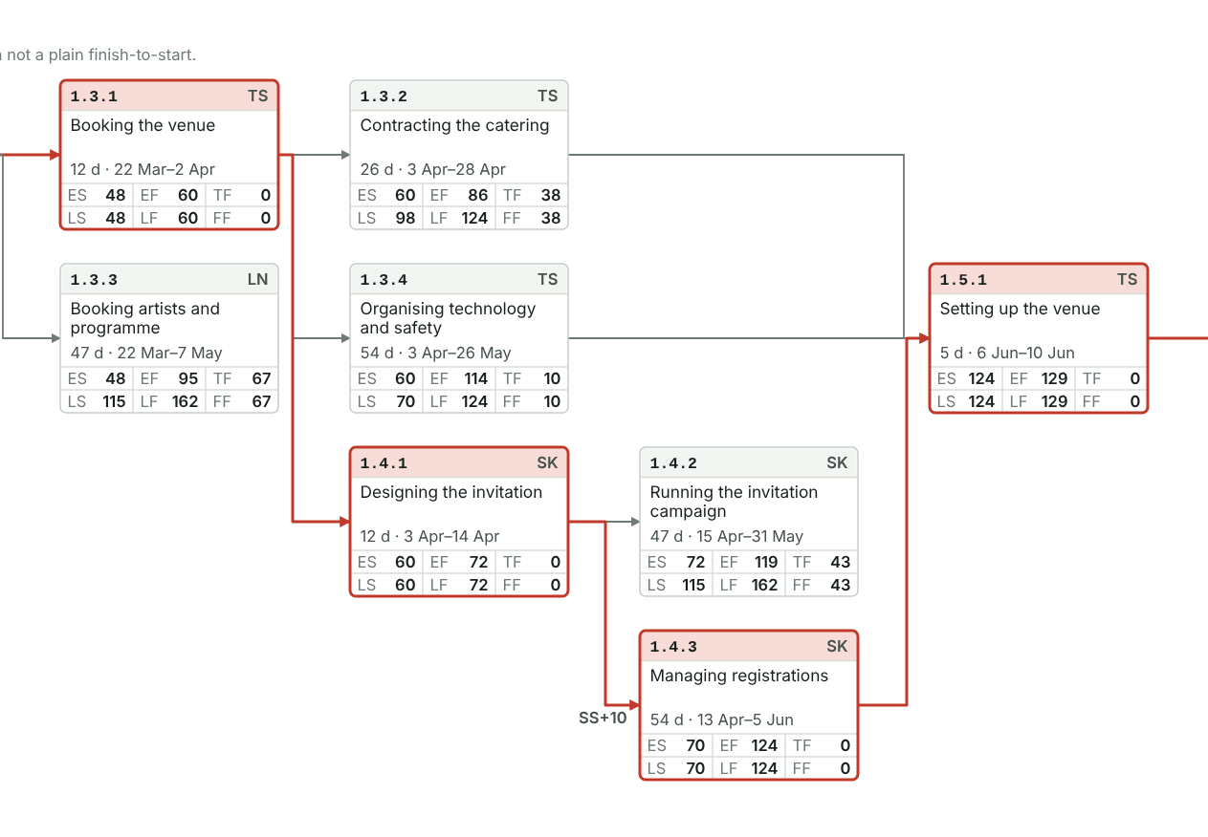
Figure 42: Part 2 of 3
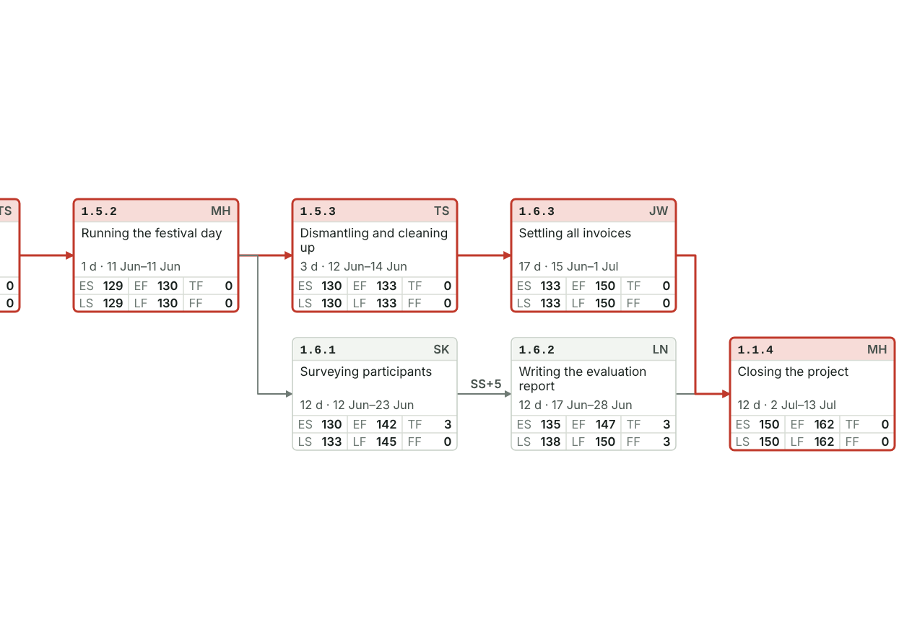
Figure 43: Part 3 of 3. Work packages in columns by their position in the chain. Each box: WBS code and responsible person, name, duration with the earliest dates, then the six values. Red boxes and arrows form the critical path. Wide diagrams scroll sideways.

4.2 Detailed resources and costs: over time
The cost plan of section 3.5 at work package level, spread over the months of the schedule: staff per month, costs per month, the cost curve and the payments.
Method: Resources and costs at work package level
- Staff allocation plan: person-days per work package for each resource type or department.
- Cost plan: cost per work package for each project cost type. The many accounting cost types are grouped into four: staff, external labour, material or investment, other.
- Spread both over the schedule: each line evenly over the calendar days of its work package.
- The resource histogram shows the peaks; check them against what the departments can give.
- The cumulative cost curve has an S shape. It is the cost baseline you control against.
- Set the incoming payments against it to see when costs run ahead of payments. Total billed minus the budget is the gross margin.
- Use the comparison to agree payment plans and as the basis for earned value analysis.

Staff over time

Staff required per month
Planned person-days per resource type and month. Each line is spread evenly over the calendar days of its WBS line.
Resource type | Feb 26 | Mar 26 | Apr 26 | May 26 | Jun 26 | Jul 26 | Total
Project management | 5.5 | 4.7 | 3.6 | 3.7 | 4.6 | 5 | 27
Corporate Communications | 4.3 | 11.1 | 4.8 | 3.9 | 3.5 | 4.4 | 32
Facility Management | – | 0.5 | 7.3 | 4.7 | 19.6 | – | 32
Marketing | 2 | – | 6.1 | 8.1 | 6.5 | 3.3 | 26
Finance | 0.2 | 2.9 | 2.9 | 0.4 | 0.4 | 4.2 | 11
Event technology | – | – | 1.3 | 2.3 | 8.4 | – | 12
Total | 12.1 | 19.2 | 25.9 | 23.1 | 42.8 | 17 | 140

Resource histogram
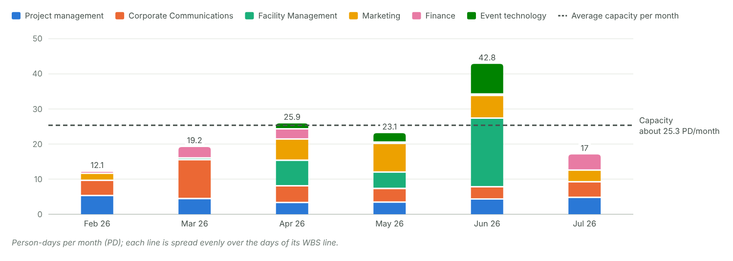
Figure 44: Planned person-days per month, stacked by resource type. The dashed line is the total available capacity spread evenly over the project months.

Costs over time

Costs per month
Planned costs per project cost type and month (€, rounded).
Cost type | Feb 26 | Mar 26 | Apr 26 | May 26 | Jun 26 | Jul 26 | Total
Staff | € 5,228 | € 8,072 | € 9,744 | € 8,264 | € 13,246 | € 7,226 | € 51,780
External labour | – | € 319 | € 16,531 | € 8,465 | € 4,185 | – | € 29,500
Material or investment | – | – | € 128 | € 989 | € 1,383 | – | € 2,500
Other | – | € 1,500 | € 8,333 | € 1,435 | € 231 | – | € 11,500
Total | € 5,228 | € 9,891 | € 34,736 | € 19,153 | € 19,046 | € 7,226 | € 95,280

Cost histogram and cumulative cost curve
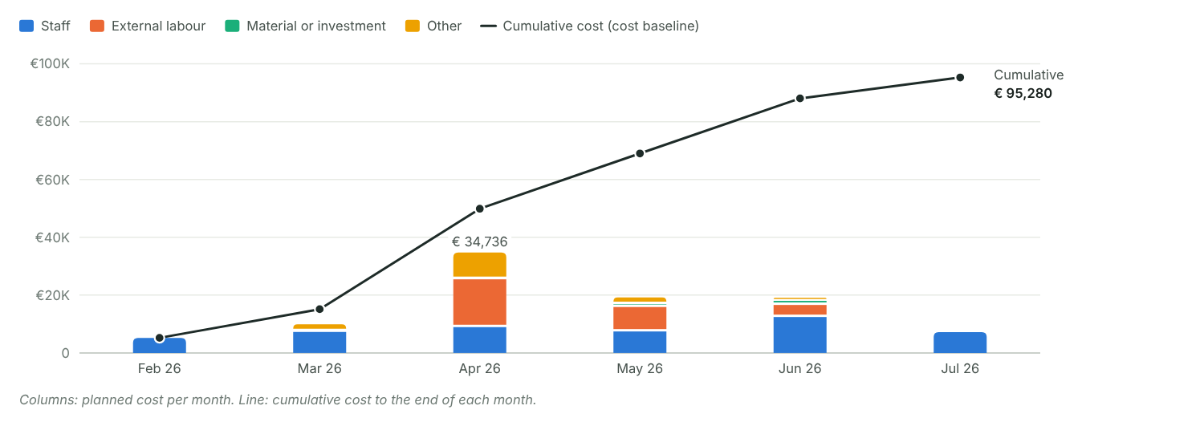
Figure 45: Planned costs per month by cost type (columns) and the cumulative cost (line) on the same axis. The line is the cost baseline.

Payments and gross margin

Incoming payments
No. | Date | Description | Amount (€) | Received
1 | 20 Apr 2026 | Main sponsor, first instalment on signing | € 5,000 | Yes
2 | 10 Jul 2026 | Main sponsor, second instalment after the festival | € 3,000 | Yes
 | Total |  | € 8,000

Total billed | € 8,000
Gross margin | −€ 87,280

Costs and payments
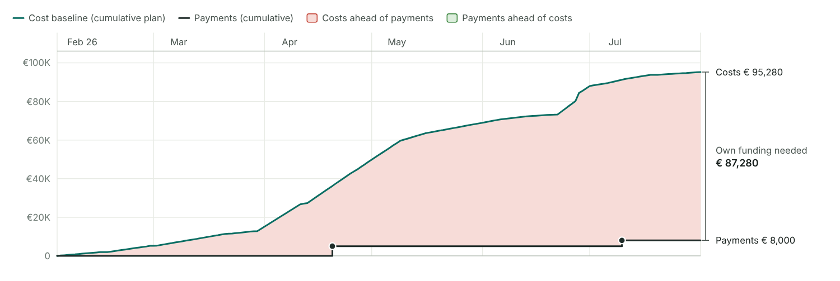
Figure 46: Cumulative cost baseline against cumulative payments. Red areas: costs run ahead of payments (you pre-finance); green areas: payments run ahead.

Checks
✓ Every line has dates and appears in the monthly view.
✗ Capacity exceeded: about 25.3 PD per month available, more needed in Apr 26 (25.9 PD), Jun 26 (42.8 PD). Agree the peaks with the line managers.

4.3 Consolidate and coordinate the detailed planning
The plans from the detailed planning are brought together, checked against each other and agreed by the team. Afterwards everyone works from the same validated plans.

Step record S3: Consolidate and coordinate
Status | Done
When | 20 Feb 2026
Format used | Follow-up workshop
Who took part | PM, core team
What we did | Completed the bar chart, staff plan, cost plan and risk table
Result | Validated plans
Method: How the plans come together
- Team members prepare their plans alone or in pairs.
- In a face-to-face follow-up workshop the team puts the plans side by side: dates, staff, costs and risks must fit each other.
- Change what does not fit and mark each plan as validated.
- Set up project marketing so the project is visible to the people it affects.
- Complex projects may need several planning cycles.

Follow-up workshop
Date | 20 Feb 2026
Place | Training room, head office
Planning cycles | 1
Participants | Marc Huber, Lea Novak, Tom Schmid, Sara Kovac, Jonas Weber, Eva Lang

Plan check
Plan | Status | What changed | By | Section
Linked bar chart / schedule | Changed | Catering and safety now start after the venue contract; predecessors added | Marc Huber | 4.2
Staff deployment (resource plan) | Changed | Helpers moved out of the ERP go-live week; two temporary staff for the setup | Tom Schmid | 4.2
Cost plan | Validated |  | Jonas Weber | 4.2
Risk analysis | Validated | Two new risks from the workshop | Marc Huber | 5
RACI chart | Validated |  | Marc Huber | 4.2
WP specifications | Validated |  | Lea Novak | 4.2
Communication plan | Validated |  | Sara Kovac | 4.1
Project marketing | Validated | Four measures agreed | Sara Kovac | 4.3

Consolidation status
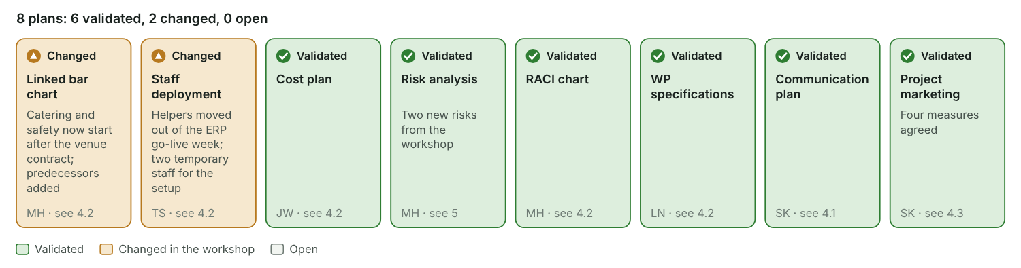
Figure 47: The eight plans at a glance. Green plans are validated, amber plans were changed in the workshop, grey plans are still open. The note shows what changed.

Project marketing
Make the project known to the people it affects, so they support it and are not surprised by it.

Project marketing plan
No. | Measure | Target group | Channel | When | Responsible | Status
1 | Teaser on the intranet | Employees | Intranet | 2 Mar 2026 | Sara Kovac | Done
2 | Save-the-date e-mail to all staff | Employees | E-mail | 16 Mar 2026 | Ben Wolf | Done
3 | CEO video invitation | Employees | Intranet | 27 Apr 2026 | Sara Kovac | Done
4 | Posters in the canteens and at the entrances | Employees | Poster | 4 May 2026 | Ben Wolf | Done
5 | Status update at the board meeting | Management board | Meeting | 15 Apr 2026 | Marc Huber | Done

4.4 Finalise the PM plan
The PM plan collects every plan of the project in one place. Send it to all core team members and settle the last open points before it goes to the project owner.

Step record S4: Finalise the PM plan
Status | Done
When | 24 Feb 2026
Format used | E-mail, one-to-one talks
Who took part | PM, project assistant
What we did | Put all plans into the PM plan and sent it round
Result | PM plan 1.0 (draft)
Method: What the PM plan does
- Shows the current status of the project at any time.
- Keeps all project management instruments together and consistent.
- Records the project history, which helps when the project manager changes.
- Lets the organisation learn from the project.

Finalising
Sent to all PMTMs on | 24 Feb 2026
Last internal meeting on open points | 25 Feb 2026
Where the PM plan is stored | Team drive: Summer Festival 2026 / 1.1 Project management / PM plan

Contents of the PM plan
Section | Document | Included | Version | File or location | Owner | Status
3.3 | Project Charter | Yes | 1.0 | Charter_v1.0.pdf | Marc Huber | Final
3.4 | Stakeholder analysis | Yes | 1.0 | Stakeholders.xlsx | Marc Huber | Final
3.5 | Results plan | Yes | 1.0 | Results-plan.docx | Lea Novak | Final
3.5 | Work breakdown structure (WBS) | Yes | 1.0 | WBS.xlsx | Marc Huber | Final
4.2 | WP specifications | Yes | 1.0 | WP-specifications.docx | Eva Lang | Final
3.5 | Milestone plan | Yes | 1.1 | Schedule.xlsx, tab Milestones | Marc Huber | Final
3.5, 4.2 | Bar chart / schedule | Yes | 1.1 | Schedule.xlsx, tab Bar chart | Marc Huber | Final
4.2 | Network analysis |  |  |  |  | Not needed
3.5, 4.2 | Resource plan | Yes | 1.0 | Resources.xlsx | Marc Huber | Final
3.5, 4.2 | Cost plan | Yes | 1.0 | Cost-plan.xlsx | Jonas Weber | Final
4.1 | Organisation chart | Yes | 1.0 | Organisation.pptx | Eva Lang | Final
4.1 | Role descriptions | Yes | 1.0 | Roles.docx | Marc Huber | Final
4.1 | Communication plan | Yes | 1.0 | Communication-plan.xlsx | Sara Kovac | Final
4.1 | Ground rules and project culture | Yes | 1.0 | Ground-rules.docx | Eva Lang | Final
4.2 | RACI chart | Yes | 1.0 | RACI.xlsx | Marc Huber | Final
5 | Risk table | Yes | 1.1 | Risks.xlsx | Marc Huber | Final
7 | Change request process | Yes | 1.0 | Change-requests.docx | Marc Huber | Final
4.3 | Project marketing plan | Yes | 1.0 | Marketing-plan.xlsx | Sara Kovac | Final
8 | Situational analysis and method check | Yes | 1.0 | Tailoring.xlsx | Marc Huber | Final

Version history
No. | Version | Date | What changed | Author | Sent to
1 | 0.9 | 24 Feb 2026 | Draft with all plans after the follow-up workshop | Marc Huber | All PMTMs, project assistant
2 | 1.0 | 27 Feb 2026 | Approved in the PSC meeting; baseline saved | Marc Huber | PO, PSC, all PMTMs
3 | 1.1 | 14 Apr 2026 | Venue contract signed four days late: milestone plan, bar chart and risk table updated | Marc Huber | PO, all PMTMs

Filing structure
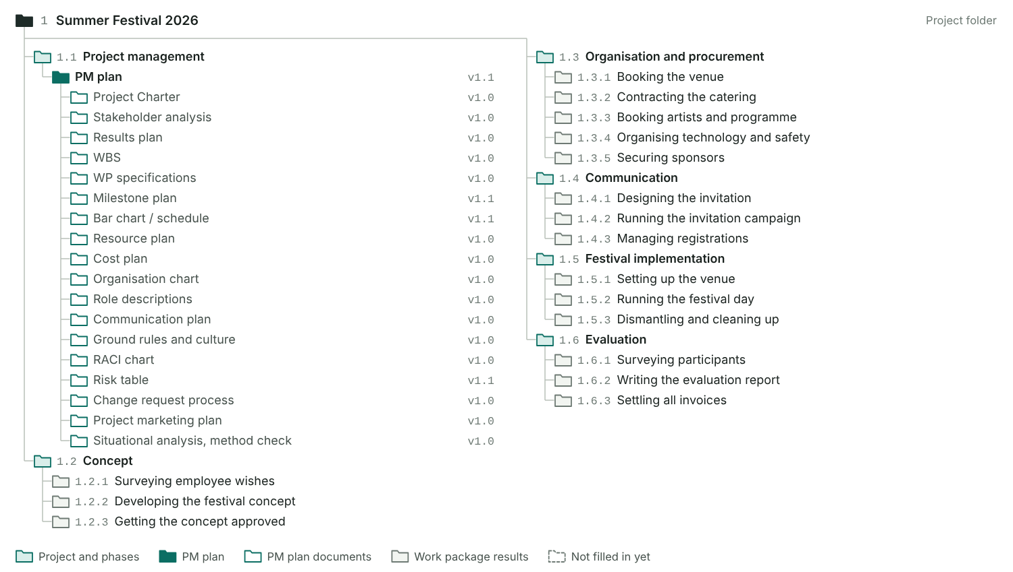
Figure 48: The WBS doubles as the filing structure. The project management phase holds the PM plan with one folder per included document; every other phase holds one folder per work package for its results.

4.5 Approve the PM plan
The project manager presents the planning to the project owner or the steering committee. Their approval of the final charter and the PM plan 1.0 ends the project start process.

Step record S5: Approve the PM plan
Status | Done
When | 27 Feb 2026
Format used | PO meeting
Who took part | Anna Berger, Paul Gruber, Marc Huber
What we did | Presented the PM plan; agreed reporting every four weeks
Result | PM plan 1.0 approved, baseline saved

Approval meeting
Date | 27 Feb 2026
Format | PSC meeting
Decision | Approved
Participants | Anna Berger, Paul Gruber, Marc Huber
Final charter approved | Yes
Approved PM plan version | 1.0
Baseline saved on | 27 Feb 2026

Agreed in the meeting
☑ Roles agreed
☑ Communication structures agreed
☑ Reporting rhythm agreed
☑ How changes are handled (change request process) agreed
☑ Baseline saved

Baseline
Baseline | Frozen on | Version | Where stored | Note
Milestone baseline | 27 Feb 2026 | 1.0 | Schedule.xlsx, tab Milestones | Eight milestones, baseline column frozen
Schedule baseline | 27 Feb 2026 | 1.0 | Schedule.xlsx, tab Bar chart | Baseline start and end of every work package
Cost baseline (S-curve) | 27 Feb 2026 | 1.0 | Cost-plan.xlsx | Planned cost per month, cumulated
Scope baseline (WBS) | 27 Feb 2026 | 1.0 | WBS.xlsx | All work packages with their results
Risk budget | 27 Feb 2026 | 1.0 | Risks.xlsx | Contingency for the top risks
Project controlling compares every later status with the baseline: milestones, dates, costs, scope and the risk budget.

Approval checks
✓ PM plan 1.0: approved
✓ Final Project Charter approved
✓ Baseline saved on 27 Feb 2026, the day of approval
✓ 5 of 5 agreements ticked
• Project start process took 28 days, from project approval to PM plan approval

5 Risk management
Find the risks, put a value on them and decide what you do about them. The risk values add up to the risk budget the sponsor approves.
Method: Risk management in four steps
The team does this together and repeats it throughout the project. It builds on the plans and can change them. Some risks will always stay unidentified.
- Identify: collect risks from the project plans, checklists, content documents, expert interviews, brainstorming and lessons learned. Look at content and quality, dates, and resources and costs.
- Assess: estimate what the risk would cost if it happens and how likely it is, usually between 5% and 70%. Risk value = risk cost × probability. Work on the highest values first.
- Plan measures: preventive measures act now, corrective measures are ready for when the risk occurs. Pick a strategy for each risk: avoid, reduce, transfer or accept.
- Implement and control: put the preventive measures into the WBS and the cost plan. Review the risks regularly, reassess them, add new ones, trigger corrective measures and record the changes.

Risk management in four steps
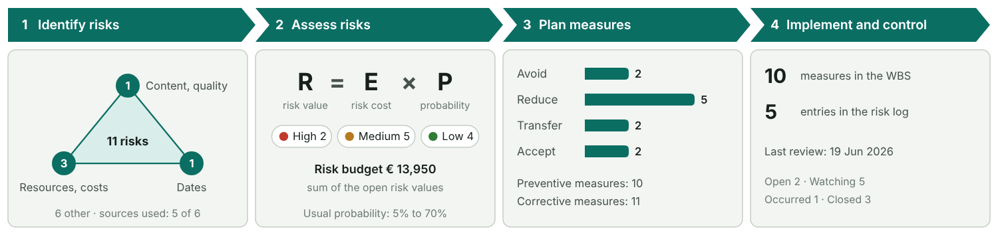
Figure 49: Filled from the risk table and the risk log. Corners of the triangle: risks on content and quality, resources and costs, and dates.

Terms
Term | Meaning | In our project
Risk | A single future event that may affect content and quality, dates, resources or costs. The effect can be negative or positive. | Rain on the festival day
Crisis | An event that threatens the project as a whole. It goes to the sponsor at once. | Losing the venue two weeks before the festival
Risk management | Finding and assessing risks, planning measures, carrying them out and checking them. | Risk table built in the follow-up workshop on 20 February, reviewed every four weeks

Identify and assess
Steps 1 and 2
Sources used | Project plans, Checklists, Expert interviews, Brainstorming, Lessons learned
First risk assessment | 20 Jan 2026
Full risk analysis | 20 Feb 2026

Priority thresholds
High from | € 5,000
Medium from | € 1,500

Risk table
No. | Title | Description and cause | Category | Risk cost (€) | Delay | Probability (%) | Risk value (€) | Priority | Strategy | Preventive measure | WBS of the measure | Cost of prevention (€) | Corrective measure | Owner | Status | Positive
1 | Bad weather on the festival day | Rain or a storm on 27 June; an open-air programme cannot run. | External | € 12,000 |  | 30% | € 3,600 | Medium | Reduce | Rent a marquee as a fallback and plan a bad-weather programme | 1.3.4 Organising technology and safety | € 2,500 | Move the programme into the marquee | Tom Schmid | Watching
2 | Venue contract delayed | The landlord is slow to sign; catering and technology cannot be booked before the venue is fixed. | Dates | € 4,000 | 1 | 40% | € 1,600 | Medium | Reduce | Start talks early and hold a second venue as an option | 1.3.1 Booking the venue | € 300 | Shift the dependent bookings, use the second venue if needed | Tom Schmid | Occurred
3 | Permit refused by the city | The authority does not approve the safety concept; the festival cannot take place as planned. | Stakeholders | € 40,000 | 4 | 15% | € 6,000 | High | Avoid | Early talks with the authority, safety concept submitted six weeks ahead | 1.3.4 Organising technology and safety | € 500 | Hold a smaller festival on the company grounds | Tom Schmid | Closed
4 | Catering supplier cancels | The caterer drops out at short notice; a replacement costs more. | Resources and costs | € 9,000 | 0.50 | 20% | € 1,800 | Medium | Transfer | Contractual penalty for cancellation, backup caterer on standby | 1.3.2 Contracting the catering | € 400 | Call in the backup caterer | Tom Schmid | Watching
5 | Low registrations | Fewer than 300 people register; fixed costs per guest rise and the event looks empty. | Content and quality | € 6,000 |  | 25% | € 1,500 | Medium | Reduce | Reminder mails and ambassadors in every department | 1.4.2 Running the invitation campaign | € 600 | Invite partners and retirees, scale down the catering order | Sara Kovac | Closed
6 | ERP rollout blocks staff time | The ERP rollout in May needs the same people from Finance and Facility Management. | People and organisation | € 4,000 | 2 | 30% | € 1,200 | Low | Accept |  |  |  | Hand tasks to the project assistant, buy external help for set-up | Marc Huber | Watching
7 | Injuries at the festival | A guest or child is injured at the venue; liability claims follow. | External | € 60,000 |  | 10% | € 6,000 | High | Transfer | Event liability insurance and a first-aid service on site | 1.3.4 Organising technology and safety | € 900 | First aid on site, report the claim to the insurer | Tom Schmid | Open
8 | Sponsor withdraws | The main sponsor pulls out; €8,000 of income is missing. | Resources and costs | € 8,000 |  | 20% | € 1,600 | Medium | Reduce | Signed agreement with instalments | 1.3.5 Securing sponsors | € 200 | Cut programme items, ask the board for extra budget | Jonas Weber | Closed
9 | Heat wave | Above 32 °C guests suffer and stay away in the afternoon. | External | € 3,000 |  | 25% | € 750 | Low | Reduce | Water stations and shade sails | 1.5.1 Setting up the venue | € 1,200 | Shorten the afternoon programme, hand out more water | Mia Fischer | Watching
10 | Noise complaints from neighbours | Neighbours complain about the music in the evening; the city may order an early end. | Stakeholders | € 2,000 |  | 30% | € 600 | Low | Avoid | Letter to the neighbours, music ends at 22:00 | 1.4.2 Running the invitation campaign | € 150 | Lower the volume, contact person on site | Lea Novak | Open
11 | Second sponsor joins | A local supplier is interested in sponsoring the children’s programme. | Resources and costs | € 4,000 |  | 30% | € 1,200 | Low | Accept | Send the sponsoring package with the invitation | 1.3.5 Securing sponsors |  | Extend the children’s programme | Jonas Weber | Watching | Yes
 | Total |  |  |  |  |  | € 24,650 (threats) |  |  |  |  | € 6,750

Totals
Risk budget | € 13,950
Risk value of all risks | € 24,650
Cost of prevention | € 6,750
High risks not closed | 1

Risk matrix
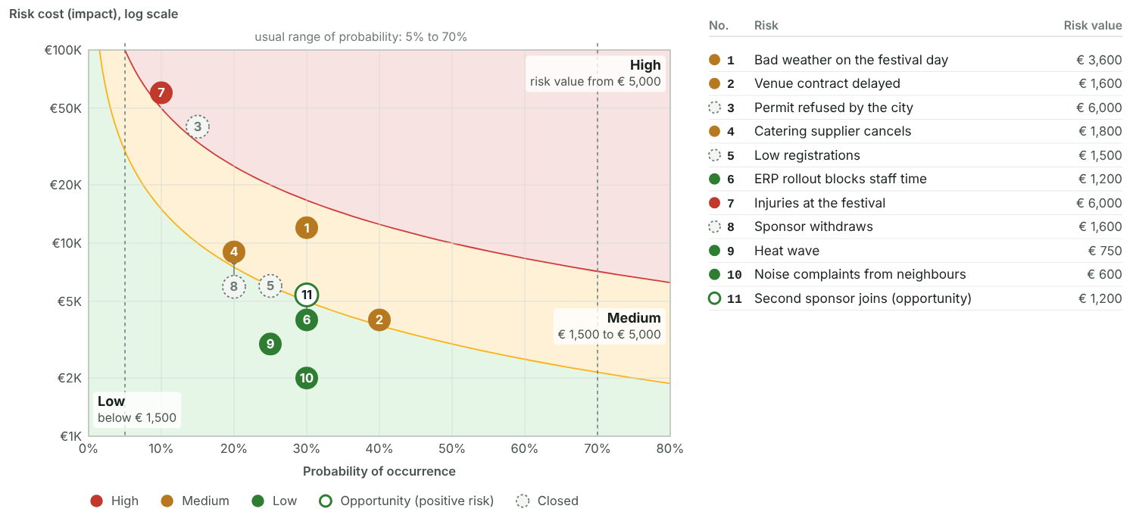
Figure 50: Each dot is one risk, numbered as in the table. The curved lines are the thresholds: along each line the risk value is the same. Dots that would cover each other are moved aside, with a thin line to their exact spot.

Risk strategies
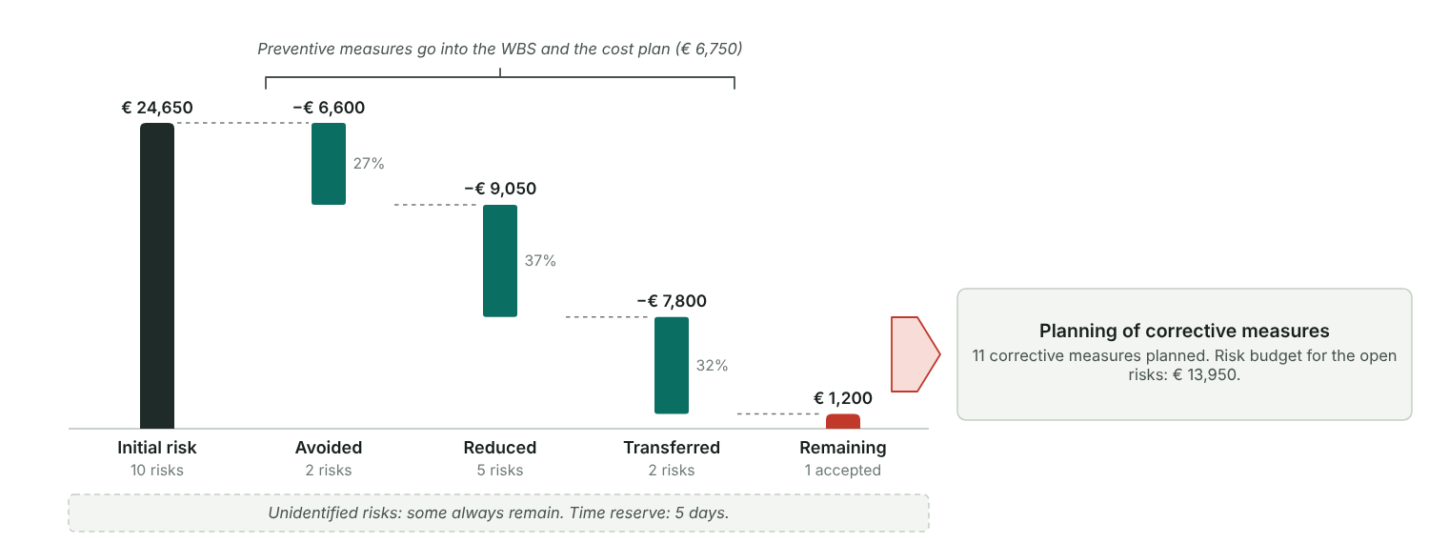
Figure 51: Start with the risk value of all risks, take off what you avoid, reduce and transfer, and what remains is the risk you accept. Opportunities are left out.

Risk budget against prevention
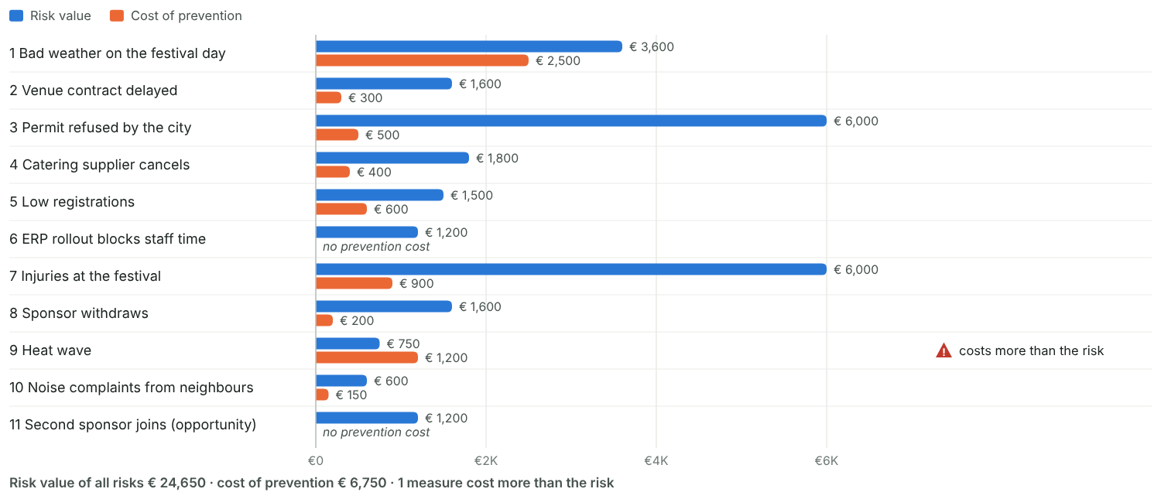
Figure 52: For each risk: what it is worth (risk value) and what the preventive measure costs. A measure that costs more than the risk value rarely pays.

Risk budget and reserves
Risk budget approved by the sponsor | Yes
Approved on | 27 Feb 2026
Time reserve | 5
Risk budget in the cost plan | Yes

Risk controlling
Step 4

Risk log
Date | Risk | What changed | New probability (%) | New risk cost (€) | Measure triggered | By
6 Mar 2026 |  | Risk review in the team meeting: all risks reassessed, no changes. |  |  |  | Marc Huber
10 Apr 2026 | 2 Venue contract delayed | Landlord asks to change the liability clause; signature moves from 10 to 14 April. | 100% | € 1,500 | Catering and technology bookings shifted by 4 days | Tom Schmid
20 May 2026 | 5 Low registrations | 380 registrations after the first reminder; target reached by 5 June with 430. | 5% |  | Second reminder through the ambassadors | Sara Kovac
9 Jun 2026 | 3 Permit refused by the city | The authority approved the safety concept; risk closed. |  |  |  | Tom Schmid
19 Jun 2026 | 1 Bad weather on the festival day | Long-range forecast for 27 June: showers likely in the afternoon. Assessment kept at 30%. | 30% | € 12,000 | Marquee confirmed, bad-weather programme sent to the artists | Marc Huber
Involve as many people as you can, also outside the core team. Build the first risk table on a flip chart. Keep the list to the critical risks you can influence. Use your company’s standard risk table if there is one.

Checks
✓ Every probability lies between 5% and 70%.
✓ Every High risk has a preventive measure and an owner.
✓ Every open risk has a strategy (avoid, reduce, transfer or accept).
✓ Every preventive measure is linked to a WBS line.
✗ Prevention costs more than the risk value: 9 Heat wave. Choose a cheaper measure or accept the risk.
✓ 2 High risks: a number the team can manage.
✓ The sponsor approved the risk budget on 27 Feb 2026.
✓ The risk budget is part of the cost plan.
• Risk budget € 13,950 is 14.6% of the planned cost (€ 95,280); prevention adds € 6,750.
✓ Risk controlling: 5 dated entries in the risk log.

6 Kick-off and start workshop
Choose how the team plans together in the start phase, then prepare the kick-off and the start workshop.
Method: Four formats you can combine
Effort and planning quality both rise from the first format to the last. Most projects combine several of them.
- Planning alone: the PM drafts plans at the desk. Quick, but the plan rests on one view.
- One-to-one meetings: the PM works through single topics with the people who know them.
- Kick-off meeting: the PM presents the results so far and briefs the team. Information flows one way.
- Project start workshop: the team works out planning and organisation together. It costs the most effort and gives the best plans and the strongest commitment.

Kick-off meeting and start workshop compared
Aspect | Kick-off meeting | Project start workshop | In our project
Purpose | Present results and brief the team with filtered information | Work out planning and organisation together | Kick-off to inform all helpers; workshop for the core team to plan together
Communication | One way: talk and presentation | Team work; the PM works as part of the project management team | Kick-off: presentations by PO and PM; workshop: group work with an internal coach
Effect | Information | Acceptance, motivation and commitment | Everyone knew the plan; the core team owned the detailed planning
Effort | Medium | High: preparation, follow-up and coordination | Kick-off half a day to prepare; workshop three days to prepare and follow up
Planning quality | Usually low | Usually high | Workshop produced the WP list, schedule draft and risk list
Duration | 2 to 4 hours | Half a day to 2 days | Kick-off 2 hours, workshop 1 day

Formats used in this project
Format | Used | When | Participants | Note
Planning alone | Yes | 19 Jan 2026 | 1 | PM drafted the six fields and a first WBS
One-to-one meetings | Yes | 21 Jan 2026 | 6 | Talks with PO, Facility Management, Finance and Marketing
Kick-off meeting | Yes | 4 Feb 2026 | 12 | Whole team, PO for the first hour, three volunteer helpers
Project start workshop | Yes | 5 Feb 2026 | 8 | Seehotel Am Wald, moderated by an internal coach
Follow-up workshop | Yes | 20 Feb 2026 | 6 | Completed bar chart, cost plan and risk table

Formats: effort and planning quality
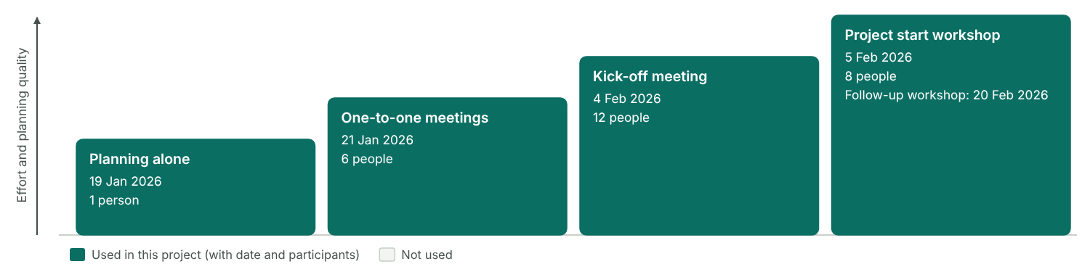
Figure 53: The four formats as steps. Each step up costs more effort and gives better plans. Filled steps are the ones this project used.

Kick-off meeting
A short meeting to inform everyone: what the project is, what has been decided, who does what.

Kick-off
Date | 4 Feb 2026
Duration | 2 hours (14:00–16:00)
Place | Main building, conference room 3
Participants | Anna Berger, Marc Huber, Lea Novak, Tom Schmid, Sara Kovac, Jonas Weber, Mia Fischer, Ben Wolf, Eva Lang

Kick-off agenda
No. | Time | Topic | Presenter | Material
1 | 14:00 | Welcome: why we hold a summer festival | Anna Berger | Slides
2 | 14:15 | Project charter: objectives, scope, date and budget | Marc Huber | Charter, slides
3 | 14:45 | Phases, milestones and the high-level plan | Marc Huber | Milestone plan
4 | 15:15 | Project organisation, roles and sub-teams | Marc Huber | Organisation chart
5 | 15:40 | Start workshop tomorrow, next steps, questions | Marc Huber | Workshop agenda
6 | 15:55 | Closing words | Anna Berger

Project start workshop
The PM is responsible. Decide what you prepare and present, and what the team works out on the day.

Start workshop
Date | 5 Feb 2026
Duration | 1 day
Place | Seehotel Am Wald
External location | Yes, external location
Moderation | Internal coach from Learning and Development
Social event | Dinner at the hotel after the workshop
Participants | Marc Huber, Lea Novak, Tom Schmid, Sara Kovac, Jonas Weber, Mia Fischer, Ben Wolf, Eva Lang

Start workshop agenda
No. | Time | Topic | Method | Result | Responsible | Prepared or worked out
1 | 09:00 | Welcome, goals and agenda of the day | Presentation | Shared goals for the day | Marc Huber | Prepared in advance and presented
2 | 09:20 | Results so far: charter, six fields, milestone plan | Presentation | Charter validated, questions answered | Marc Huber | Prepared in advance and presented
3 | 10:00 | Roles, sub-teams and ground rules | Group work | Role descriptions, ground rules | Marc Huber | Worked out in the workshop
4 | 11:00 | Coffee break | Break
5 | 11:15 | Communication plan and meetings | Plenary discussion | Communication plan | Eva Lang | Worked out in the workshop
6 | 12:30 | Lunch | Break
7 | 13:30 | Work packages per sub-team | Group work | WP list with responsible persons | Tom Schmid | Worked out in the workshop
8 | 15:00 | Detailed schedule and dependencies | Group work | Draft of the linked bar chart | Lea Novak | Worked out in the workshop
9 | 16:15 | Risks and measures | Plenary discussion | Risk list with owners | Jonas Weber | Worked out in the workshop
10 | 17:00 | Open points, next steps, feedback | Plenary discussion | To-do list until the follow-up workshop | Marc Huber | Worked out in the workshop

Start workshop checks
✓ 8 participants (3 to 15 work well)
✓ Held at an external location, away from daily business
✓ The agenda mixes prepared items (2) with items worked out together (6)
• Social event: Dinner at the hotel after the workshop
• The start workshop also counts as a quality measure: the whole team checks the plan.

7 Contract management in customer projects
In a customer project the contract process runs next to the project management process. Keep the two in step.
This project is set to "Event". This page can stay empty; use it only if you want to track contracts with suppliers.
Method: Two processes side by side
Sales runs the contract process, the PM runs the project. Plan the points where they meet. What makes it hard:
- The project rests on a legal contract that is hard to change.
- The people usually change between the offer and the implementation, so information gets lost when the contract is signed.
- The interests of the parties can contradict each other.
- A valid offer already needs some project planning.
- Contract and project documents repeat each other, for example the description of services.

Contract process in this project
Step | Activities | Roles | Results | When | Who in our project | Status | Note
Acquisition | Evaluate customer expectations, check technical and commercial feasibility, plan the offer process | Sales | Rough business case, first risk assessment, customer requirements, plan for the offer |  |  | Not applicable | Internal event, no customer
Preparation of offer | Plan the offer in detail where needed, prepare its contractual, commercial and content parts, assess risks, get approval | Sales, department | Offer documents, business case and project plans, negotiation strategy |  |  | Not applicable
Contract negotiation | Hand the offer to the customer, take in feedback, appoint the negotiation team, negotiate and sign | Sales, department | Adapted offer, signed contract | Mar–Apr 2026 | Tom Schmid, Purchasing | Done | Venue and catering contracts, with us as the customer
Project handover | Appoint PM and project team, brief the project organisation, release the offer team | Sales, department, PM | Project organisation in place, project assignment, offer team released |  |  | Not applicable
Contract analysis and detailed planning | Analyse the obligations of both parties, find risks and open points, plan the project | PM, PMTMs | Implementation plan, risk analysis, claim and change request strategy | Apr–May 2026 | Tom Schmid, Jonas Weber | Done | Key obligations of the supplier contracts listed below

Contract and project process
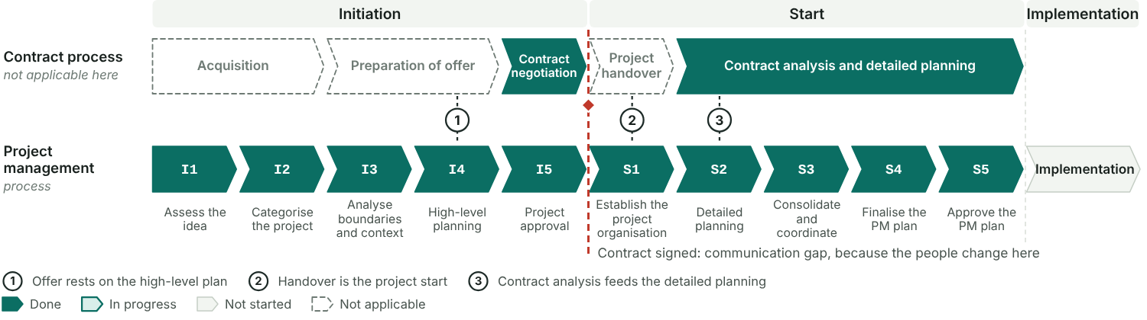
Figure 54: The contract process above, the ten steps of the project below. The numbered points are where both must be in step. The red line marks the signature, where the offer team hands over to the project team.

Contract analysis
After the handover, go through the contract and list what each party has to do, by when, and what is still open.

Obligations from the contract
No. | Obligation | Party | Clause | Due | Risk or open point | WBS
1 | Venue: pay a 30 % deposit (€2,700) on signature | Us | § 4.1 | 24 Apr 2026 |  | 1.3.1 Booking the venue
2 | Venue: provide power (400 V), water and toilets on the grounds | Supplier | § 3.2 | 22 Jun 2026 | Power for the marquee not covered; clarified in May | 1.5.1 Setting up the venue
3 | Venue: get the safety concept approved by the authority before set-up | Both | § 5 | 5 Jun 2026 | Approval came on 9 June, four days late | 1.3.4 Organising technology and safety
4 | Venue: hand back the grounds cleaned by 30 June, 18:00 | Us | § 7.2 | 30 Jun 2026 | Book the cleaning crew early | 1.5.3 Dismantling and cleaning up
5 | Catering: confirm the final number of guests 10 days before the event | Us | § 3 | 17 Jun 2026 | Late registrations; 5 % tolerance agreed | 1.4.3 Managing registrations
6 | Catering: food and drinks for 400 guests, with vegetarian and children’s menus | Supplier | § 2 | 27 Jun 2026 |  | 1.5.2 Running the festival day
7 | Catering: pay the final invoice within 14 days | Us | § 6 | 14 Jul 2026 |  | 1.6.3 Settling all invoices

Strategies
Claim strategy | No customer contract. Towards suppliers: report every deviation in writing at once, keep delivery notes and photos, and hold back payment for services not delivered.
Change request strategy | Every change to scope, date or budget goes to the PM in writing. The PM assesses the impact on schedule and costs within three days. The PO decides changes above €1,000; smaller ones the PM decides within the risk reserve.

Change request log
No. | Date | Requested by | Description | Scope impact | Schedule impact | Cost impact (€) | Decision | Decided by | Date decided
1 | 20 May 2026 | Tom Schmid (venue and logistics) | Add a marquee (20 × 10 m) as rain cover for the catering area | Marquee, set-up and lighting added | 1 | € 2,500 | Accepted | Anna Berger | 22 May 2026
 | Total |  |  |  |  | € 2,500

8 Tailoring the planning process
Fit the planning process to the project: analyse the situation, choose the methods and line up the steps.
Method: The planning process is a small project of its own
Delimit it like a project: by its start and end events, its content, the people involved, its context and how it relates to your company standard. The PM is responsible and makes it transparent to everyone:
- which steps belong to the initiation and which to the project start,
- which communication formats are used,
- which methods are used, and how deep.

Boundaries of the planning process
Start event | Marc Huber appointed as PM, preliminary charter available (19 Jan 2026)
End event | PM plan 1.0 approved by PO and PSC (27 Feb 2026)
Participants | PO and PM in I1–I3 and I5; PM with four designated core team members in the I4 planning workshop; the whole team at the kick-off; core team, team members and assistant in the start and follow-up workshops; PO and PSC in S5.
Context | First festival of this size. The date was fixed by the board, the budget sits in the HR budget, and venues and artists book up early in summer.
Relation to the company standard | Company standard for small internal projects, with one deviation: a full-day start workshop because six departments work together.

Situation analysis
Rate the project on each criterion. The profile shows what the planning process has to cover and who is needed when.

Situation analysis
Group | Criterion | Rating | Note
Planning situation | Clarity of order or contract | clear and good
Planning situation | General planning situation | sufficient
Planning situation | Budget situation | rather non-critical | Budget approved, but no reserve beyond the risk reserve
Planning situation | Deadline situation | rather critical | Date fixed by the board; venues book up early
Project features | Room for manoeuvre | medium flexibility
Project features | Probable need for changes | lower
Project features | Level of innovation | small
Project features | Technique or content | known
Project organisation | Internal participants | 4–7 | 6 internal team members
Project organisation | External participants | 1–3 | Venue, catering and event technology
Project organisation | Location of the team | on site
Project organisation | Content experience of the team | good
Project organisation | PM experience of the team | fairly good | First project for two core team members
Environment | Relation to stakeholders | good
Environment | Relation to the customer | good | Internal customer: HR and the board

Result
Critical answers | 1
Overall profile | Mostly uncritical (average 1.6 on a scale of 1 to 4). Watch: deadline situation

Situation analysis profile
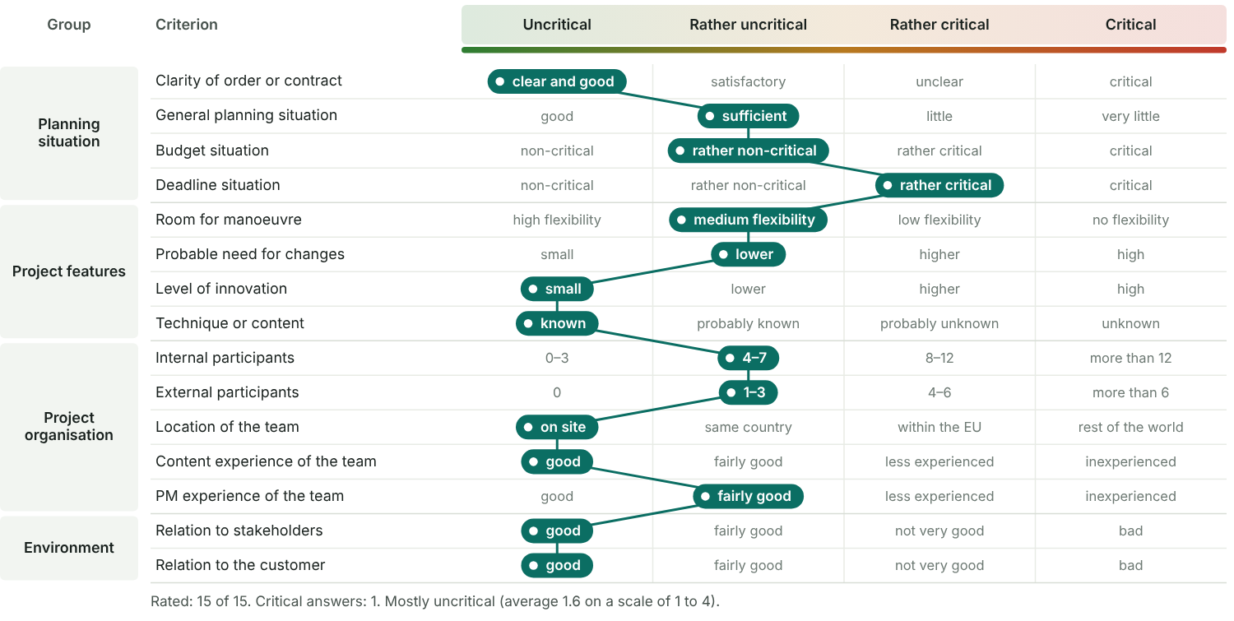
Figure 55: One row per criterion, from uncritical on the left to critical on the right. The chosen answers are joined into a profile line; the further right it runs, the more care the planning needs.
What the profile means for the planning process | The profile is mostly uncritical, so a lean initiation is enough: one-to-one talks and a half-day planning workshop. The tight deadline is the main risk: fix the date and book the venue in the initiation, and plan all bookings in detail at the start workshop. Finance and Facility Management are needed from I4; the internal coach is needed for one day in S1.

Method check
For every method, decide whether it already exists, is prepared in the initiation or in the start process, or is not needed. The list is also the content of the PM plan.

Method check
Method or document | Level | Usual timing | Section | Decision | Depth | Note
Project assignment (charter) | Foundation | Initiation, finalised in the start process | 3.3 | Initiation process | Detailed
Stakeholder analysis | Foundation | Initiation | 3.4 | Initiation process | Rough
List of deliverables, results plan | Compulsory (base camp) | Initiation | 3.5 | Initiation process | Rough
Work breakdown structure | Compulsory (base camp) | Initiation | 3.5 | Initiation process | Detailed
Milestone plan | Compulsory (base camp) | Initiation | 3.5 | Initiation process | Detailed
Resource plan | Compulsory (base camp) | Initiation, detailed in the start process | 3.5, 4.2 | Start process | Detailed | Rough estimate in I4
Cost plan | Compulsory (base camp) | Initiation, detailed in the start process | 3.5, 4.2 | Start process | Detailed | Financing plan kept rough: HR budget plus sponsors
Organisation chart | Organisation | Start process | 4.1 | Start process | Detailed
Definition of roles | Organisation | Start process | 4.1 | Already exists | Detailed | Company role descriptions used
Communication plan | Organisation | Start process | 4.1 | Start process | Detailed
Ground rules | Organisation | Start process | 4.1 | Start process | Rough
RACI chart | Organisation | Start process | 4.2 | Start process | Detailed
WP specification | Optional (detailed) | Start process | 4.2 | Start process | Rough | Only for the critical work packages
Linked bar chart or network plan | Optional (detailed) | Start process | 4.2 | Start process | Rough | Linked bar chart; no full network analysis
Risk analysis, qualitative or quantitative | All levels, grows with complexity | First assessment in initiation, full analysis in the start process | 5 | Start process | Rough | Qualitative risk table
Contract analysis | External projects | After the project handover | 7 | Not required |  | Internal project; supplier contracts checked by Purchasing
Change request process | Additional | Start process | 7 | Start process | Rough
Project marketing | Additional | Start process |  | Start process | Rough | Intranet news and posters

Method pyramid
Figure 56: The more complex the project, the further up the pyramid the planning goes. Risk management runs up the side because it grows with complexity. Each method is styled by its decision in the method check.

Tailoring checks
✓ Start and end event of the planning process defined
✓ 15 of 15 situation criteria rated
✓ 18 of 18 methods decided
✓ No foundation or base camp method is skipped
• Contract analysis is only needed for customer projects.

Planning navigator
A project runs on five process levels that shift against each other. The navigator lines them up.
Method: Four steps to your navigator
- Take the generic project management process: initiation, then start.
- Define the planning and communication steps and assign them to it.
- Define the content phases of the project.
- Assign deliverables and project management methods to the steps.

Navigator of this project
Process | Planning and communication steps | Content phases covered | Deliverables | PM methods
Initiation | I1–I3 in one-to-one talks and an initial PO meeting; I4 in a half-day planning workshop; I5 in a PO meeting | None | Preliminary charter, six fields, stakeholder list, WBS, milestone plan, rough budget | Project assignment, stakeholder analysis, WBS, milestone plan, rough cost plan, first risk list
Start | Kick-off and start workshop (S1–S2), one-to-one talks (S2), follow-up workshop (S3), e-mail (S4), PO and PSC meeting (S5) | 1.2 Concept (survey of employee wishes) | Final charter, PM plan 1.0, organisation chart, communication plan, ground rules | Organisation chart, RACI chart, WP specifications, linked bar chart, staff and cost plan, risk analysis, change request process

Planning navigator
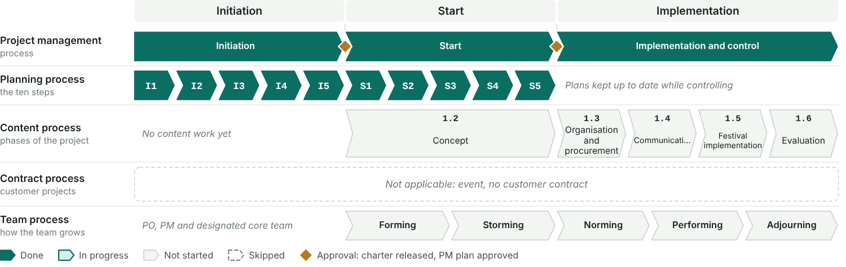
Figure 57: Five process levels under one header. Positions are relative, not dates. The planning steps take their colours from the step records; the content phases come from the WBS and the table above.

Large external or small internal project
Aspect | Large external project | Small internal project | Our project
Initiation | Assess the idea, categorise, boundaries and context, rough and detailed planning, consolidate and compile the PM plan, approval | Assess the idea or task, boundaries and context | As in a small internal project, plus a planning workshop in I4
Start | Kick-off, establish the organisation | Establish the organisation, project planning, PM plan, approval of the PM plan | Kick-off, start workshop and follow-up workshop
Content phases | Rough and detailed concept, implementation, test, training, piloting, launch | Analysis, rough and detailed concept, implementation, training | Concept, organisation and procurement, communication, festival, evaluation
Deliverables in initiation | Contract, project assignment, requirements, functional specification, PM plan, risks | Preliminary project assignment | Preliminary charter with milestone plan and rough budget
Deliverables in start | Communication structures, ground rules, change request process | Final project assignment, PM plan, project organisation | Final charter, PM plan 1.0, project organisation

Our project is closer to | Small internal project

